For Immediate Release
June 22, 2016 – Los Angeles, CA
Contact: bryson@birdphotobooth.com
Price $39-$99 Bird Photo Booth 2.0:
The world’s first wireless bird feeder and motion-activated bird camera combo for everyone

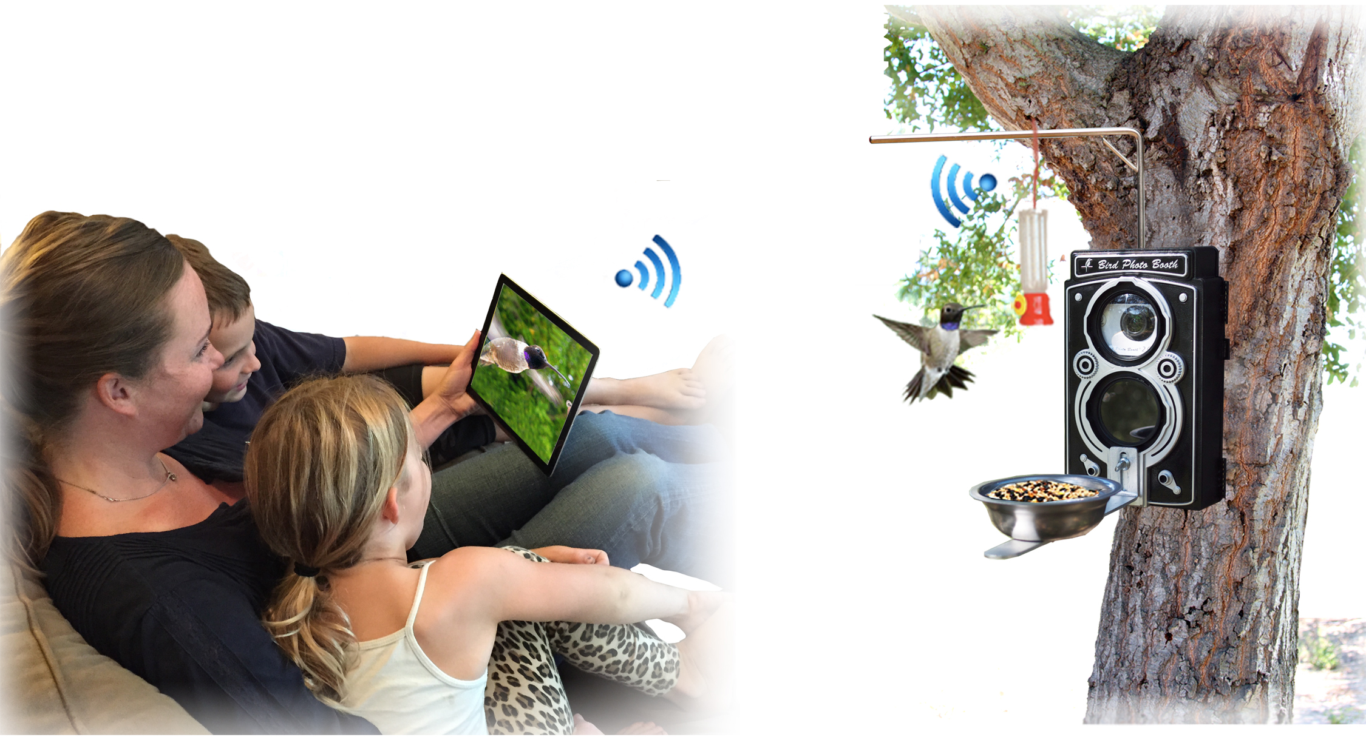
Bird Photo Booth 2.0 reimagines the bird and wildlife watching experience.
Remotely watch, photograph, and film birds in real time.

Bryson Lovett launches Bird Photo Booth 2.0, a simple, affordable photographic tool built to empower people of all ages to discover and share nature’s most meaningful untold stories. Currently 200% funding on Kickstarter.com. Price $39-$99.

Bird Photo Booth 2.0 is a thoughtful new product from award-winning inventor, photographer, and birder, Bryson Lovett. Seeking a more interactive, rewarding, and affordable way to photograph birds and wildlife with the ultimate close-up detail, Lovett set to work creating and constructing the first product that unites bird watching, bird feeding, and bird photography.

Tired of buying expensive photography equipment, and having to sneak quietly up to birds (only for them to eventually get startled and fly away), Lovett created Bird Photo Booth 2.0 the first interactive bird feeder and HD motion-activated Wi-Fi bird camera combination. It brings new enjoyment, ease, and affordability to experiencing and photographing your favorite birds in action, without them flying away.

Its unique and innovative design feature a custom developed Motion-Activated Wi-Fi bird camera option making it the preferred and easiest way to remotely watch, photograph and film birds in remarkable quality.

Bird Photo Booth 2.0 works in two ways: (No app. downloads or quarters needed.)

1. By using our Motion-Activated Wi-Fi Bird Cam that is specifically optimized for the Bird Photo Booth 2.0 weatherproof enclosure, or,
2. By placing any iOS or Android smartphone inside Bird Photo Booth 2.0’s weatherproof enclosure and control it in seconds with the Bluetooth remote.

Bird Photo Booth 2.0 eliminates the need for expensive photo equipment; now anyone can afford to take stunning professional photos and videos of wildlife and share them with friends and family.

Quick facts:

Built for a lifetime of fun: Bird Photo Booth 2.0 brings a new interactive view of nature into your hands as birds playful personalities are streaming live to mobile devices. Bird Photo Booth is addicting and fun, as birds will pose for you in real time.

Custom Motion-Activated Wi-Fi Bird Cam: The Bird Photo Booth 2.0 Wi-Fi Bird Cam allows users to capture HD footage and burst photos unattended via custom developed motion detection functionality. Also, users can view a live stream of the bird action at the feeder by connecting to the camera’s built-in Wi-Fi, via an app.

Easy to use: Easy for everyone to enjoy, whether you're the first-time bird watcher or the professional bird photographer, you'll be photographing birds and sharing them with your friends and family in no time.

Innovative & unique: It’s the only combined bird feeder and bird camera combination. Bird Photo Booth 2.0 includes a powerful macro lens, which magnifies the birds streamed live to you on your mobile devices. Retro twin lens cameras from 1930's inspire its unique design.

Extraordinarily detailed pictures and video: Its professional macro and UV lenses capture birds with a new precision:

Story:
Lovett Lab Inc was founded by Bryson Lovett who’s unrelenting passion for wildlife and the outdoors turned into a mission to making the art of bird and nature photography better, easier, and more affordable. As an inventor, photographer, and product designer, chief birding officer Bryson Lovett believes in building meaningful products, which empower, motivate, and do good by inspiring people of all ages to see and share the natural world through innovative technology and beautiful design.

Bryson set out to reimagine the bird watching experience when he successfully funded the original Bird Photo Booth back in 2012. Now, in 2016, the wireless bird watching revolution continues with an all-new Bird Photo Booth 2.0 that made its first appearance at the 2016 National Hardware Show winning a Lawn, Garden, and Outdoor Innovation Award.

Quotes:
“What excites me the most about the Bird Photo Booth 2.0, is the new possibilities it presents to bird and wildlife photography. The combination of a bird feeder with a custom developed motion-activated bird cam produces HD footage that was previously unattainable in all of bird and nature photography. We can’t wait to see what our customers do with this product.” -Bryson Lovett, Chief Birding Officer

“I am incredibly excited to be back on Kickstarter. Bird Photo Booth 2.0 is more powerful than ever. I’ve reimagined the bird watching experience by uniting the joys of birding into a single, easy to use experience.” –Bryson Lovett , Chief Birding Officer

Check out the Bird Photo Booth 2.0 Kickstarter campaign here:

https://www.kickstarter.com/projects/bird-feeders/bird-photo-booth-20-see-life-through-a-new-lens

Press Kit:
Download high-quality Bird Photo Booth 2.0 images and videos directly via our press kit link here:

http://bit.ly/1Ug9CDP

Contact: [Bryson Lovett] at [818-618-1796] email mailto:bryson@birdphotobooth.com or visit
https://birdphotobooth.com

