CORRECTION FROM SOURCE: Smell the Future: Ainos Elevates Health and Technology With AI Nose and VELDONA

Correction: updated partner for VOC detection platform development
From giving AI the sense of smell and breakthrough in rare disease treatments, Ainos is shaping 2025 with bold technologies and strategic collaborations

SAN DIEGO, CA / ACCESSWIRE / December 18, 2024 / Ainos, Inc. (NASDAQ:AIMD)(NASDAQ:AIMDW) ("Ainos", or the "Company"), a diversified healthcare company focused on novel AI-powered point-of-care testing ("POCT") and VELDONA® low-dose interferon therapeutics, is pleased to provide a letter to shareholders from its Chairman of the Board, President, and Chief Executive Officer, Mr. Chun-Hsien (Eddy) Tsai.

Dear Shareholders,

As 2024 draws to a close, I am honored to share Ainos, Inc.’s significant achievements this year. Guided by our commitment to innovation, excellence, and corporate responsibility, we continue to push the boundaries of technology, bringing real, meaningful change to healthcare, industry, and beyond. I firmly believe that every step we take at Ainos contributes to the betterment of humanity and the world.



AI Nose Technology: Elevating AI, giving it the sense of smell

Our mission is to give AI the sense of “smell” through Smell ID, a breakthrough in digitizing scent. This innovation is unlocking new sensory dimensions for AI across healthcare, industrial safety, and environmental monitoring. Our technology holds immense potential to mitigate environmental risks, supporting global sustainability initiatives.
- Women’s Health: Our Ainos Flora device is designed to revolutionize women’s health and sexually transmitted infections (STI) testing by overcoming barriers to accessibility, privacy, and affordability. The first-generation device achieved an impressive results of up to 94% accuracy in clinical trials. We plan to commence clinical studies for the second-generation Ainos Flora in H1 2025, positioning us as a leader in the global POCTmarket. With over 1 million new STI cases occurring daily worldwide and POCT estimated to be accounting for only 31% of the total STI tests, we believe Ainos Flora is uniquely positioned to address this massive and underserved market.
- Elder Care: Our AI Nose technology is set to enable AI-powered, telehealth-friendly and data-driven remote monitoring solutions, solving unique challenges in elderly care. We will first seek to address the challenges faced by Japan’s nursing care system amid the country’s aging population. Roughly one-third of Japan population is aged 65 years or older and Japan will face a shortfall of around 570,000 caregivers in fiscal 2040.
- Smart Manufacturing: Collaborating with Japan’s Nisshinbo Micro Devices Inc. and Taiwan’s Inabata Sangyo Co., we developed a VOC detection platform achieving an impressive 80% accuracy. We plan to prepare for mass production in H1 2025, and we will first seek to transform safety and efficiency in Asia’s semiconductor industry.
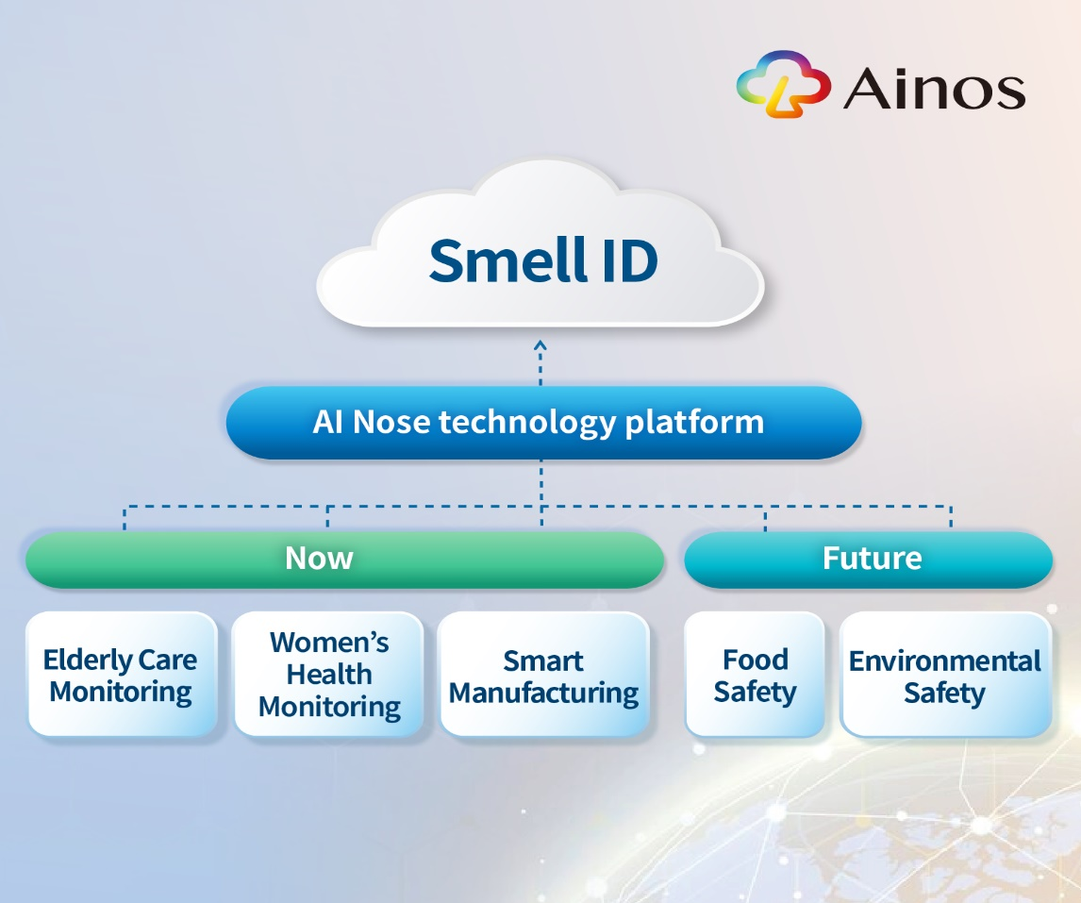

VELDONA®: Pioneering Next-Generation Therapies

Our low-dose oral interferon therapy, VELDONA®, continues to demonstrate potential in clinical applications, reinforced by global patent protection.
- Sjögren’s Syndrome: With Institutional Review Board (IRB) approval from Taipei Medical University, we aim to begin a clinical study in H1 2025 and complete the trial in 2026, targeting solutions for patients suffering from this debilitating condition.
- HIV-Related Oral Warts: We are preparing to launch a clinical trial to evaluate VELDONA®’s efficacy in addressing oral warts among HIV-positive patients, a common yet challenging complication in HIV care. We aim to begin the clinical study in H1 2025 and complete it in 2026.
- Veterinary Medicine: Trials for feline chronic gingivostomatitis (FCGS) are target for completion by H1 2025, opening new opportunities in the pet healthcare market.

- Strategic collaborations: We are also thrilled to announce a strategic collaboration with Taiwan Tanabe Seiyaku Co., Ltd., a subsidiary of Japan’s Mitsubishi Tanabe Pharma Corporation, a globally renowned pharmaceutical leader. This partnership will drive VELDONA®’s manufacturing and commercialization for Sjögren’s syndrome treatment in Taiwan while strengthening our position for future global markets.

Looking Ahead: Ambitious Goals for 2025 and Beyond

As we enter 2025, we are committed to accelerating growth and innovation with a clear focus on the following:
1. Advancing AI Nose Technology: Drive mass production and market deployment for smart healthcare, woman’s health, senior care, and industrial applications. Over H1 2025, we will advance mass production for our senior care and smart manufacturing projects and commence a clinical study for our second-generation Flora.
2. Progressing VELDONA® Clinical Trials: Submit Investigational New Drug (IND) applications to the U.S. FDA for Sjögren’s syndrome and HIV-related oral warts by H2 2025.
3. Strengthening Strategic Partnerships: Expand our collaboration with Mitsubishi Tanabe Pharma and pursue new opportunities for AI Nose and VELDONA® technologies worldwide.
4. Expanding Our IP Portfolio: Secure and develop additional intellectual property to strengthen our technological leadership and long-term value.

Join Our Journey in Creating a Better Future Together
At Ainos, we are not only focused on delivering business success but are deeply committed to improving human health, ensuring environmental sustainability, and enhancing quality of life globally. Moving forward, we will continue driving innovation, unlocking new market opportunities, and delivering tangible contributions to society.

To our shareholders, thank you for your continued trust and support. Together, let us step confidently into 2025, leading the way in technological innovation and creating a brighter tomorrow for the world.

Sincerely,
Chun-Hsien Tsai
Chairman, President, and CEO
Ainos, Inc.

About Ainos, Inc.
Headquartered in San Diego, California, Ainos is a diversified healthcare company focused on novel AI-powered point-of-care testing (POCT) and low-dose interferon therapeutics (VELDONA®). The Company's clinical-stage product pipeline includes VELDONA® human and animal oral therapeutics, human orphan drugs, and telehealth-friendly POCT solutions powered by its AI Nose technology platform. The name "Ainos" is a combination of "AI" and "Nose" to reflect the Company's commitment to empowering individuals to manage their health more effectively with next-generation AI-driven POCT solutions. To learn more, visit https://www.ainos.com. Follow Ainos on X, formerly known as Twitter, (@AinosInc), LinkedIn and Webull Corporate Connect to stay up-to-date.

Safe Harbor Statement
Certain statements in this press release are forward-looking statements within the meaning of Section 27A of the Securities Act of 1933, as amended, and Section 21E of the Securities Exchange Act of 1934, as amended. All statements other than statements of historical fact are forward-looking statements. Forward-looking statements can be identified by the use of words such as "anticipate," "believe," "estimate," "approximate," "expect," "intend," "plan," "predict," "project," "target," "future," "likely," "strategy," "foresee," "may," "guidance," "potential," "outlook," "forecast," "should," "will" or other similar words or phrases. Similarly, statements that describe the Company's objectives, plans or goals are, or may be, forward-looking statements. Forward-looking statements are based only on the Company's current beliefs, expectations, and assumptions. Forward-looking statements are subject to inherent uncertainties, risks, and changes in circumstances that are difficult to predict and many of which are outside of the Company's control. The Company's actual results may differ materially from those indicated in the forward-looking statements.
Important factors that could cause the Company's actual results to differ materially from the projections, forecasts, estimates and expectations discussed in this press release include, among others, the cost of production and sales potential of the products announced in this press release; the Company's dependence on projected revenues from the sale of current or future products; the Company's limited cash and history of losses; the Company's ability to achieve profitability; the Company's ability to raise additional capital to continue the Company's product development; the ability to accurately predict the future operating results of the Company; the ability to advance Ainos' current or future product candidates through clinical trials, obtain marketing approval and ultimately commercialize any product candidates the Company develops; the ability to obtain and maintain regulatory approval of Ainos' product candidates; delays in completing the development and commercialization of the Company's current and future product candidates, which could result in increased costs to the Company, delay or limit the ability to generate revenue and adversely affect the business, financial condition, results of operations and prospects of the Company; intense competition and rapidly advancing technology in the Company's industry that may outpace its technology; customer demand for the products and services the Company develops; the accuracy of third-party market research data, the impact of competitive or alternative products, technologies and pricing; disruption in research and development facilities; lawsuits and other claims by third parties or investigations by various regulatory agencies governing the Company's operations; potential cybersecurity attacks; increased requirements and costs related to cybersecurity; the Company's ability to realize the benefits of third party licensing agreements; the Company's ability to obtain and maintain intellectual property protection for Ainos product candidates; compliance with applicable laws, regulations and tariffs; continued listing on and compliance with the applicable regulations of the Nasdaq Capital Market; and the Company's success in managing growth. A more complete description of these risk factors and others is included in the "Risk Factors" section of Ainos' Annual Report on Form 10-K for the year ended December 31, 2023, and other public filings with the U.S. Securities and Exchange Commission ("SEC"), many of which risks are beyond the Company's control. In addition to the risks described above and in the Company's filings with the SEC, other unknown or unpredictable factors also could cause actual results to differ materially from the projections, forecasts, estimates and expectations discussed in this press release.
The forward-looking statements made in this press release are expressly qualified in their entirety by the foregoing cautionary statements. Any forward-looking statements contained in this press release represent Ainos' views only as of today and should not be relied upon as representing its views as of any subsequent date. Ainos undertakes no obligation to, and expressly disclaims any such obligation to, publicly update or revise any forward-looking statement to reflect changed assumptions, the occurrence of anticipated or unanticipated events or changes to the future results over time or otherwise, except as required by law.
Contact Information
Feifei Shen
ir@ainos.com

