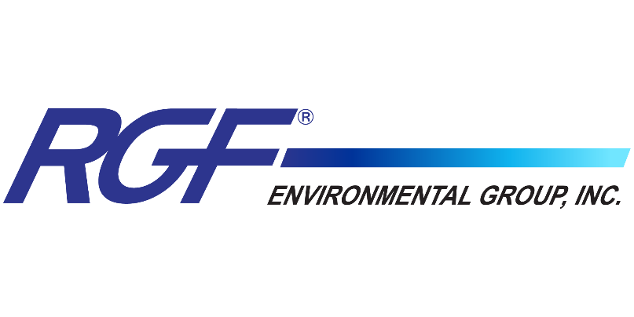
FOR IMMEDIATE RELEASE

RGF® Environmental Group Results for Aerosol Treatment Technology Evaluation with Photocatalytic Device in EPA Independent Study

The test concluded that both PHI-PKG5 and PHI-PKG9 resulted in reduced levels of MS2 by 93% over the control in 90 minutes.

Port of Palm Beach, FL (November 03, 2021) RGF® Environmental Group, Inc., a leading environmental design and manufacturing company, has proven the effectiveness of the PHI-PKG™ products in the reduction of MS2 Bacteriophage, a surrogate for SARS-CoV-2 (COVID-19) in a recent study published by the EPA on a variety of air purifiers.
EPA utilized its specialized Aerosol Test Facility in Research Triangle Park, NC and experience in conducting research with aerosol treatment technologies recently named RGF® as a leader for control of MS2 (Surrogate for SARS-CoV-2) using its photocatalytic devices. The test used both the PHI-PKG5 and PHI-PKG9.

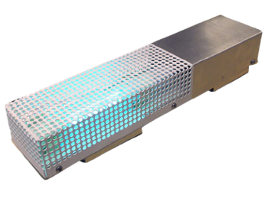
The PHI-PKG™ device is powered by RGF's proprietary PHI-CELL® technology, which combine a UVC light on an advanced catalyst to create low concentrations of gaseous hydrogen peroxide in the air that disperses throughout your space. This device is effective at reducing viruses, bacteria, mold spores, odors, volatile organic compounds and other microbes in the air and on surfaces in your home or office.
A large test section in EPA’s Aerosol Test Facility was sectioned off from the recirculating wind tunnel to serve as the test chamber for the study. The 12 ft x 10 ft x 25 ft chamber provided a 3,000 cubic ft air-conditioned space for the targeted testing specifically for mass transit applications but relates directly with air-conditioned spaces. The test placed the PHI-PKG5 and PHI-PKG9 products into the chamber and conducted airborne virus sampling taken from the breathing zone simulating real-world environments with the virus.

The test concluded that both PHI-PKG5 and PHI-PKG9 resulted in reduced levels of MS2 by 93% over the control in 90 minutes.

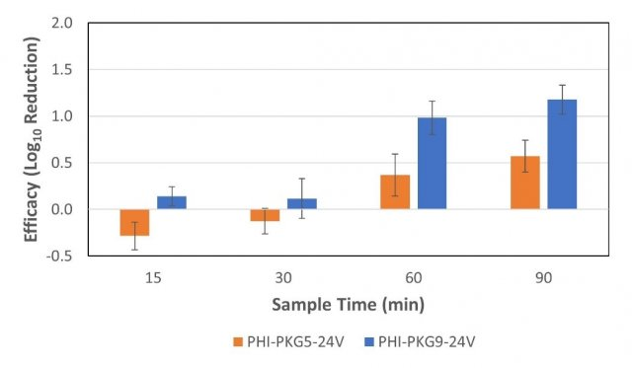

The EPA testing showed the SARS-CoV-2 virus was significantly neutralized within the occupied space on airborne virus, reducing the risk of person-to-person infection by respiratory particles and aerosols. The PHI-PKG™ is an “active” solution that neutralizes SARS-CoV-2 within the occupied space, eliminating the need for virus particles to travel through the HVAC system filters or UV air purification system.

DISCLAIMER: The summary and any comments herein are based on the results from an independent laboratory study performed under controlled conditions and are not in any way medical claims. The product(s) and technologies described are not medical devices and are not intended to diagnose, treat, cure, or prevent any disease, virus or illness.
RGF Environmental is committed to the principle that “Clean Air is Life”. For more than 30 years, we have manufactured safe and effective IAQ devices that reduce the risks of airborne microbial contaminants, including SARS-CoV-2. We will continue our efforts to develop innovative IAQ devices and conduct scientific research with leading government, private and academic laboratories to provide documentation on the safety and efficacy of our products.

About RGF® Environmental Group, Inc.

RGF® manufactures over 500 environmental products and has a 36+ year history of providing the world with the safest air, water and food without the use of chemicals. RGF® is an ISO 9001:2015 certified research and innovation company, holding numerous patents for wastewater treatment systems, air purifying devices, and food sanitation systems. Situated in the heart of the Port of Palm Beach Enterprise Zone, RGF® Headquarters span 10 acres, with 200,000 square feet of manufacturing, warehouse and office facilities. RGF’s Lakeland, FL facility adds over 40,000 square feet for back-up production and lamp production. RGF® continues to upgrade its facilities, creating an increased vertical approach to manufacturing, further allowing the company to provide the highest quality and best-engineered products on the market. For more information, visit RGF.com.

Media Contact

For more information about the third-party study or to schedule an interview, please contact Malia Powers with PowerOn Marketing at malia@poweronmarketing.com or 813-763-7488.

