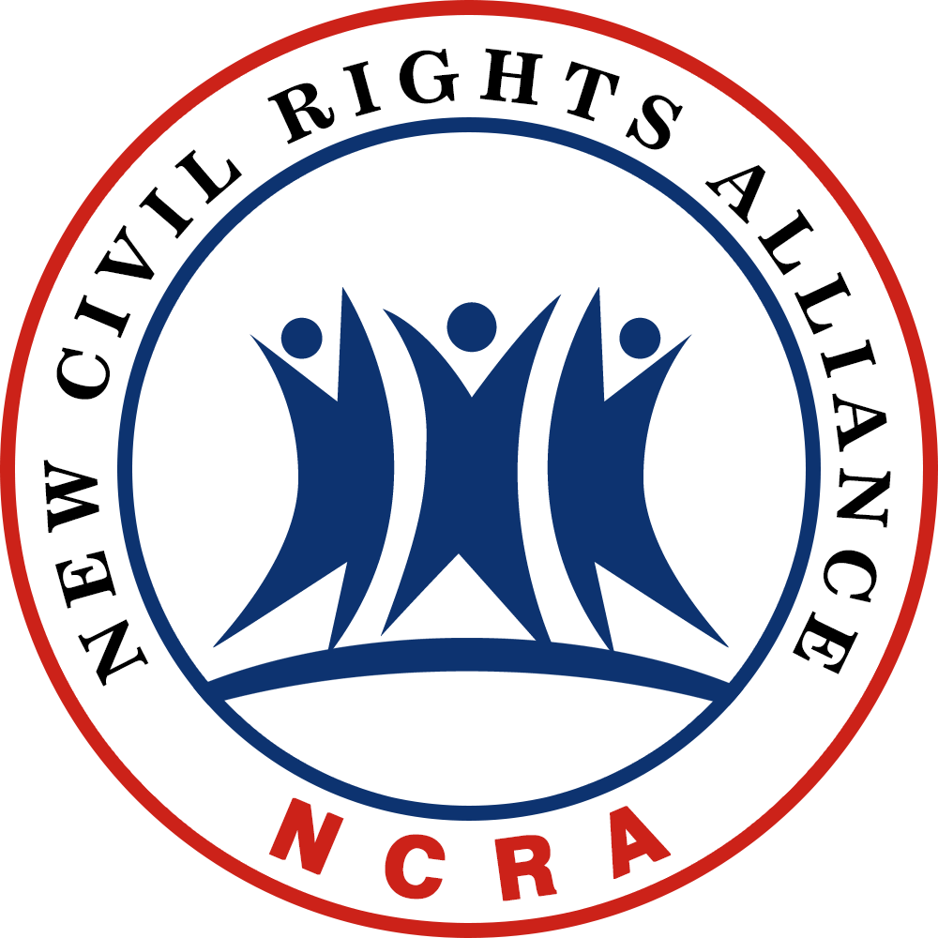

WASHINGTON, DC — New Civil Rights Alliance (NCRA) condemns the cultural form of violence (Cultural Violence) represented by the MV, “Meet the Flockers.” The racist video, produced by rapper YG (aka Keenon Daequan Ray Jackson), bluntly incites violence— home invasions which target Asian Americans and their businesses. The wording and tone of video blatantly glorifies criminal acts against Asian Americans.

Entertainment pieces such as “Meet the Flockers” represent the Cultural Violence (seen in a variant of hip hop culture) that has become a root cause of Direct Violence. Historically, Hitler’s promotion of cultural violence against Jews caused the direct violence leading to the Holocaust. Today in America, Cultural Violence desensitizes the devastating effects of hateful behaviors. It motivates the commitment of heinous actions through entertainment for commercial profit, which, in turn, have directly contributed to the high crime rates in this great Nation.

After 50 years of the Civil Rights movement, the discrimination is prohibited by law. However it failed to build a true equality for all individuals and true respect for each other at the cultural level. It also did not alleviate poverty in the inner city that is the breeding ground for problems such as crime. We did not address the cultural violence explicitly that continues to plague our society. A new civil rights movement is needed to build a new culture of
civility, respect, and personal responsibility. Every individual should be treated with respect and not to be discriminated against, patronized, pandered to, or taken advantage of for political gain. Every individual should also be held accountable, while being respected, for their actions, regardless of their racial background. We should embrace great cultural values from all diverse racial groups but strongly denounce the ugly side of the cultural aspects that promote crime and heinous bias against each other.

Join us — the African American, Latino, White, and Asian American communities — on October 12, 2016, 7:00 PM, for a peaceful protest against Cultural Violence when rapper YG has a concert in the Washington, DC area at The Fillmore in Silver Spring, Maryland. We will also protest at YG’s other concerts in Philadelphia, New York, and Boston and other cities throughout the month of October. Our voice against cultural violence will be heard. It will be a long journey. Together, we will prevail!

Link to video: Link to offensive and racist lyrics:
http://goo.gl/IoWoCW http://goo.gl/f06LDH
If you would like to schedule an interview with Mr. Cliff Zhonggang Li, Secretary General of the New Civil RIghts Alliance (NCRA), please call NCRA direct at 954-233-0672 x 527 or email us at cliff.li@NewCR.org.
Press Release
September 29, 2016

New Civil Rights Alliance
Declares War on the Cultural Violence represented by the Music Video “Meet the Flockers” and Calls for a New Civil Rights Movement at the Cultural Level. Join us on
Oct. 12, 2016 at a Protest Rally in the DC Area

NEW CIVIL RIGHTS ALLIANCE
910 17th Street NW 8th Floor
Washington, DC 20006
Media Contact: Dr. Larry H. Shinagawa
T: 954-233-0672 x 527
E: press@NewCR.org

