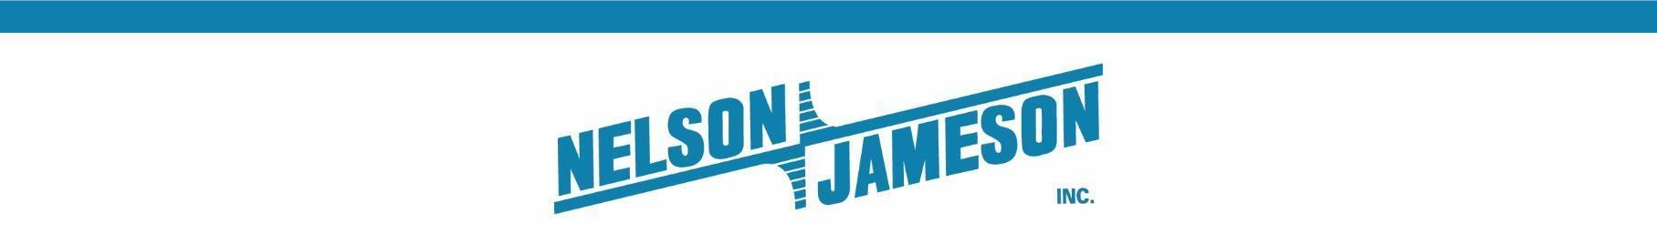

FOR IMMEDIATE RELEASE

Nelson-Jameson’s California Distribution Center Receives Seventh Consecutive 100% Score in Safe Quality Food Program
Turlock attains highest level of safety and quality recognition by international standards

MARSHFIELD, WI – October 11, 2023 – Nelson-Jameson, a leading food processing distributor, announced a seventh consecutive 100% score in a Safe Quality Food (SQF) audit at its Turlock, California strategic distribution center. Audits are conducted by the Eagle Certification Group, an independent certification body licensed by SQF, which has set an internationally recognized and highly respected standard in the industry. An SQF registered site indicates a commitment to providing quality products that are safely received, handled, stored, and delivered, and a 100% score indicates the highest level of safety and quality by all measures.

“Safety and quality are paramount to operations at Nelson-Jameson, and our dedication to the SQF program runs deep,” says Mike Rindy, President of Nelson-Jameson. “We are very proud to receive a seventh straight 100% score in Turlock. Still, we view SQF as an ongoing journey of constant vigilance and continuous improvement.”

To obtain the SQF certification, companies need to meticulously document program adherence, and this documentation is reviewed, monitored, verified, and validated throughout the year. SQF regularly releases updated codes and plans to release a new code update in 2025-2026.

Nelson-Jameson is audited under a Warehousing & Distribution certification code, and the company is then responsible for writing policies and procedures that pertain to the code. Practitioners at each Nelson-Jameson strategic distribution center are assigned to run point on the program, but SQF responsibilities are shared across the entire facility.

“We want our customers to know that we share their commitment to safety and quality from end to end, and we’re committed to participating in SQF audits each year,” says Rindy.

The SQF program was started at Nelson-Jameson’s Marshfield, Wisconsin headquarters in 2009 with the initial Marshfield audit taking place in 2011. Marshfield’s audits have averaged a score of 98.5% over the past 12 years. The company is expanding its roster of locations participating in the SQF program, with an Amarillo, Texas location scheduled for its first audit November 2-3, 2023. The company’s upcoming new strategic distribution center in Jerome, Idaho is on track to participate in SQF in 2025, once it’s fully operational.

More information on the company can be found at https://nelsonjameson.com.

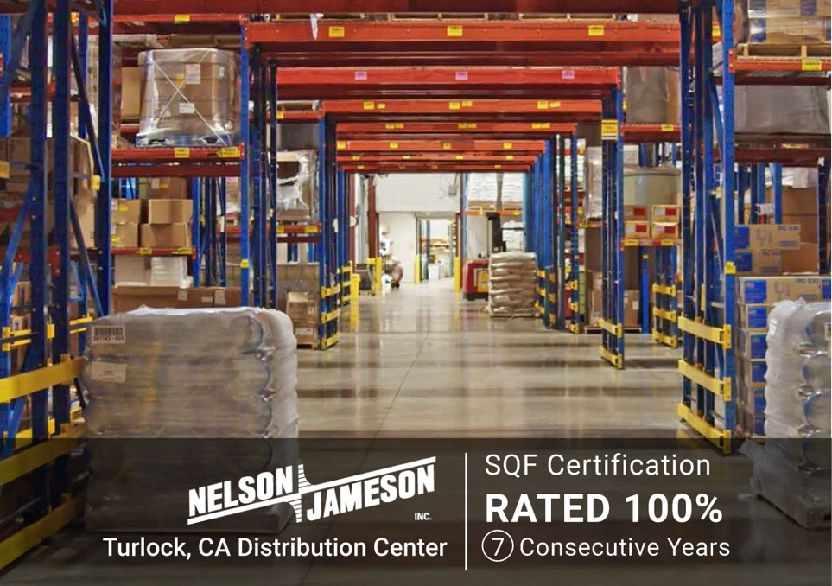

Photo caption (Courtesy of Nelson-Jameson): Nelson-Jameson’s Turlock, California strategic distribution center receives seventh consecutive 100% score in Safety Quality Food Program.

###
About Nelson-Jameson

Nelson-Jameson is a fourth-generation, family-owned distributor to the dairy industry. From the company’s roots in dairy production supplies, it has expanded to offer a broad range of food processing products and services that help food and beverage organizations operate efficiently with the highest quality, safety, and compliance standards. The company represents more than 850 vendors, distributes more than 60,000 curated products, and employs more than 260 people nationwide. The dairy industry leader also operates NEXT Logistics, a transportation arm that provides delivery services from its Wisconsin, California, Idaho, Pennsylvania, and Texas strategic distribution centers.

For more than 75 years, Nelson-Jameson has supported food, beverage, and dairy processors with innovative products and a comprehensive set of solutions that keep pace with changing consumer tastes, manufacturing processes, and distribution channels. The company values delivering the exceptional for its customers by leading with the guiding principles of kindness and mutual respect. Nelson-Jameson is a supplier of choice for customers in all 50 states and international markets.

For more information, please visit: https://nelsonjameson.com

Media Contact:
Karolyn Raphael
karolyn@wingermarketing.com
(312) 494-0422

