FOR IMMEDIATE RELEASE Media Contact:
March 13, 2023 Will Gregory | (816) 645-6116



Ambiflo Unearths Broadband Coverage Gaps, Simplifies Design/Build for Tower Development
Startup gives every rural telecom company the ability to get into the tower business

KANSAS CITY, March 13, 2023 / -- As rural telecom operators face the possibility of reduced government support, their need to diversify into tertiary businesses has grown. Aside from Fiber, MSP and Data centers (which are highly specialized and/or capital intensive), tower development supporting small/macro cell densification stands apart as the most valuable investment opportunity available.

The tower business has historically been difficult to enter due to the highly speculative nature of finding coverage gaps in carrier networks. Carriers themselves judge their progress by the total number of sites deployed rather than real-time/data/AI-driven analysis. In other words, they are relying too heavily on relationships, rather than science. Consequently, 5G deployment has been dismal. The cost per tower remains too high and as carriers continue to engage in price wars, somethings gotta give.

Current estimates show that Federal Communications Commissions’ (FCC) maps measuring broadband coverage significantly overestimates the number of Americans with access to high-speed connectivity. According to Broadband Now, that has left an estimated 21 million Americans out of current U.S. federal broadband coverage plans and millions are incorrectly designated as “served,” preventing them from receiving the $65 billion available through Infrastructure Investment and Jobs Act funding to improve broadband access. Reports reveal that a mere 10% increase in broadband access could add ~175,000 more jobs and $37.2 billion to the economy per year.

“There are millions of people in the U.S. without consistent broadband coverage. In the 21stcentury, if you don’t have access to broadband, you don’t have access to the full range of information and opportunities that should be available to you. Unfortunately, it’s hard to address this problem because we don’t have the data to show us where there are gaps in broadband coverage and performance. This prevents communities from getting the federal funding they deserve.” said Zia Khan, Senior Vice President of Innovation at The Rockefeller Foundation.

Ambiflo gives every rural telecom company the ability to get into the tower business by unearthing coverage gaps, predicting locations to address the gap and selecting the best location (economically) to bring the cost of development/deployment down. Developed by a team of industry veterans at veteran industry experts from companies like Vodafone, Sprint, Ericsson, the only missing ingredient is rural telco operators to bring to the table via technical expertise and localized relationships.

Roughly 65 percent of counties tested fall below Federal BroadBand Standards and 76 percent of counties tested averaged cellular connections below the FCC’s minimum standard:

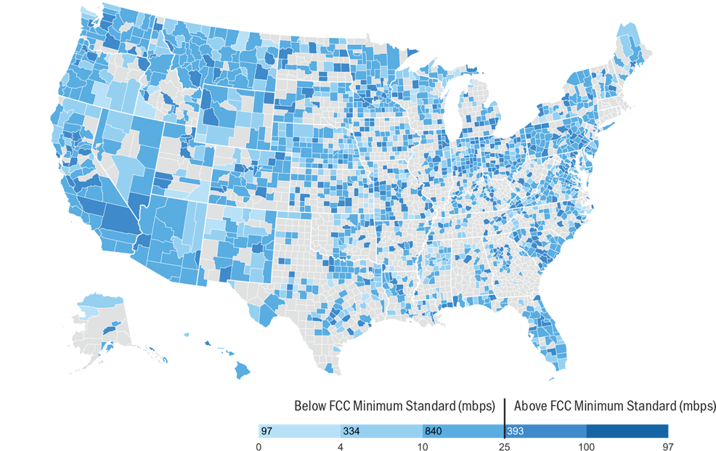

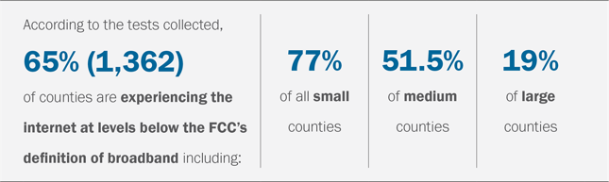

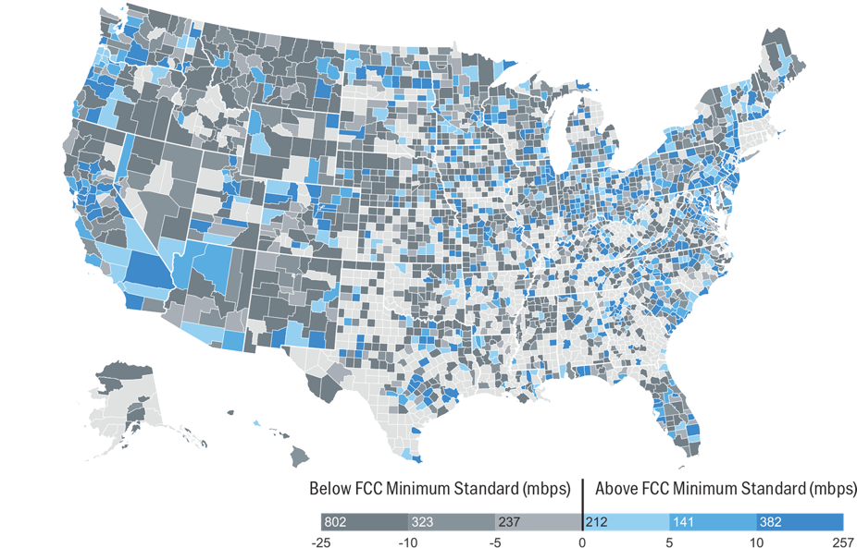

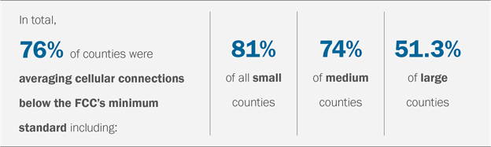

(Maps/data via the National Association of Counties (NACo)

Large carriers like T-mobile, AT&T, and Verizon pay for rooftop or tower rights for their antennas,” said Martin Donnely, CEO Ambiflo. “With Ambiflo, you know before they do where they will need to be.”
With industry expertise and interactive tools like Site Finder (automatically finds the optimum locations for new cells, creates value grids – turning geographies into heat maps, automated ROI analysis) and Site Stamp Tool (1-Click to birth new sites, auto generates workflow and 3D build) Ambiflo can quickly and effectively solve the coverage gap.

About Ambiflo
Ambiflo brings together a diverse team of highly experienced and passionate people with a shared love of doing things differently and doing things better. The decision to create Ambiflo was quite a recent one – early 2020 – and events since then have – to say the least – been quite fast-paced, reflecting the team’s eagerness to develop innovative solutions at speed and iterating often using a mix of modern development approaches.
For more information visit Ambiflo.com.

