March 2^{nd,} 2022

Leader in Internet of RoadWorkTM announces formation of the
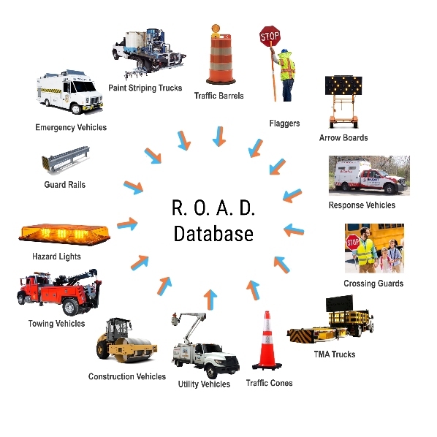
R.O.A.DTM Database

“Wheel of Safety” - Internet of Road WorkTM Applications

Cato, NY --- iCone Products LLC announces today the creation of a cloud-based data service for digitally marked work zone events called the R.O.A.D™ Database.
Smart and connected work zones are becoming commonplace in North America, supported by integrated Internet of Things (IoT) technology. Consolidating this set of traffic control and roadway infrastructure devices – otherwise known as an "Internet of Road Work (IoR™)” – allows drivers, contractors, traffic managers, and others to receive real-time status information about key traffic control devices being used in roadway construction operations and any disruptive anomalies they may cause to surface transportation.
The Real Ontime Accurate Data (R. O. A. D.)™ for Work Zones is a cloud-based database of road event data supplied by preeminent equipment and infrastructure developers, IoT equipment retrofit companies, construction operators, maintenance and traffic control companies. These organizations all work together to provide data for safer roads. This database represents an industry-first in that it is populated by the actual producers and generators of the work-zone data, collectively known as the Work-Zone Data Industry (WZDi™).
The R.O.A.D Database will be the clearinghouse for work zone-generated attributes that may require corrective or attentive action or alertness from roadway users. The launch of the R.O.A.D database will involve a significant portion of the WZDi, made possible through relationships with several major traffic control equipment manufacturers, pavement marking companies and other significant producers of smart work zone technology and data that perform tasks on a daily basis such as temporary work zones, lane closures, protecting lives and equipment, painting lanes, closing roads, and performing maintenance, through automatic communications from devices integrated inside roadway assets.
One of the founding data suppliers to the R.O.A.D Database is the originator of the Internet of RoadWork (IoR™), iCone Products’ ConnectedTech™ Data Community (CTDC), which combines universal smart retrofit kits for work zone equipment and includes data from devices built by most of the companies within the portable traffic control equipment market.
The R.O.A.D Database will adhere to the established protocol of data feeds for the collection and distribution of information related to the location and activity of road work developed by The Federal Geographic Data Committee Transportation Subcommittee Work Zone Data Working Group. R.O.A.D. intends to enhance this feed with additional certification of valid traffic control components with secure, documented data transfers, with a verified chain of custody from the field device to the client. This extra layer of compliance is the WZDi’s process of ensuring that the data produced is accurate, timely, and meaningful.

About iCone Products:
iCone Products, LLC is guiding the future of Work Zone Safety! As the creator of the IoR - Internet of RoadworkTM, iCone has developed a suite of ConnectedTech™ products that collects and transmits real-time information about the status of the roadways into the cloud. Navigation applications, traffic control centers, and contractors receive the information to assist motorists in navigation, protect crews in work zones, and create an overall safer environment on public roadways around the world. As an integrated technology platform, iCone’s devices can mark virtually anything that may intrude upon a public right-of-way that would cause a vehicle to change either its speed or direction of travel.
iCone’s ConnectedTech Data Community is designed to provide a unique and broad digital collection of surface roadway operators that collectively contribute information along with iCone Internet of Roadwork (IoR™) - enabled equipment to a repository of data that provides increased safety through an additional layer of security for both workers and oncoming motorists. This data is also provided to the navigation community, improving route navigation through direct communication with in-car navigation systems such as Google Maps, Waze and eventually directly displayed in the dash of automobiles.

All Inquires please contact:
Garvin Forrester
COO
g.forrester@iconeproducts.com

