H O M E B O O K S M U S I C F I L M T E L E V I S I O N T H E AT E R E V E N T S G I V E AWAY S I N T E R V I E W S A B O U T C O N TA C T    


BY KEVIN 
JUNE 18, 2024 
IN FILM

Beloved Bluegrass Musical ‘Paradise: A Town of Sinners and Saints’ Now Available on Prime Video
LATEST STORIES


Exclusive Interview: Romina D’Ugo Delves Into ‘I Like Movies,’ Her Character Development Process, WILYMI Jewelry, and More

On June 19, 2024

Exclusive Interview: Molly Kunz Talks ‘Wide Eyed and Wicked,’ Exploring Multi-faceted Characters, Her Collaboration with Writer-Director G.S. Foxwood, and More
On June 19, 2024

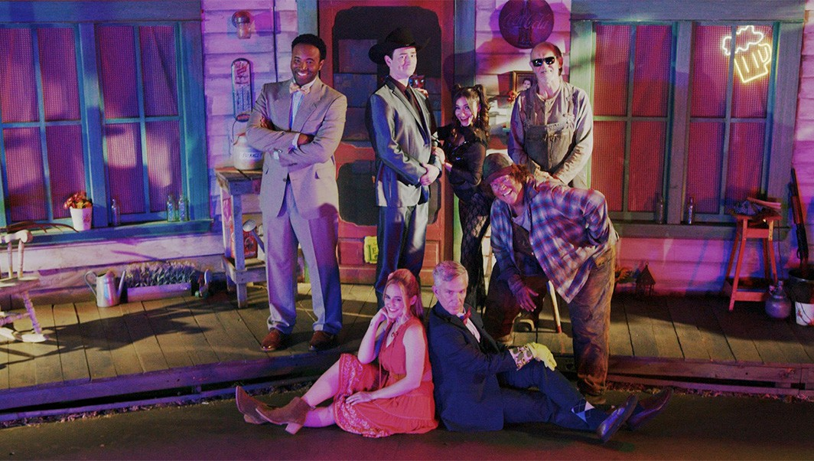
From the creative genius of National Lampoon writers Bill Robertson and Tom Sage, and the visionary direction of Justin Ward (known for his work on The Meanest Man in Texas and Relish), emerges the uproarious comedy sensation, Paradise: A Town of Sinners and Saints. With a collection of nineteen original, foot- stomping tunes and a delightful mix of irreverent humor,
has captured hearts worldwide, boasting a perfect 100% rating on Rotten Tomatoes.

Nestled in the heart of a small, southern coal mining community, Paradise finds itself grappling with severe financial challenges.

P E O P L E A L S O R E A D

Exclusive Interview: Romina D’Ugo Delves Into ‘I Like Movies,’ Her Character Development Process, WILYMI Jewelry, and More

Exclusive Interview: Molly Kunz Talks ‘Wide Eyed and Wicked,’ Exploring Multi-faceted Characters, Her Collaboration with Writer-
Director G.S. Foxwood, and More

Exclusive Interview: Jacklyn Romano Talks Life After ‘Love Undercover,’ the Friendships She Made, Her Businesses and Empowering Women, and More
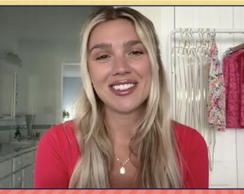

On June 19, 2024

Beloved Bluegrass Musical ‘Paradise: A Town of Sinners and Saints’ Now Available on Prime Video

On June 18, 2024

Find Your Perfect Match at the Love Island USA Villa

Amidst this backdrop of uncertainty, a ray of hope emerges with the
On June 17, 2024

arrival of a fast-talking evangelist portrayed by Jon Root (known for roles in Brooklyn Nine-Nine and The Orville), alongside a determined Latin TV producer, played by Eric Cassalini. Their ambitious plan? A
Tribeca Film Festival 2024: Co- Creator Sean Quinn and Star Rowen Kahn Talk ‘Yanqui’

reality television show concept promising to rescue Paradise from its economic woes.

Yet, skepticism lingers among the town’s residents, particularly in Louanne, their reluctant matriarch-by- default portrayed by Mary Sarah (a standout from The Voice Season 10). As the preacher and TV producer forge ahead with their unconventional alliance, they enlist the help of Chastity, a former stripper portrayed by Raquel Castro (known for her roles in The Voice Season 1 and the feature film Jersey Girl alongside Jennifer Lopez and Ben Affleck).

But beneath the surface of their well-intentioned efforts, dark secrets lurk, and Paradise’s salvation may come at a price far steeper than its residents ever imagined.

Paradise: A Town of Sinners & Saints Official Trailer - Now Streaming on Tubi & Xum…
Don’t miss out on this hilarious, heart-warming story, now available to stream on Prime Video.

 Article Tags : Paradise: A Town of Sinners and Saints

S H A R E T H I S A R T I C L E




↑



Kevin

Kevin is a writer living in New York City. He is an enthusiast with an extensive movie collection, who enjoys attending numerous conventions throughout the year. Say hi on Twitter and Instagram !

Discussion about this post

Leave a Reply

Comment *

Name * Email *

Website
Post Comment

This site uses Akismet to reduce spam. Learn how your comment data is processed.

ABOUT POP-CULTURALIST.COM CATEGORIES SEARCH

Pop Culturalist is a digital media outlet launched in 2015 that celebrates entertainment in all its forms. From binge- watching our favorite shows and catching the latest blockbusters to enjoying a night on Broadway, the team is OBSESSED with pop culture.
Award Shows Books Comedy
Comics Conventions Events
Fashion Film Gaming Giveaways
Interviews
Music
News Ones to Watch Podcasts
Type and Enter to Search

Man Crush Monday
Recaps Reviews Sports Spotlight
Copyright © 2024, Pop-Culturalist.com. All rights reserved.
Television Theater Tour
Uncategorized
Woman Crush Wednesday

Copyright © 2023, Pop-Culturalist.com. All rights reserved.

