Donald Stuart Seigal "Aka" ANTHEMan Releases 3 Brand new Super catchy Love song youtubes just for you
Friday 14, February 2025 959 AM NEW YORK CITY, NY / ACCESSWIRE February 14, 2025 / Donald Stuart Seigal aka ANTHEMan™ and his Antheman band Releases 3 Brand new Super Catchy Love song youtubes just for you:

“Always Paradise” https://youtu.be/Jn2aNh6tKVY
"Valentine Wish" https://youtu.be/V298tkTEVsI
"Glad" https://youtu.be/iS31DNzlr-0
Tell me what you think!

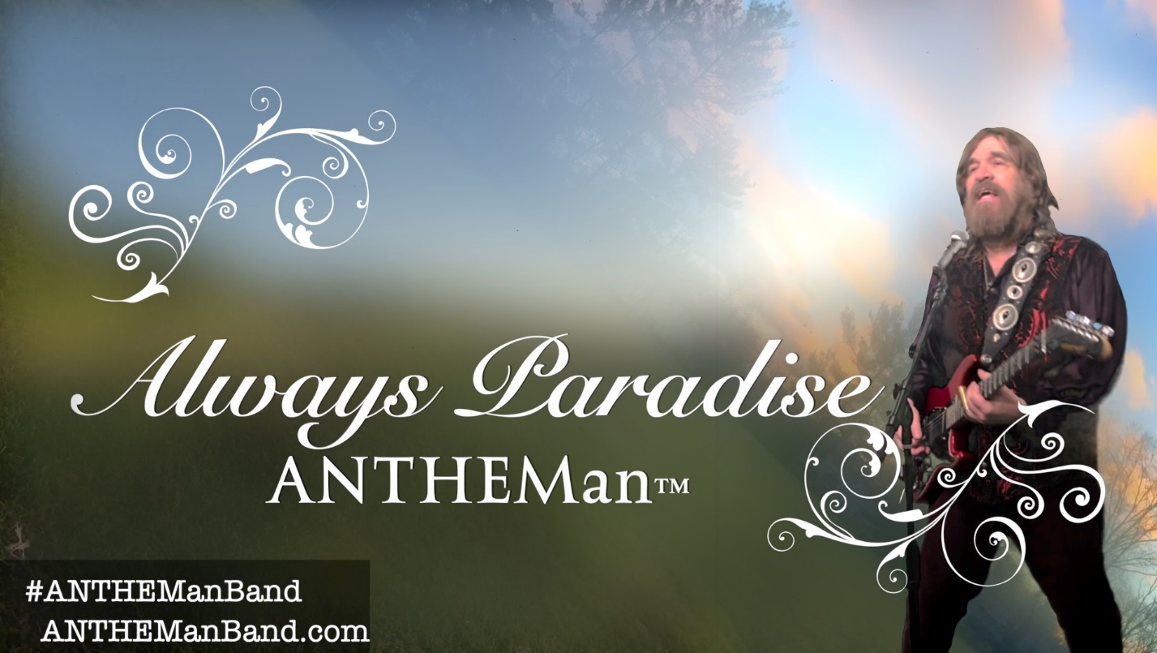
ANTHEMan™ and The #ANTHEManBand performing Always Paradise
youtube Video link for: “Always Paradise” https://youtu.be/Jn2aNh6tKVY
The first song released today is Antheman’s soulful upbeat “Always Paradise,” a soon to be country music classic where love is so powerful and wonderful, it’s always paradise.
The “Always Paradise” video features a dreamscape paradise with surreal storm clouds, rainbows & lightning that the artist recorded on his own with his iphone.

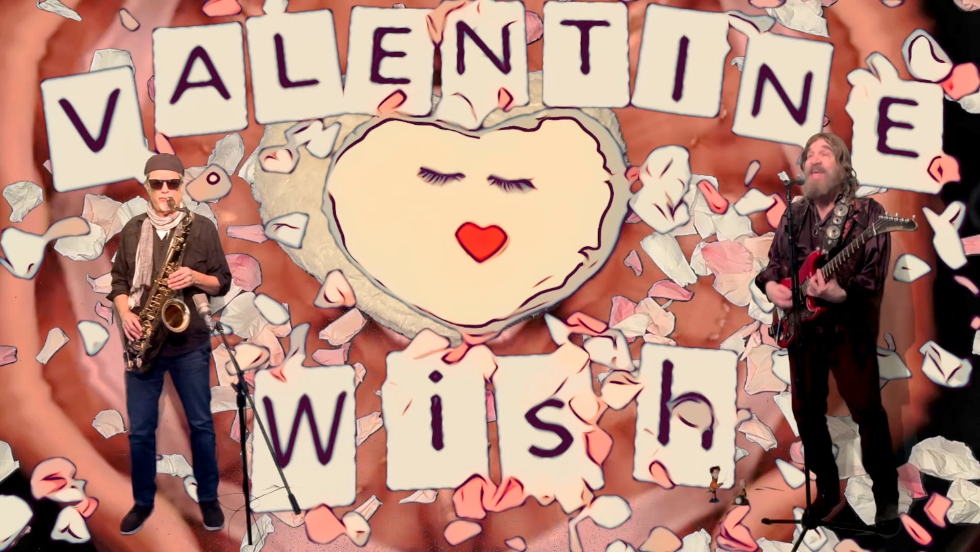 ANTHEMan™ and The #ANTHEManBand performing Valentine Wish
youtube Video link for: “Valentine Wish” https://youtu.be/V298tkTEVsI
The second song released today is “Valentine Wish” is a throwback power ballad about longing to find someone you love, to love you back.
The “Valentine Wish” video features a kaleidoscope Valentines pillow over a Pop Power Ballad.

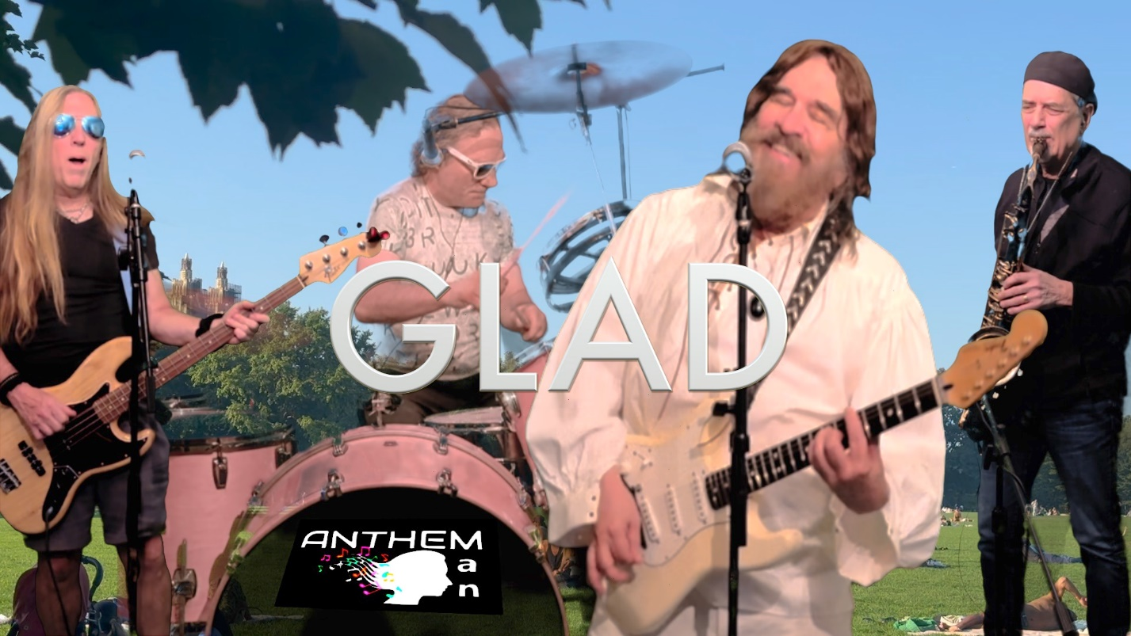ANTHEMan™ and The #ANTHEManBand performing Glad
youtube Video link for: “Glad” https://youtu.be/iS31DNzlr-0
The third song released today is “Glad,” where you’re so ecstatic about your relationship that you want to sing and dance to this super infectious song.
The “Glad” video features ANTHEMan and the #Anthemanband rocking out all over Central Park in the heart of NYC with this celebration song.

So, who is ANTHEMan? ANTHEMan is the songwriter Donald Stuart Seigal
Donald Stuart Seigal "aka" Antheman songs have appeared on popular TV shows and movies in over 20 Countries around the world:
Among them, Don wrote a song called "Suzanna" which was inspired by a real-life experience, about going on a road trip and having to say good bye to his young children. The song appeared in the 2023 NY Mets-themed Hallmark Movie called "Hearts in the Game." The song also appeared in a hilarious Allstate Bergman the NCAA football kicker commercial and the 2024 NHL Stanley Cup Boston Pizza commercial. LINK to the commercial: https://www.youtube.com/watch?v=PEDXc4_rfdI
Here is a youtube link to the full song Suzanna:
https://www.youtube.com/watch?v=G2xfVQfrxWs
About Donald Stuart Seigal "aka" ANTHEMan;
Donald Stuart Seigal, owner of Rat A Tat LLC, is on over 300 TV shows and film productions (licensed by APM & Sonoton Music Libraries.) His music has been heard on NBC, CBS, ABC, HBO, MTV, Nickelodeon, Disney, Comedy Central, and productions in 20 nations worldwide. As a songwriter and musician, he has written and recorded with members of rock bands, including Springsteen's E Street band, Alice Cooper, Blue Oyster Cult, Nektar, toured with the Lester Lanin Big Band and as a band leader with his own original Rock & Pop songs & music productions he was the opening band act up for Chick Corea, Return To Forever, Rick Derringer, Ritchie Havens, and The Turtles.

I hope you enjoy my songs as much as I had fun making them, that were inspired by all the beautiful people in my life.

Love,

ANTHEM
A
N
Donald Stuart Seigal

