

KORBEL® CALIFORNIA CHAMPAGNE
THE OFFICIAL BUBBLY OF THE BOSTON RED SOX
April 6, 2023, Guerneville, CA – The 123rd season of Boston Red Sox baseball has begun, with Korbel® California Champagne returning once again as the “Official Bubbly” for the third consecutive season. Since 1901, the team has won nine World Series championships and tied for the third-most of any Major League baseball team – cementing its iconic legacy as a cornerstone of American baseball. The partnership is a unique collaboration as both brands possess a rich and long-standing tradition in some of America’s most celebrated moments in sports and everyday occasions.
Whether sipping mimosas while watching a day game, or popping a bottle for the biggest of wins, Korbel has a sparkler for every occasion. Toasting the ordinary, extraordinary, and everything in between for 141 years and counting, the longevity, values, and quality that comprise both brands are a natural fit. We lift our glasses to the continued partnership of these two American classics.
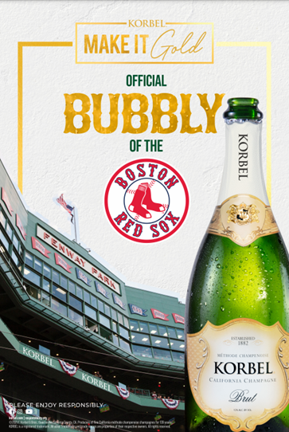
Established in 1882 in Sonoma County’s Russian River Valley, Korbel ® California Champagne produces the United States’ most popular méthode champenoise champagne. The true measure of Korbel’s success during its 141 years can be seen in the impact it has had on American consumers and its presence at various celebrations throughout the years. Owned and managed by the Heck family since 1954, Korbel currently makes eleven California champagnes and a limited amount of still wine. In a separate facility, Korbel also produces one of the country’s most respected brandies.
Contact: Margie Healy, mhealy@korbel.com, 707-824-7715

Celebrate responsibly.
F. Korbel & Bros., Guerneville, Sonoma County, CA.
Producers of fine California méthode champenoise champagnes for 141 years.
KORBEL is a registered trademark. ©2023 F. Korbel & Bros. All rights reserved.
To find out more about responsible consumption, visit Responsibility.org and OurThinkingAboutDrinking.com
All other trademarks and trade names are properties of their respective owners.

