Beam Communications Receives Another Iridium GO!® Order

MELBOURNE, AUSTRALIA, 20 July 2018: Beam Communications Pty Ltd (Beam), a wholly owned subsidiary of World Reach Limited (ASX: WWR), has received a further order for 5,000 units of the Iridium GO!® product.
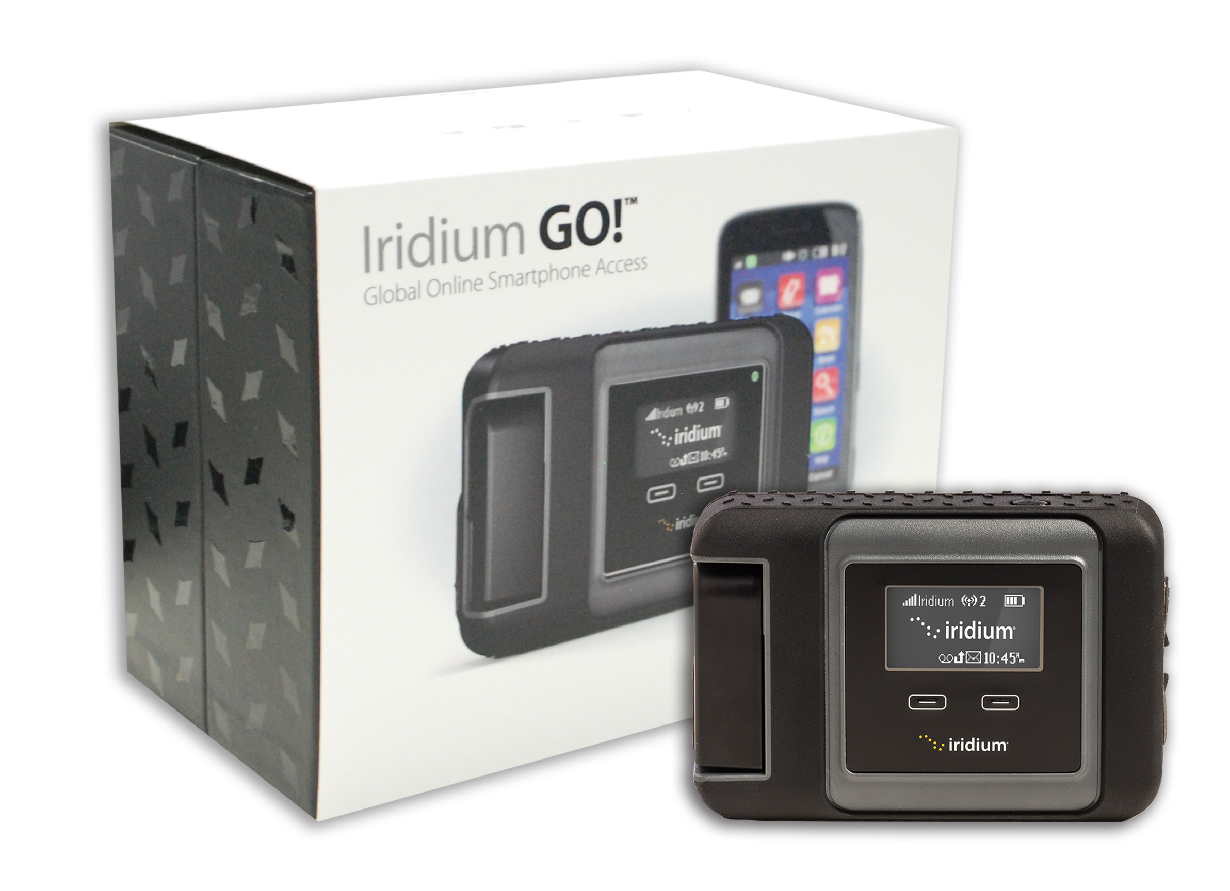
“This is now the fifth order received by Beam since commercial delivery of the product commenced in mid-2014, taking the total orders for the Iridium GO!® product to 35,000 units.” said Michael Capocchi, Beam Communications CEO. “This further order reflects the increasing end-user demand for the device and the utility it provides to customers requiring a global voice, messaging and SOS solution all in one single unit.”
Based on the delivery schedule outlined by Beam’s customer, the entire order will be supplied in the second half of FY’19. Beam will have the capacity to accelerate deliveries on request.
The success of the Iridium GO!® is largely due to its capability to enable satellite connectivity to your Apple or Android smart device, via Wi-Fi. With the Iridium GO! app, you can make phone calls, send SMS, post on Twitter or activate SOS, in the event of an emergency, when configured.

Mr. Capocchi adds, “The Iridium GO! allows users, such as everyday fishermen, hikers, remote travelers, off roader’s and grey nomads to communicate over the Iridium network in remote locations where terrestrial connection is unavailable. It’s robust, lightweight and compact design makes it easy for any user to grab and go and connect anywhere in the world.”
Charles Werb, an adventurer and publisher of Outer Edge Magazine, has had the opportunity to take the Iridium GO! with him on 4 expeditions to date. Antarctica in 2016, Solomon Islands in 2016, Russia in 2017 (image insert) and Iceland 2018. When asked about the Iridium GO! device, here’s what Charles had to say, “The Iridium GO! has become an integral part of my communication set up and the ease of operation allows me to keep in touch with my ground crew, media and family whilst I have been away. The Iridium GO! is a fantastic addition to an explorer’s “MUST HAVE” list of items to carry.”
With the continued success of various App’s supported on the Iridium GO!® device, including Exchange, Gmail and weather applications, the product now offers enhanced functionality, as well as proven reliability. Iridium will also be launching a new range of plans and promotional material to further enhance the promotion and success of the product for the coming years.
For more information on Iridium GO! please visit: www.iridiumgo.com

- END -

Media Contact:
Frances Santiago
Ph: +61 (03) 8588 4500
Email: media@beamcommunications.com

About Beam Communications Pty Ltd
Beam Communications Pty Ltd is a wholly owned subsidiary of World Reach Limited (ASX:WRR). Beam Communications designs, manufactures and distributes a wide range of Thuraya, Iridium & Inmarsat Satellite voice, data, tracking terminals and accessories for the global telecommunications market. Beam is a strategic partner to three of the four major Mobile Satellite Service operators and has an extensive global network of partner’s reselling solutions that are deployed into a wide range of vertical markets including Maritime, Transport, Government, Defence, Mining, Global Traveler, Construction, Forestry, Emergency Services, Relief Aid, Telemetry and Rural Telephony. For more information, visit www.beamcommunications.com

About Iridium Communications Inc.
Iridium® is the only mobile voice and data satellite communications network that spans the entire globe. Iridium enables connections between people, organizations and assets to and from anywhere, in real time. Together with its ecosystem of partner companies, Iridium delivers an innovative and rich portfolio of reliable solutions for markets that require truly global communications. The company has a major development program underway for its next-generation network — Iridium NEXT. Iridium Communications Inc. is headquartered in McLean, Va., U.S.A., and its common stock trades on the NASDAQ Global Select Market under the ticker symbol IRDM. For more information about Iridium products, services and partner solutions, visit www.iridium.com.

About World Reach Limited
World Reach Limited is an Australian publicly listed company (ASX:WRR) with strategic ownership of companies involved in the design, manufacture and distribution of equipment, applications and services for the global needs of Information Communication & Technology markets. For more information, visit www.worldreach.com.au

