

FOR IMMEDIATE RELEASE

Nelson-Jameson Names Amanda Nelson Sasse to Dual Leadership Roles

Fourth-generation owner now serves as VP of Philanthropy and Social Impact and President of Nelson-Jameson Foundation

MARSHFIELD, WI (October 25, 2023) – Nelson-Jameson, a leading distributor for the dairy processing industry, has announced the appointment of Amanda Nelson Sasse to two new leadership roles. Nelson Sasse, a fourth-generation owner, will now serve in a dual role as Vice President of Philanthropy and Social Impact for Nelson-Jameson, as well as President of the Nelson-Jameson Foundation (NJF).

Nelson Sasse is a direct descendant of two of Nelson-Jameson’s co-founders, Earl Nelson and Ted Nelson, and has held leadership positions across multiple departments at the company for the past 14 years. As VP of Philanthropy and Social impact, she will oversee Nelson-Jameson’s philanthropic efforts and advance its mission by driving philanthropic initiatives, fostering partnerships, and creating lasting social impact. As President of NJF, Nelson Sasse will be the liaison between Nelson-Jameson and NJF, where she will head quarterly board meetings, oversee committees, and spearhead marketing and public relations functions.

“Nelson-Jameson was built on the values of supporting employee well-being and fostering strong communities. A charitable focus is embedded in our culture,” says Nelson Sasse. “I’m thrilled to continue this 76-year-old legacy by leading the Nelson-Jameson Foundation and furthering the social impact of Nelson-Jameson as an organization.”

The Nelson-Jameson Foundation (NJF), a 501(c)(3) non-profit organization, was founded to formalize and expand Nelson-Jameson’s longstanding legacy of philanthropy and community engagement. NJF’s work centers around three pillars - employees, communities, and the industry - with programs including:

- Volunteer opportunities – NJF offers employees up to eight hours of paid time off per year to volunteer at charitable organizations of their choice during work hours. Employees are also invited to get involved with NJF by volunteering on a Foundation committee.

- Assistance Fund – Employees facing an unexpected crisis due to a federal, state or locally declared emergency can receive financial assistance through the Golden Rule Assistance Fund.

- Scholarship programs – The Foundation’s Golden Rule Scholarship Program provides family members of Nelson-Jameson employees the opportunity to apply for scholarships at accredited two- or four-year colleges. It is also committed to funding scholarships for food and dairy science students at the University of Wisconsin-Madison and University of Wisconsin-River Falls.

- Donation & charitable giving grants – NJF will continue Nelson-Jameson’s tradition of supporting 501(c)(3) entities that embody similar cultural values of community stewardship through donations and charitable grants.

- Matching Gift Program –The Program matches donations that employees make to 501(c)(3) charities of their choice, with a maximum donation of $1,000 per year.

"Amanda has made tremendous contributions to Nelson-Jameson during her tenure here, and her passion for the Nelson-Jameson Foundation’s work is unmatched,” says Nelson-Jameson President Mike Rindy. “I look forward to continuing to partner with her to deliver the exceptional and carry out our shared values across the Nelson-Jameson family of companies.”

More information on the company can be found at https://nelsonjameson.com.

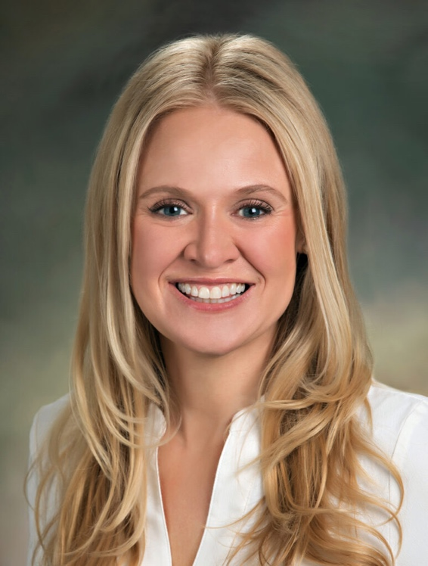

Photo Caption: Amanda Nelson Sasse is now Nelson-Jameson Foundation President and Vice President of Philanthropy and Social Impact at Nelson-Jameson.

###

About Nelson-Jameson
Nelson-Jameson is a fourth-generation, family-owned distributor to the dairy industry. From the company’s roots in dairy production supplies, it has expanded to offer a broad range of food processing products and services that help food and beverage organizations operate efficiently with the highest quality, safety, and compliance standards. The company represents more than 850 vendors, distributes more than 60,000 curated products, and employs more than 260 people nationwide. The dairy industry leader also operates NEXT Logistics, a transportation arm that provides delivery services from its Wisconsin, California, Idaho, Pennsylvania, and Texas strategic distribution centers.

For more than 75 years, Nelson-Jameson has supported food, beverage, and dairy processors with innovative products and a comprehensive set of solutions that keep pace with changing consumer tastes, manufacturing processes, and distribution channels. The company values delivering the exceptional for its customers by leading with the guiding principles of kindness and mutual respect. Nelson-Jameson is a supplier of choice for customers in all 50 states and international markets.

For more information, please visit: https://nelsonjameson.com

Media Contact:
Karolyn Raphael
karolyn@wingermarketing.com
(312) 494-0422

