IN CELEBRATION

Hernando Central High School
Unveiling Historical Marker

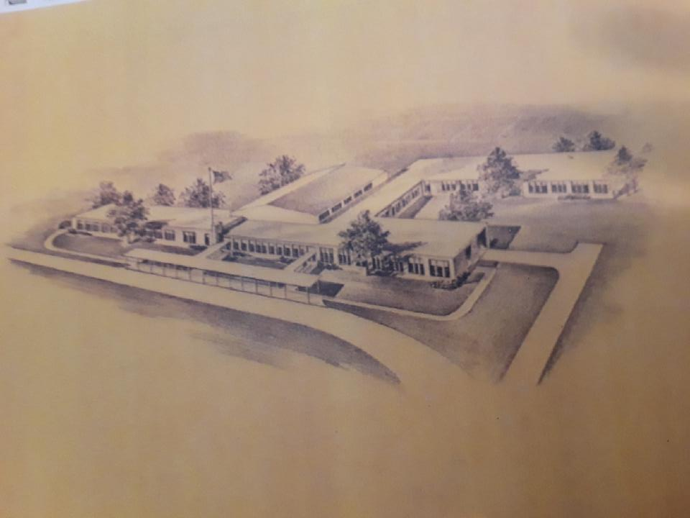

Saturday, May 25, 2019
11:30 a.m.
Oak Grove Central Elementary School
893 W. Oak Grove Road
Hernando, MS 38632

The Bridge Builder
By Will Allen Dromgoole

An old man going a lone highway,
Came, at the evening cold and gray,
To a chasm vast and deep and wide.
Through which was flowing a sullen tide
The old man crossed in the twilight dim,
The sullen stream had no fear for him;
But he turned when safe on the other side
And built a bridge to span the tide.

“Old man,” said a fellow pilgrim near,
“You are wasting your strength with building here;
Your journey will end with the ending day,
You never again will pass this way;
You’ve crossed the chasm, deep and wide,
Why build this bridge at evening tide?”

The builder lifted his old gray head;
“Good friend, in the path I have come,” he said,
“There followed after me to-day
A youth whose feet must pass this way.
This chasm that has been as naught to me
To that fair-haired youth may a pitfall be;
He, too, must cross in the twilight dim;
Good friend, I am building this bridge for him!”

THEME
“Not How Much, But How Well!”

SCRIPTURE
Proverbs 23:12
“Apply your heart to instruction and your ear to words of knowledge.”

MOTTO
“Hernando Central High School Offers a Broad Curriculum”

MASCOT
“The Mighty Tigers”


OUR PHILOSOPHY
“We believe that the Hernando School System exists to motivate the pupil to excel in individual enterprise and to develop a feeling of “Esprit De Corps” and adjust himself to his home school, community and state.

We believe that the Hernando boys and girls, to acquire a desire for intellectual attainment, vocational skills, personal, social and spiritual values, should receive inspiration and instruction in the higher values of life.

The true worth of our school will be measured by how well we can develop rational minds that will be able to render service in this society in which they live. We must endeavor to create within our pupil a desire “for him to succeed along his line of ability and interest.” Thus he will be able to acquire the most important qualities of achieving, pursuing, and acquiring: the attributes that make a good citizen in a community in which he resides.”
EXCELSIOR Annual, 1960, page 3

History of Hernando Central High
“The Hernando Central High School, the first public school built for African American students in Desoto, County, MS. Formerly known as, “The Hernando Colored School,” Hernando Central was organized July 16, 1955. The Hernando School System, under the planning of the County Board of Education and Superintendent R.E Rutherford, invested more than a half million dollars represented in building, grounds, equipment, and personnel. This public investment was for the development of Negro citizens for the “not how, but how well.” The program developer, organizer and principal of the Hernando Central School was Professor James Thomas McGlowan, Sr. This building program was completed and Hernando Central’s doors opened on Monday, November 24, 1958.
Mr. McGlowan’s principalship ended in 1960. Then, board of education elected Mr. R. C. Lamon as principal of Hernando Central. Mr. Lamon served until 1970. Other administrators were Mrs. Mary Chapman and Mr. Harvey Tucker who served in assistant principal positions.
Hernando Central consisted of 1st through 12th grade and was an asset to the community to many African Americans who were previously scattered in many dilapidated school conditions. The school was built as a result of The Supreme Court Decision outlawing racial segregation in schools and other public facilities. The school now stands and has been renovated to the new Oak Grove Central Elementary, Hernando MS.

The Supreme Court Decisions outlawed racial separation in schools and other public facilities. In 1970, Desoto County Schools accomplished an orderly and effective integration of the public schools. At this time, Hernando Central name changed to Oak Grove Elementary and later changed to Oak Grove Central Elementary. The name has changed, but the love, memories and legacy remain.

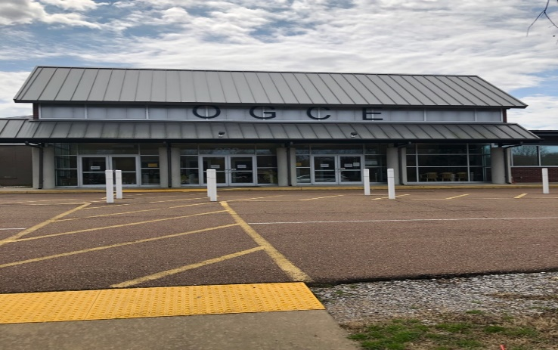
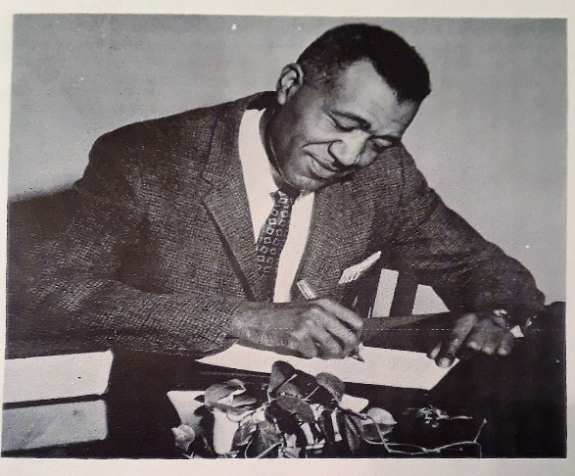

PRINCIPAL’S MESSAGE
“Greetings to the staff of the 1960 EXCELSIOR, seniors, and other members of the Hernando Central Family, and to our many friends throughout the Southland. Please accept my profound gratitude and commendation for performing another task well, thereby passing another milestone for the Greater “Hernando Central High.” Your untiring efforts and devotion to duty have won the hearts and admiration of all who are dedicated to the progress of growing institutions everywhere. Your selection of “Hernando Central offers a broad curriculum” as a theme will tell our humble beginning and growth to our present status; thus will serve as an incentive to carry us to greater Horizons in Education. Here at Central High we believe, among other things, that Education exists in order to motivate a pupil to excel along his line of abilities and interest, and to develop a feeling of belonging and contributing to the society in which he lives- always thinking and performing worthwhile service whether it is in the “common occupation,” or in “higher professions of “arts and sciences.” By this he shall “Merit” a respected place in the society of his age.
Finally I wish to commend the staff, Sponsors, and advisor, and the student body at large on the dedication of the Annual. If my humble efforts have meant anything to you in the past, from this day forward they will be doubly more.
Dear Seniors and former students, as you go out into the world, always carry in your hearts the banner of Hernando Central. Be a servant, be a friend, and be a good citizen. “Keep climbing toward your goals meditate on the road ahead and success will crown your efforts.”
Sincerely yours,
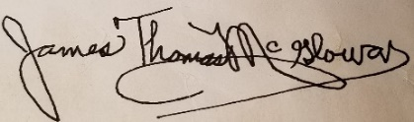
James Thomas McGlowan, Principal
Hernando Central High School
EXCELSIOR Annual, 1960, page 6
DEDICATION
EXCELSIOR Annual, 1960
Professor James Thomas McGlowan, Sr., Principal
Hernando Central High School

“He is an advisor, educator, and counselor to all who seek his services; his sound yet practical advice is sought by all. His gospel of merit has won for him high esteem by all. The story of Hernando Central’s progress is the story of Professor J. Thomas McGlowan’s contribution to the education al program of this area.

His struggle in promoting the school program has awakened our loftiest thoughts and attitudes; his interest in our development has inspired us to think nobly, and his strength and courage to fight for the right to have brought us confidence. Because of his “moving spirit” and influence our lives are richer.

All of those who follow his sound doctrine are moving forward toward higher achievement.

It is, therefore, appropriate that we salute him. As an expression of appreciation for what his record here has meant to us at Hernando Central and as a means of perpetuating deep and sincere feeling, we dedicate to him the 1960 EXCELSIOR.”

EXCELSIOR Annual, 1960, page 5

SUPERINTENDENT’S MESSAGE
“It is fitting and proper that you, the students of Hernando Central High, dedicate your year book to your principal, J. T. McGlowan. You have made this dedication because you appreciate his leadership and interest in your development.
The period of beginning is usually difficult. The work of building Hernando Central High School has not been easy. Your principal kept trying when many would have quit. Now the dream of a high school has become a reality.
It is my desire that the student body, the faculty, the principal, and parents will have a common purpose, to make Hernando Central High School one of the best schools in Mississippi.”

R. E. Rutherford
Superintendent DeSoto County
Schools

EXCELSIOR Annual, 1960, page 4

PROFESSOR JAMES THOMAS MCGLOWAN, SR.
BIO

Professor James McGlowan, Sr. received Masters of Arts Degrees from the University of Mississippi and a Specialist Degree from Hampton Institute. He furthered his doctoral education at the University of Mississippi prior to his death.
He served as Administrative Assistant at the Mississippi State Penitentiary, Parchman, MS. To the Prisoners he was s counselor, a prince of peace. He brought a smile, a word of cheer, as well as a way to develop their skills and become productive members of society.

Professor McGlowan was a builder like a carpenter, as an educator. He was able to inspire youth and prisoners to develop their potentials into the best selves that they were capable of being. He was a teacher and administrator across the state of Mississippi and in Michigan for 42 years. He was known for his aggressive ability to pioneer educational programs and leave each place a better place to live.

ORDER OF COMMENOMORATION

Program Officiant McStella Betts Hinds
Prayer Mr. Carl Hurt
Welcome and Proclamation Mr. Tom Ferguson, Mayor of Hernando, MS

SPEAKERS

Mr. Cory Uselton, Superintendent of Desoto County District Schools

Mrs. Stacey Pirtle, Principal of Oak Grove Central Elementary

Mrs. Dorothy Ann Smith Bingham, Former Hernando Central Teacher

Mrs. Geraldine Johnson Patton, Hernando Central Alumni

Debra Buford., Daughter of Principal Professor James Thomas McGlowan, Sr.

Rev. Andrew Miller, Chairman of Historical Marker Committee

Unveiling of Mississippi Historical Marker, Hernando Central High School

Song, “Hernando Central, We Love You” Former Students of Hernando Central School

Dear Hernando, how we love you
With a love that’s just for thee,
And this love shall mount and grow, grow until eternity
You are struggling dear to show us that our labor’s not in vain
We shall think of our dear motto
Let it in our heart remain not how much, but oh how well
Alma motto, we love you

Viewing of Hernando Central Photograph Display

Recessional

Tour of School

THEME

“Not How Much, But How Well!”

MOTTO

“Hernando Central High School Offers a Broad Curriculum”

OUR PHILOSOPHY

“We believe that the Hernando School System exists to motivate the pupil to excel in individual enterprise and to develop a feeling of “Esprit De Corps” and adjust himself to his home school, community and state.

We believe that the Hernando boys and girls, to acquire a desire for intellectual attainment, vocational skills, personal, social and spiritual values, should receive inspiration and instruction in the higher values of life.

The true worth of our school will be measured by how well we can develop rational minds that will be able to render service in this society in which they live. We must endeavor to create within our pupil a desire “for him to succeed along his line of ability and interest.” Thus he will be able to acquire the most important qualities of achieving, pursuing, and acquiring: the attributes that make a good citizen in a community in which he resides.”
EXCELSIOR Annual, 1960, page 3

SPRINGING FORTH THE NEW

ON EDUCATION
Elizabeth Bentley
December 1789

When infant Reason first exerts her sway,
And new-formed thoughts their earliest charms display;
Then let the growing race employ your care
Then guard their opening minds from Folly’s snare;
Correct the rising passions of their youth,
Teach them each serious, each important truth;
Plant heavenly virtue in the tender breast,
Destroy each vice that might its growth molest;
Point out betimes the course they should pursue;
Then with redoubled pleasure shall you view
Their reason strengthen as their years increase,
Their virtue ripen and their follies cease;
Like corn sown early in the fertile soil,
The richest harvest shall repay your toil.

Oak Grove Central Elementary School
893 W Oak Grove Road
Hernando, MS 38632

SPECIAL THANKS

3Links Technologies, Inc., Silver Spring, MD
Breezy Blossom Florist, Pontotoc, MS

Mayor of Hernando, MS
Superintendent of DeSoto County District Schools
Principal of Oak Grove Central Elementary School
President of Hernando Central High School Alumni

Unveiling the Hernando Central High School Historical Marker
Committee Members

Rev. Andrew Miller, Alderman Class of 1969
Dr. Carolyn Harvey, Daughter of Principal Professor James Thomas McGlowan, Sr.
Mrs. Erma Veasey-Foster, Class of ?
Mr. Chester Anderson, Class of 1965
Mr. Carl Hut, Class of 1967
Mrs. McStella Betts Hinds, Class of 1969
Mrs. Jean Richmond Johnson, Class of 1969
Mr. John E. Leake, Class of 1960
Mr. Samuel Williams, Class of 1967
Mrs. Janice Rand Isom, Class of 1969
Mrs. Jackie Anderson Jenkins, Class of 1969

School Seal

