
N E W S
R E L E A S E

For a high quality digital images of these products email: andrew.pakula@sparton.com

FOR IMMEDIATE RELEASE
Contact: Andrew Pakula
1-888-783-2584 ext #6243
andrew.pakula@sparton.com

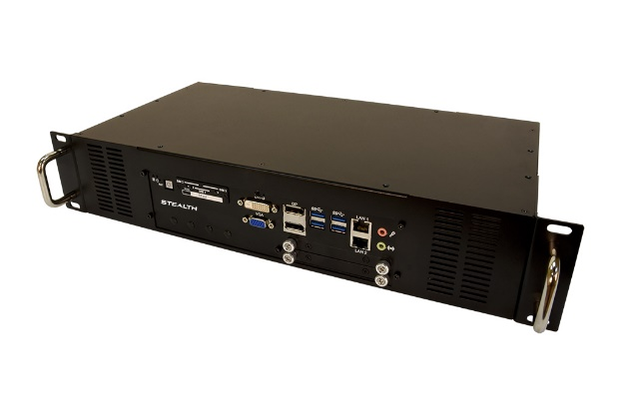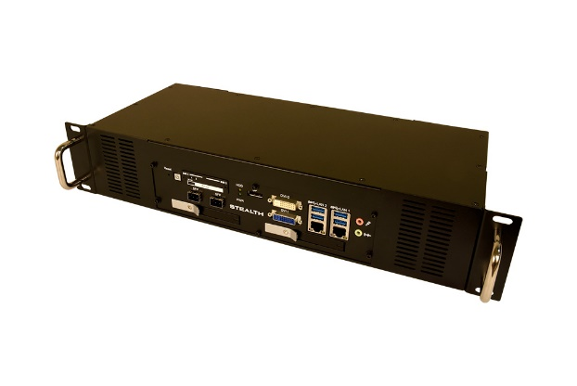
Stealth Introduces New Fanless 2U Rackmount Servers
Toronto, Canada ~ March 9th 2021 – Stealth (a Sparton company), a leader in the industrial computer and peripherals market has launched a pair of Fanless 2U Rackmount Servers. These rackmount computer models SR-2950 & SR-2960 are well equipped, versatile and are designed for a variety of demanding environments and applications.
Fanless by design, the system operates without noisy cooling fans that can draw in dirt and dust causing potentially catastrophic failures. The space saving design features a rugged extruded aluminum chassis that provides superior heat dissipation. The SR-2950 & SR-2960 can easily install into standard 19″ rack cabinets or used as standalone workstations.
Stealth’s SR-2950 Rackmount PC comes equipped with a Dedicated NVIDIA® GeForce® 1050 or 1050TI graphics card which can support up to 8K Resolution video and can support up to 7 connected displays via DisplayPort video ports.
Stealth’s SR-2960 Rackmount PC features Intel® 9th Generation Core™ i3, i5, i7 & Xeon processors, ECC Memory support and dual removable front drive bays, providing easy drive swapping and optional RAID configurations.
“The addition of these two models, SR-2950 & SR-2960, add to our innovative lineup of Fanless Rackmount Computers Family and offer our customers Certified units that can perform in their variety of operating environments.” stated Louis Houde, Business Unit Director for the Stealth.
The Stealth SR-2950 & SR-2960 are RoHS, CE & FCC, EN50121-3-2 & EN50155 certified, and designed for use in a multitude of applications including: Audio/Video Recording, Embedded Control, Digital Signs, Interactive Kiosks, IoT, Industrial Internet of Things (IIoT), Transportation/Rail, Thin-Clients, and Human/Machine Interface.
Systems are compatible with Microsoft Windows, Linux and can be custom configured to meet the exact needs of the OEM or end user. Systems come standard with 2 years’ warranty and extended warranty options are available. Basic configurations of the SR-2950 & SR-2960 Fanless 2U Rackmount Servers start at $3,795.00 USD and $2,850.00 USD respectively and are shipping now.
Product Features

- Dedicated NVIDIA® GeForce® 1050 or 1050TI graphics card (SR-2950)
- Supports up to 8K resolution, 7 Display support (SR-2950)
- Supports up to Intel® 9th Generation Core™ i3, i5, i7 & Xeon processors (SR-2960)
- ECC Memory Support
- 32 DIO (16 In/16 Out Digital input/output) ports
- Dual Removable Front Drives
- Solid State Drives (SSD) Standard
- PCIe x4 expansion slot (SR-2950)
- Wide Range 10-36 VDC Input, ideal for mobile/field
- Windows 7, 10, Server 2019, and Linux
- RoHS, CE & FCC, EN50121-3-2, EN50155 certified
- Wide Temperature Range (up to -40°C to 75°C / -40°F to 167°F) versions also available
About Stealth
Founded in 1990 Stealth, is a leading manufacturer of specialized Computers and Peripherals. The company is ISO 9001 registered and continually develops innovative products designed to meet the exact needs of their clients. For three decades Stealth has provided thousands of proven reliable product solutions that have assisted clients with a myriad of applications. Our impressive customer base includes a wide range of customers from single man operations to Fortune 500 companies, Military installations and Governments worldwide. Stealth's website may be accessed at www.stealth.com
About Sparton Corporation
Sparton is a provider of engineered products for the defense industry. With decades of experience, the Company designs, develops, and produces proprietary products for domestic and foreign defense as well as commercial needs. Sparton’s range of engineered products spans everything from sonobuoys to inertial systems to ruggedized displays and rugged computers. Sparton's Web site may be accessed at www.sparton.com.
#########

