CLARK Celebrates Grand Opening of Global Headquarters in Texas
Dallas, Texas — April 8, 2025 — CLARK Material Handling, a pioneer and leader in the material handling industry, proudly announces the grand opening of its Global Headquarters in the Dallas Fort Worth Metroplex. This milestone marks the official return of CLARK’s headquarters to the United States, solidifying the company’s status as an iconic American brand and positioning it for global growth in the decades to come.
CLARK’s new headquarters in Flower Mound, TX, a facility owned by CLARK, is designed to foster collaboration and serve as a central hub for CLARK’s continued innovations in forklift technology and material handling solutions. The 56,972 square foot building features a Product Showroom, Forklift Experience center, CLARK History Hall, Dealer Sales & Service Training Classes, Warehousing & Distribution center, as well as the Global Administrative offices. This state-of-the-art facility is a testament to CLARK’s enduring commitment to its customers, employees, and dealer network.
The location was strategically selected for its proximity to the DFW International Airport, providing convenient access for global partners. In March 2022, a temporary global office was established while plans for a permanent facility took shape. Following a yearlong construction process, the new headquarters officially opened in November 2024. The facility currently employs 36 associates, with plans to expand to 65 by the end of the year. Meanwhile, the U.S. factory in Lexington, KY, will continue operations, supported by robust Research & Development, Engineering, Manufacturing, and Quality teams.
“This grand opening is not just the culmination of years of planning and hard work; it is the beginning of a new era for CLARK. By returning our headquarters to the United States, we honor our legacy while confidently building the future of the material handling industry.”
Chuck Moratz, President & CEO of CLARK Material Handling
“Bringing CLARK’s global headquarters to the United States reaffirms our commitment to delivering exceptional products and services. This move strengthens our foundation as a global leader and ensures we remain close to the customers and markets that drive our success.”
S.S. Baik, Chairman of CLARK Material Handling
We celebrate not just a building but a bold vision for CLARK’s future. This headquarters exemplifies our mission to innovate and lead, all while staying rooted in the values that have made us a trusted name for over a century. CLARK Material Handling invited partners, dealers, and the community to join in celebrating this momentous occasion as the company embarks on an exciting new chapter from its Dallas headquarters. CLARK Honorary Chairman S.H. Baik was in attendance to offer his congratulations.
“Since 2003, I envisioned a future where we would one day return our global headquarters to America, the birthplace of the forklift. This new facility is the realization of that vision - a commitment to our heritage, our people, and our continued growth. I am proud to see CLARK take this significant step forward, strengthening our ability to serve customers worldwide while honoring our legacy of innovation and excellence.”
S.H. Baik, Honorary Chairman of CLARK Material Handling

CLARK Material Handling Company
Since the forklift was invented by Eugene Clark in Buchanan, Michigan (USA) in 1917, CLARK has been one of the worldwide market leaders in the material handling equipment business. With more than 100 years of experience in the sector, and over 1.4 million forklifts sold worldwide, the CLARK brand, which is proud of its roots in the United States of America, is associated with modern and robust product design, progressive, sophisticated technology, and excellent customer service. Since 2003, CLARK has offered a complete product portfolio consisting of forklift trucks with electric or combustion engines and load capacities from 1.5 to 8 tons, reach trucks, warehouse trucks, tow tractors and a comprehensive range of services.
You can also visit CLARK online at https://www.clarkmhc.com/

Photo:
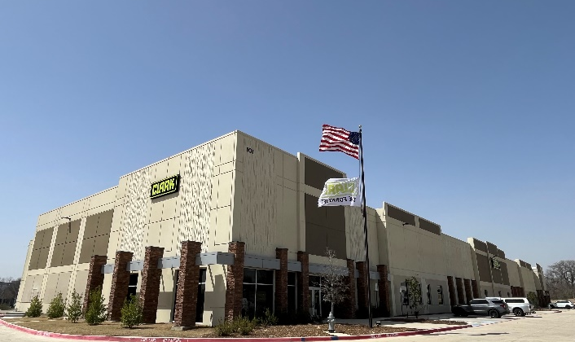 | Image 1: New Global Headquarters of CLARK Material Handling Company in Flower Mound, Texas
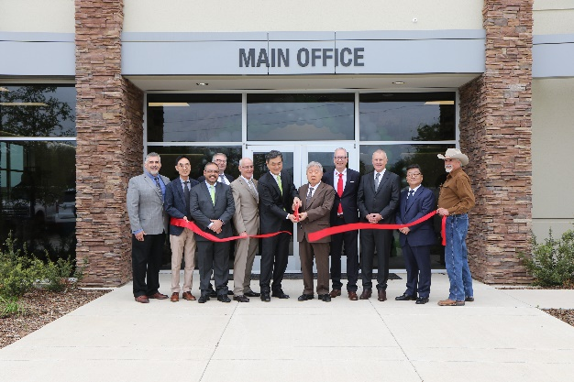 | Image 2: Ribbon Cutting at New Global Headquarters of CLARK Material Handling Company in Flower Mound, Texas.  From left: Jeff Gallegos, COO; CI Kim, CEO CLARK Costa Rica, Mauro Arrais, CLARK Brazil, Rolf Eiten, Global HQ Advisor and former CLARK Europe CEO; Chuck Moratz, CEO CLARK Material Handling Company (North America); SS Baik, CLARK Chairman; SH Baik, CLARK Honorary Chairman; Stefan Budweit, CEO CLARK Europe; Robert Hammond, CEO CLARK South Pacific; SD Kim, CLARK International CEO; Richard Milano, Global HQ Building Consultant.
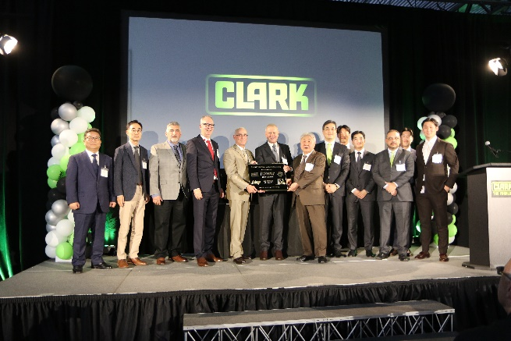 | Image 3: The formal presentation of the building plaque commemorating the CLARK Global Headquarters Grand Opening in Flower Mound, Texas.
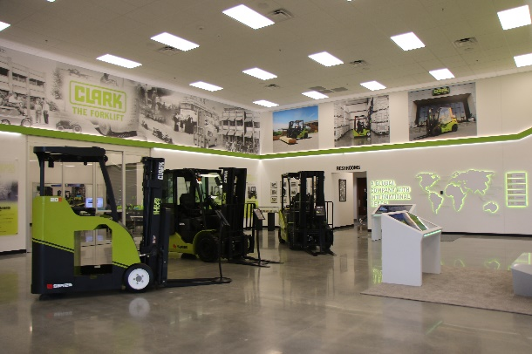 | Image 4: Internal image from the Showroom inside the New Global Headquarters of CLARK Material Handling Company in Flower Mound, Texas

Press contact:
CLARK Global HQ
Cynthia Barnes
Corporate Communications Contact
101 Lakeside Pkwy
Flower Mound, TX 75028
Phone: (859) 300-4707
E-Mail: cynthiabarnes@clarkmhc.com
https://www.clarkmhc.com/

