NEWS RELEASE

WESTERN ALASKA MINERALS DRILLING CONFIRMS DISTRICT-SCALE POTENTIAL

TUCSON, ARIZONA, US – November 5, 2024 - Western Alaska Minerals (the "Company" or "WAM") (TSXV: WAM) is pleased to report drilling and trenching results that show continuity of mineralization across its Illinois Creek CRD project. Additional assay results from the Warm Springs (WS) zone strengthens evidence of a critical link between the Waterpump Creek (WPC) silver deposit (75 Moz at 980 g/t AgEq Inferred¹) and the Illinois Creek (IC) gold deposit (373,000 oz AuEq indicated and 152,000 oz AuEq inferred¹), significantly enhancing the district-scale potential of the 100%-owned project.

The final six 2024 drill holes completed at Warm Springs further demonstrate the extensive scale of the Carbonate Replacement Deposit (CRD) hydrothermal system at the Illinois Creek Project (see September 10, 2024 news release). The Warm Springs zone is characterized by an upper horizon of multistage intense silicification and brecciation, associated with massive to semi-massive pyrite and gold-copper mineralization. This mineralization style is exemplified in the upper intercepts of holes IC24-0008, IC24-0010, and previously reported IC24-0004 (see August 29, 2024 news release).

Highlights:

- Initial exploration drilling at the Warm Springs target confirms a ~1.7 km x 1.0 km mineralized corridor, south of the WS fault, trending east-northeast with eight of nine holes encountering significant CRD-style alteration and mineralization.
- Intersections of complex multi-stage mineralization characterized by thick intervals of silica pyrite mineralization punctuated by thin zones of both Illinois Creek (Au/Ag/Cu) and Waterpump Creek (Ag/Pb/Zn) styles of mineralization.
- Drill highlights include:
IC24-0010 2.5 meters grading 2.31 g/t Au, 73 g/t Ag
IC24-0010 0.5 meters grading 53 g/t Ag, 3.1% Pb, 12.4% Zn
IC24-0008 10.4 meters grading 1.02 g/t Au
IC24-0008 2.1 meters grading 2.68 g/t Au, 214 g/t Ag, 0.9% Cu
IC24-0008 1.5 meters grading 3.54 g/t Au, 6.7 g/t Ag
IC24-0005* 1.2 meters grading 687 g/t Ag, 33.6% Pb
IC24-0005* 3.2 meters grading 88.5 g/t Ag, 2.4% Pb, 4.0% Zn
IC24-0004* 1.0 meters grading 5.6 g/t Au, 12.8 g/t Ag,
IC24-0004* 0.2 meters grading 12.5 g/t Au, 167 g/t Ag, 0.9% Cu, 2.4% Pb

"These results mark a significant milestone in demonstrating the scalability of our Illinois Creek CRD project," stated Kit Marrs, CEO of Western Alaska Minerals. "The mineralization encountered at Warm Springs provides strong evidence for a connection between our high-grade Waterpump Creek silver deposit and the Illinois Creek gold deposit.”

¹ For full disclosure visit https://westernalaskaminerals.com/projects/illinois-creek-crd/ for details on the NI 43-101 report
Discussion

In 2024, Western Alaska Minerals' exploration strategy targeted the expansive, untested corridor between our established Illinois Creek and Waterpump Creek deposits. This multi-kilometer district-scale system, spanning at least 6 by 8 kilometers, was the focus of drilling at the high-priority Warm Springs and LH prospects. The program successfully validated and expanded our understanding of this large-scale mineralized footprint.

CSAMT and 3D IP geophysical surveys, conducted in 2022 and 2023, combined with extensive soil geochemistry and drilling has revealed compelling district-scale metal zonation (see Fig. 1 below). This zonation ranges from silver-lead-zinc mineralization at Waterpump Creek, representing the distal portion of the system, to gold-copper-silver mineralization at Illinois Creek, indicating proximity to the intrusive source.

Figure 1. District-scale zoning in relation to the existing Waterpump Creek and Illinois Creek resources.
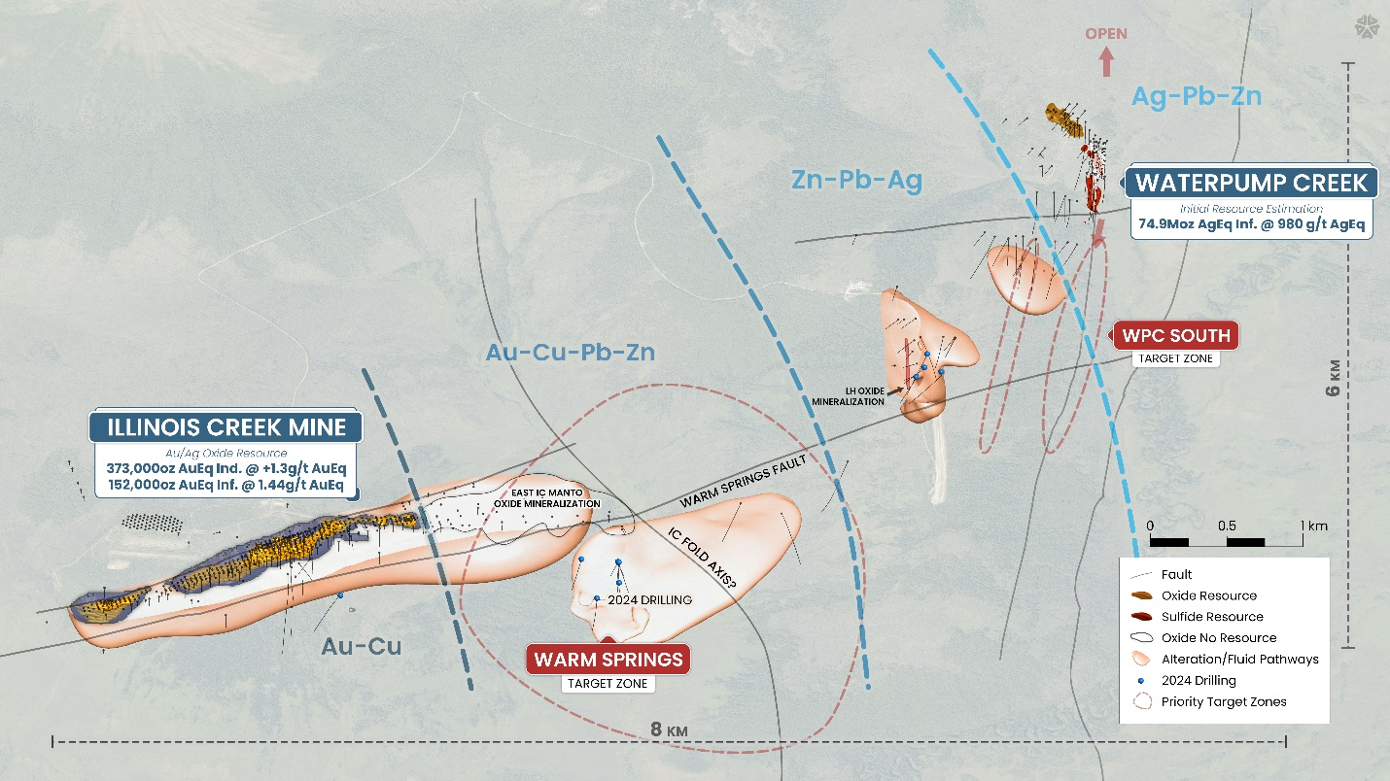

Warm Springs Key Findings:

- Results suggest Warm Springs could be a new spoke of CRD mineralization analogous to both the IC and WPC resources.
- Mineralization is characterized by paragenetically complex multi-stage silica/pyrite mineralization with thin zones of both IC and WPC styles of mineralization.
- The mineralization lies immediately below a major impermeable fluid barrier capping a thick section of receptive dolomite.
- Preliminary interpretation of a 2024 SkyTEM aerial electromagnetic survey supports additional targeting in the Warm Springs zone with newly recognized high-angle feeder structures and a major antiformal fold axis.
- Importantly, the 2024 exploration drill results and the new SkyTEM survey emphasize the continued westward potential for the gold-copper-rich proximal part of the CRD system.
LH Key Findings

- Drill hole LH24-0015 cut 0.25 meters grading 192 g/t silver, 1.9% lead and 3.8% zinc.
- Trench LH-01-7 grab sample ran 599 g/t silver and 46.8% zinc.
- 2024 exploration at the LH zone, including drilling and surface trenching, has identified a narrow vertical structure that appears to be vertically oriented, controlling CRD-style alteration and Ag-Pb-Zn gossan mineralization. While this structure shows potential at depth, it appears unlikely to represent an offset of the Waterpump Creek fault. Rather, the data suggests LH represents a distinct, separate part of the broader Illinois Creek CRD mineralized system.
- Stratigraphic and 2024 drill implications along with the preliminary SkyTEM interpretation suggest the main WPC structure remains untested downdip farther to the east below capping impermeable schists. This target has been named “Waterpump Creek South”.
Figure 2. North wall of Trench LH-01 depicting 4 gossans with grab-sample assaying 599 g/t Ag, 46.8% Zn, and 4,300 ppm Pb
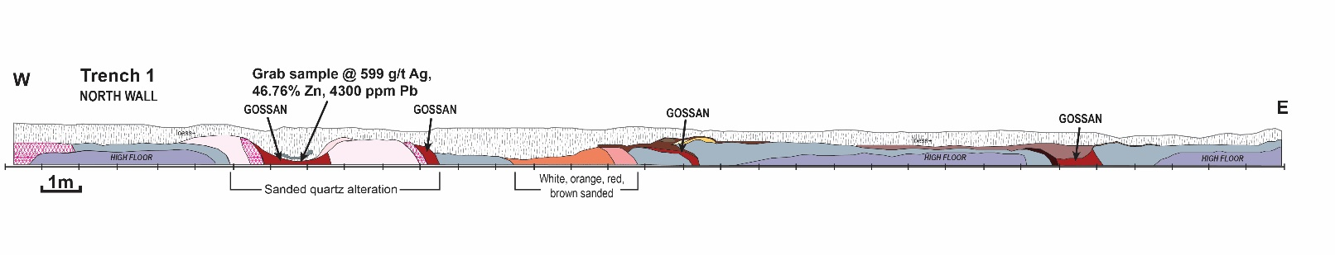

Figure 3. Location of Waterpump Creek South and LH Targets
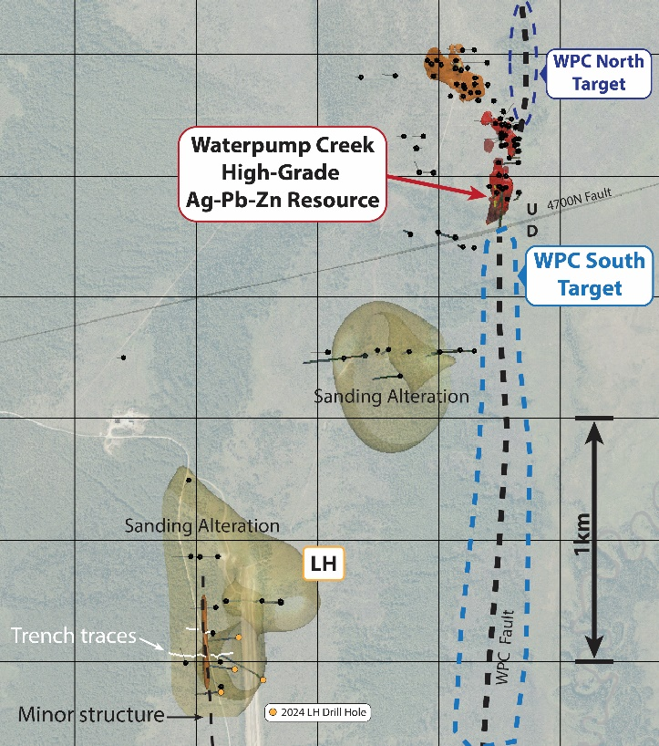

Table 1. Intercepts from Warm Springs drill holes IC24-0004 through IC24-0012
Hole | From (m) | To  (m) | Length | Au (g/t) | Ag (g/t) | Cu (pct) | Pb (pct) | Zn (pct)
IC24-0004 | 84.17 | 88.85 | 4.68 | 1.29 | 11.6 | 0.04 | 0.26 | 0.05 | Previously reported
Including | 84.17 | 84.35 | 0.18 | 12.50 | 167 | 0.91 | 2.44 | 0.03
IC24-0004 | 244.40 | 247.36 | 2.96 | 2.13 | 7.0 | 0.03 | 0.35 | 0.30
Including | 246.35 | 247.36 | 1.01 | 5.57 | 12.8 | 0.05 | 0.38 | 0.26
IC24-0005 | 212.60 | 213.75 | 1.15 | 0.226 | 687 | 0.00 | 33.64 | 1.10 | Previously reported
IC24-0005 | 318.60 | 319.30 | 0.70 | 0.035 | 94.1 | 0.00 | 6.79 | 0.36
Including | 318.60 | 319.30 | 0.70 | 0.035 | 94.1 | 0.00 | 6.79 | 0.36
IC24-0005 | 352.20 | 355.41 | 3.21 | 0.020 | 88.5 | 0.00 | 2.39 | 4.00
IC24-0006 | 220.46 | 221.52 | 1.06 | 0.61 | 1.9 | 0.00 | 0.02 | 0.11
IC24-0008 | 90.68 | 95.14 | 4.46 | 1.51 | 111.9 | 0.48 | 0.26 | 0.07
Including | 90.68 | 92.80 | 2.12 | 2.68 | 214.0 | 0.93 | 0.36 | 0.07
IC24-0008 | 119.54 | 129.99 | 10.45 | 1.02 | 3.8 | 0.00 | 0.13 | 0.12
Including | 120.74 | 122.23 | 1.49 | 3.54 | 6.7 | 0.01 | 0.28 | 0.13
IC24-0008 | 136.55 | 146.52 | 9.97 | 0.76 | 7.5 | 0.01 | 0.13 | 0.16
Hole | From (m) | To  (m) | Length | Au (g/t) | Ag (g/t) | Cu (pct) | Pb (pct) | Zn (pct)
IC24-0008 | 258.47 | 262.45 | 3.98 | 0.10 | 2.9 | 0.08 | 2.56 | 0.83
IC24-0008 | 279.20 | 280.62 | 1.42 | 0.01 | 99.8 | 0.00 | 2.00 | 1.24
IC24-0010 | 95.12 | 102.72 | 7.60 | 1.09 | 29.9 | 0.06 | 0.51 | 0.37
Including | 100.22 | 102.72 | 2.50 | 2.31 | 73.3 | 0.16 | 1.01 | 0.16
IC24-0010 | 122.55 | 125.58 | 3.03 | 0.45 | 4.4 | 0.00 | 0.15 | 0.30
IC24-0010 | 222.50 | 225.11 | 2.61 | 0.11 | 25.5 | 0.01 | 1.11 | 7.87
IC24-0010 | 249.85 | 250.30 | 0.45 | 0.01 | 53.3 | 0.01 | 3.07 | 12.35
IC24-0011 | 120.40 | 122.22 | 1.82 | 1.42 | 12.7 | 0.04 | 0.12 | 0.24
IC24-0012 | 83.52 | 85.91 | 2.39 | 0.43 | 18.6 | 0.0 | 1.26 | 0.06
including | 85.24 | 85.91 | 0.67 | 0.04 | 61.9 | 0.0 | 3.90 | 0.13
All intercepts are core length and are believed to be true width. Core recovery averaged 88.9% for reported intercepts.

The remaining holes returned no significant results.

Table 2. Intercepts for LH
Hole | From (m) | To (m) | Length | Ag (g/t) | Pb (pct) | Zn (pct)
LH24-0014 | No Significant Intercepts
LH24-0015 | 170.20 | 170.45 | 0.25 | 192 | 1.91 | 3.81
LH24-0015 | 200.25 | 210.25 | 10.00 | 10.1 | 0.22 | 1.07
LH24-0016 | 118.42 | 120.38 | 1.96 | 18.2 | 1.60 | 2.50
LH24-0017 | No Significant Intercepts
All intercepts are core length and are believed to be true width, except for LH24-0015 170.20 to 170.45 m with a true width of ~0.13m. Core recovery averaged 90.2% for reported intercepts.

Table 3. Assay results for grab samples for the LH trenches
Trench ID | Ag (g/t) | Cu (pct) | Pb (pct) | Zn (pct)
LH-01-1 | 82.5 | 0.04 | 1.92 | 12.70
LH-01-5 | 10.0 | 0.12 | 3.50 | 2.96
LH-01-7 | 599 | 0.03 | 0.43 | 46.76
LH-02b-7 | 14.7 | 0.48 | 1.37 | 1.22

Looking Ahead

The Company's technical team is currently interpreting the 2024 drill results in conjunction with the newly acquired SkyTEM airborne EM survey. The geophysical data shows vastly improved resolution of resistivity across the property due to a much tighter survey spacing. The survey will provide targeting for the next phase of exploration in 2025 once both data sets are integrated with the existing geologic model for the Illinois Creek CRD district.

Quality Assurance and Quality Control

Drill core samples were transported from site to the ALS Minerals laboratory in Fairbanks, Alaska for sample submission. The samples were then shipped to ALS Minerals in Reno, Nevada, for sample preparation. Analysis of samples were completed at both the Reno and the ALS Mineral’s North Vancouver laboratories, which are certified under ISO 9001 and accredited under ISO/IEC 7025.

The gold content is determined by fire assay of a 30-gram charge with an AA finish (Au-AA23). Silver, lead, copper, and zinc along with other elements are analyzed by ICP-MS utilizing a four-acid digestion (ME-MS61). Over-limit samples for silver, lead, copper, and zinc are determined by using either an ore grade four-acid digestion and ICP-ES finish (ME-OG62) or ore-grade titration analysis (VOL50 or VOL70) for very high-grade samples.

Control samples consisting of certified reference samples, duplicates, and blank samples were systematically inserted into the sample stream and analyzed as part of the Company’s quality assurance / quality control protocol.

Qualified Person

The Qualified Person who reviewed and approved the technical disclosure in this release is Andrew West, Certified Professional Geologist, a Qualified Person as defined under National Instrument 43-101. Mr. West is the Vice President for Western Alaska Minerals with a MS in Geology and 30 years of experience in mineral resources, mine, and exploration. He is a Certified Professional Geologist with the American Institute of Professional Geologists (AIPG CP-11759).

His review verified the technical data disclosed, including geology, sampling, analytical and QA/QC data underlying this news release, including reviewing the reports of ALS, methodologies, results, and all procedures undertaken for quality assurance and quality control in a manner consistent with industry practice.

About WAM

Our mission is to advance a mineable and scalable CRD, ultimately reshaping the mineral landscape of western Alaska and establishing a new CRD district.

WAM’s CRD system encompasses a 373K oz AuEq NI 43-101-compliant indicated and 152K oz AuEq Inferred resource*** at the past producing Illinois Creek gold-silver mine***, and the Waterpump Creek high-grade silver-lead-zinc deposit with an inferred resource estimate of 74.9Moz at 980 g/t AgEq*, open to the north. Within the same CRD system sits the Honker gold vein prospect. Twenty-five kilometers northeast of the Illinois Creek CRD lies the Round Top copper and the TG North CRD prospects. All prospects were originally discovered by Anaconda Minerals Co. in the early 1980’s***. WAM’s 100% owned claims and uplands mining lease cover 73,120 acres (114.25 square miles or 29,591 hectares), approximately 45 km east of an ocean barge-compatible section of the Yukon River. Since 2010, WAM, along with its precursor company, Western Alaska Copper & Gold, reassembled the Anaconda land package and has been engaged in exploring the district.

Headquartered in both Alaska and Arizona, WAM brings together a team of seasoned professionals with a shared vision of pioneering new frontiers in mineral exploration. Our strategic approach is underpinned by cutting-edge technology, innovative techniques, and a deep understanding of the geological intricacies of the region.

As of May 2024, the Company has 41,939,920 subordinate voting shares issued and outstanding and 224,801 proportional shares issued and outstanding. Each proportional share is convertible to 100 common shares at the request of the shareholder and in the discretion of the Company. Because of these conversion rights, for market capitalization and financial analysis purposes, the Company believes it is appropriate to convert the proportional shares to common shares and add the product of the conversion to the current number of common shares outstanding. When doing so, the sum of subordinate voting shares (41,939,920) and converted proportional shares (22,480,100) equals 64,420,020 shares. Further information regarding the Company’s share structure is available upon request.

***Information on our historical gold and Waterpump Creek resources, as well as historical work performed by Anaconda Minerals Co. and NovaGold (2005/2006) can be found in our NI 43-101 report, dated April 2, 2024, authored by Bruce Davis, PhD, FAusIMM, titled “Western Alaska Minerals Corp. ILLINOIS CREEK PROJECT UPDATE Illinois Creek Mining District, Western Alaska, USA” on our website: https://www.westernalaskaminerals.com/_resources/pdfs/Illinois-Creek-NI43101-Technical-Report.pdf?v=0.317

On behalf of the Company

“Kit Marrs”
Kit Marrs

President & CEO

Phone: 520-200-1667

For further information please contact:

Vanessa Bogaert, Director of Corporate Communications/IR at vanessa@westernalaskaminerals.com
Or visit our website at: www.westernalaskaminerals.com

Forward Looking Information

This news release contains “forward-looking information” within the meaning of applicable Canadian securities legislation. “Forward-looking information” includes, but is not limited to, statements with respect to the activities, events or developments that the Company expects or anticipates will or may occur in the future. Generally, but not always, forward-looking information and statements can be identified by the use of words such as “plans”, “expects”, “is expected”, “budget”, “scheduled”, “estimates”, “forecasts”, “intends”, “anticipates”, or “believes” or the negative connotation thereof or variations of such words and phrases or state that certain actions, events or results “may”, “could”, “would”, “might” or “will be taken”, “occur” or “be achieved” or the negative connation thereof.

Such forward-looking information and statements are based on numerous assumptions, including among others, Although the assumptions made by the Company in providing forward-looking information or making forward-looking statements are considered reasonable by management at the time, there can be no assurance that such assumptions will prove to be accurate and actual results and future events could differ materially from those anticipated in such statements.

Important factors that could cause actual results to differ materially from the Company’s plans or expectations include risks relating to market conditions, metal prices, and risks relating to general economic, market or business conditions, uninsured risks, regulatory changes, defects in title, availability of personnel, materials, and equipment on a timely basis, accidents or equipment breakdowns, unanticipated environmental impacts on operations and costs to remedy same, and other exploration or other risks detailed herein and from time to time in the filings made by the Company with securities regulators. Although the Company has attempted to identify important factors that could cause actual results to differ materially from those contained in the forward-looking information or implied by forward-looking information, there may be other factors that cause results not to be as anticipated, estimated or intended. There can be no assurance that forward-looking information and statements will prove to be accurate, as actual results and future events could differ materially from those anticipated, estimated or intended. Accordingly, readers should not place undue reliance on forward-looking statements or information.

Neither TSX Venture Exchange nor its Regulation Services Provider (as that term is defined in the policies of the TSX Venture Exchange) accepts responsibility for the adequacy or accuracy of this release.

