Roto-Rooter Does it Again: Two Kittens Heroically Saved in One Week
SACRAMENTO & FRESNO, CA – July 10, 2024 - The days following the Fourth of July turned into unforgettable moments for the Roto-Rooter family as their Sacramento and Fresno locations stepped in to rescue trapped kittens.
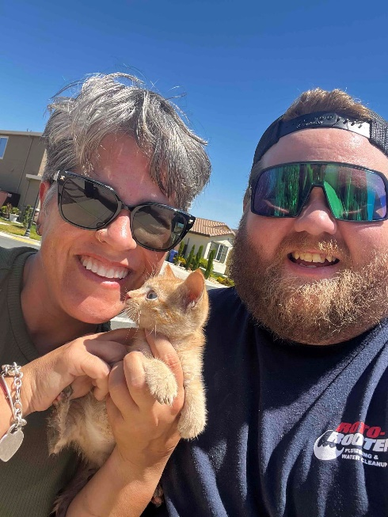
On July 7, 2024, the Fresno location received a call from a local pet rescue service that a kitten was trapped in a sewage pipe. After days of unsuccessful attempts to locate and rescue the trapped feline, the rescue service reached out to the trusted Sanger Roto-Rooter location for assistance. Loreto Fernandez, a seasoned technician, sprang into action and set up his advanced camera feed to see where the kitten was stuck. Once the kitten was found in the street sewer, the smart little guy luckily grabbed onto the end of the camera and was able to follow the camera through the 3.5” pipe. As the kitten got closer, they pulled him out to safety. According to a statement in Your Central Valley, the rescued kitten, once a stray, is now poised to be adopted alongside its sibling by the homeowner who discovered them on her property.
The rescue efforts continued on July 8, 2024, when the Sacramento branch received a call that another kitten was trapped in a storm drain. Our Sacramento technician, Jonathan Goodner, made his was over to the location as soon as possible to help the poor kitten. Goodner was able to successfully locate and remove the orange tabby kitten from the drain, bringing relief and joy to all involved.
Roto-Rooter Plumbing and Water Cleanup is renowned for its 24/7 service and 80 years of local expertise, they remain committed to tackling all plumbing challenges, big or small. For more information about their services, visit RotoRooterCA.com or call 1-800-GET-ROTO.
Sources: Your Central Valley: https://www.yourcentralvalley.com/news/local-news/kitten-stuck-in-sanger-sewage-line-for-2-days-rescued/

