FOR IMMEDIATE RELEASE

A Mouthwatering Story about One Man’s Quest
to Serve a Better Hot Dog

Random Media Proudly Debuts
HOT DOUG’S: the MOVIE

Cultural and Culinary Documentary about Fandom and Going Out on Top

Serving it up on DVD, Digital & VOD – Beginning June 25, 2019!

Los Angeles, Calif./Chicago, Ill. – May 2019 – Random Media and Markos Films take audiences on a mouthwatering, culinary journey, with HOT DOUG’S: the MOVIE, coming to DVD, Digital and VOD, beginning June 25, 2019. Inspired by chef Doug Sohn’s love of “encased meats” and his desire to create a sausage superstore, HOT DOUG’S: the MOVIE follows Sohn on a journey that takes him from being at the top of his game to a decision to close his restaurant at the height of its popularity, after 13 years of business.
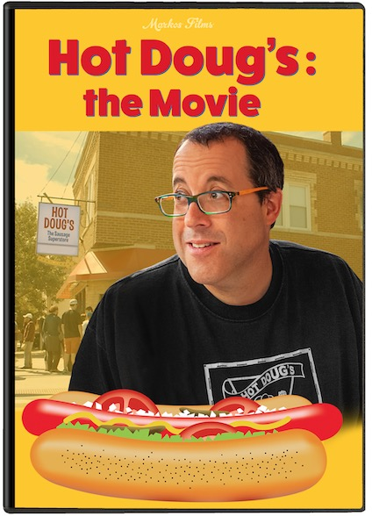

Hot Doug’s opened in 2001 and quickly became a phenomenon, ushering in the era of gourmet-casual dining and attracting fans from around the world, including Anthony Bourdain, who included it as ‘one of the 13 places to eat before you die.’’ Love for Doug and his crew, who operated like family, made the restaurant an institution, with hungry fans waiting in line for hours to try culinary delicacies that transcended the average hot dog, made with ingredients including foie gras, venison, curry pork, and escargot; bearing names like ‘The Joe Strummer,’ ‘The Anna Kendrick,’ and ‘The Elvis.’ HOT DOUG’S: the MOVIE is the remarkably delightful story of a special place that will leave you hungry for more.

TRAILER: https://vimeo.com/316437707
(More)

Hot Doug’s: the Movie/Page Two

HOT DOUG’S: the MOVIE is directed and produced by Christopher Markos and produced by Nicholas Markos. It stars Doug Sohn, Steve Albini, the late Homaro Cantu and Dan Sinker. A Markos Films Production, HOT DOUG’S: the MOVIE is distributed by Random Media. It has a running time of 57 minutes and is unrated (‘PG’ is suggested).

Synopsis:
HOT DOUG’S: the MOVIE is a look into a unique cultural and culinary institution that grew from one man’s desire to create a better hot dog. Named by Anthony Bourdain as ‘one of the 13 places to eat before you die’, Hot Doug’s pioneered gourmet casual in the most wonderful ways.

Fans of the restaurant travelled from far and wide, waiting hours to get in. Dozens of devotees went so far as to get Hot Doug’s tattoos. The incredible culinary offerings of this little ‘sausage superstore’ created a following that no one would have predicted.

Iconoclast chef Doug Sohn did it his way, defying conventional wisdom at every turn. And the results were magic. Hot Doug’s: the Movie talks to Doug, the staff, and the fans, and it takes us behind the scenes to see just what made this place so special to so many.

Logline
The remarkable story of one man’s quest to serve a better hot dog that turned into a culinary and cultural phenomenon.

About Random Media:
Random Media is a content company that acquires and distributes films on a worldwide basis through movie theatres, conventional brick and mortar retailers, digital platforms, cable and satellite companies and television networks. Random Media is known for its commitment to building strong, supportive relationships with its filmmakers. The companies’ growing library includes such acclaimed films as Getting Grace, Killswitch: The Battle for Control of the Internet, The Lost City of Cecil B. DeMille, The Landing and Reinventing Rosalee.

# # #

Hot Doug’s: the Movie/Page Three

COMPLETE ARTWORK and PRESS INFO:
https://www.dropbox.com/sh/hdbvwt5xo81puwx/AADbGsSvKDfe1w-40cMWejnTa?dl=0

TRAILER:
https://vimeo.com/168985017

OFFICIAL FILM SITE:
http://hotdougsthemovie.com

SOCIAL MEDIA:
Twitter: https://twitter.com/HotDougstheMovie

Facebook: https://www.facebook.com/hotdougsmovie/

IMDB: http://www.imdb.com/title/tt5785854/

WATCH THE FILM:
Review copies on DVD and digital link are available
Please contact: Rick Rhoades RickRhoades@HighRoadsPR.com 818-468-5585

