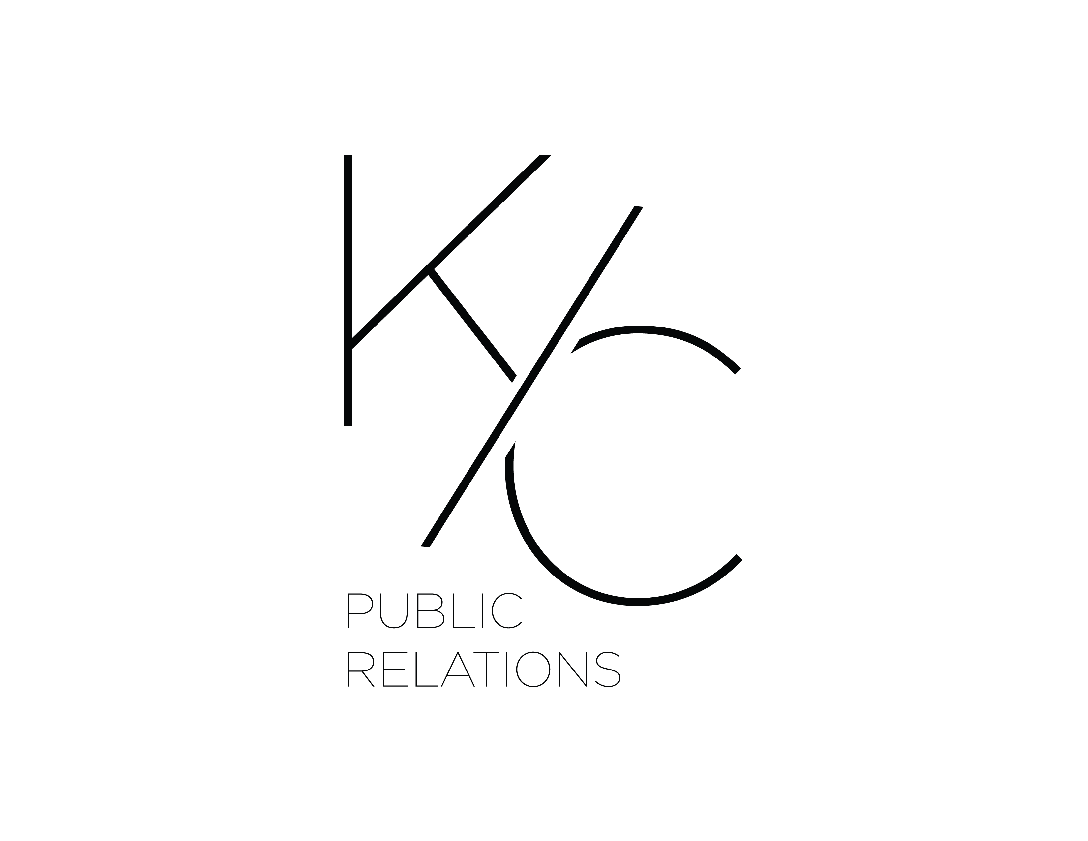
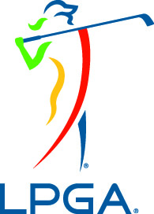

FOR IMMEDIATE RELEASE:

KC Public Relations Selected by LPGA to Handle U.S. Public Relations Initiatives

(New York, NY) - The Ladies Professional Golf Association (LPGA) has chosen New York based, KC Public Relations to spearhead their domestic public relations efforts throughout the 2018 season.

KC Public Relations (offices in Buffalo and New York City) will lead with their editorial, broadcast and lifestyle relationships. KCPR will recapture LPGA’s current audience, as well as audiences from parallel markets across sport, fashion and overall lifestyle.

“We are excited for this opportunity. Our team has a passion for golf and we are eager to not only bring the LPGA to the top of mind of viewers and readers, but to also shine a light on the LPGA’s elite players (professionally and off-course interests), and its affiliated foundations,” states Curtis Rogers, Co-founder of KC Public Relations.

"We are thrilled to be partnering with KC Public Relations," said Mark Lamport-Stokes, the LPGA's Director of Public Communications. "This alliance will not only give us a much-needed extra footprint in New York - the biggest media market in the United States - but also the opportunity to showcase the quality, personalities and lifestyles of our players in various media outlets."

The partnership between the LPGA and KC Public Relations will begin February 2018. For more information regarding KC Public Relations or LPGA, please visit www.KCPublicrelations.com and www.LPGA.com.

About KC Public Relations
A New York-based agency with a focus on public relations, brand ideation, digital influence, social media and event management to create and cultivate brand awareness. With offices in Buffalo and New York City, KC Public Relations focuses their efforts of fifteen plus years in crafting campaigns, messaging, and branding for both leading and challenger brands. KC Public Relations was voted a top ten agency by Expertise.com for 2018. Follow KC Public Relations on the web via: www.kcpublicrelations.com, www.facebook.com/KCPRofficial, www.twitter.com/KCPRofficial, www.instagram.com/kcpublicrelations.

About LPGA (Ladies Professional Golf Association)
The LPGA is the world’s leading professional golf organization for women. Founded in 1950, the association celebrates a diverse and storied membership with more than 1,700 members representing 29 different countries. With a Vision to inspire, empower, educate and entertain by showcasing the very best of women’s golf, LPGA Tour Professionals compete across the globe, while dedicated LPGA Teaching and Club Professionals (T&CP) directly impact the game through teaching, coaching and management. The Symetra Tour – Road to the LPGA serves as the official developmental tour of the LPGA, consistently producing a pipeline of talent ready for the world stage. The LPGA is headquartered in Daytona Beach, Florida. Follow the LPGA on its television home, Golf Channel, and on the web via: www.LPGA.com, www.facebook.com/lpga.official, www.twitter.com/lpga, and www.youtube.com/lpgavideo.

###

Contact:
Curtis Rogers
KC Public Relations
716.860.2331
curt@kcpublicrelations.com

