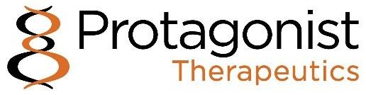

Protagonist Reports Fourth Quarter and Full Year 2024 Financial Results and Provides Corporate Update

$165.0 million icotrokinra (formerly JNJ-2113) milestone earned in Q4 2024, received in January 2025

PN-881, a potential best-in-class oral IL-17 receptor antagonist peptide nominated as a development candidate in Q4 2024

Top line results for rusfertide Phase 3 VERIFY clinical trial in polycythemia vera expected in March 2025

Top line results for icotrokinra Phase 2b ANTHEM clinical trial in moderate to severe ulcerative colitis expected in March 2025

Cash, cash equivalents and marketable securities of $559.2 million as of December 31, 2024, combined with $165.0 million milestone payment, anticipated to provide cash runway through at least end of 2028

NEWARK, Calif., February 21, 2025 – Protagonist Therapeutics (Nasdaq: PTGX) (“Protagonist” or “the Company”) today reported financial results for the fourth quarter and full year ended December 31, 2024, and provided a corporate update.
“Protagonist is quickly approaching multiple late-stage transformational events expected in the first quarter of this year, including the top line results from the VERIFY Phase 3 study of rusfertide in polycythemia vera and from the ANTHEM Phase 2b ulcerative colitis study of icotrokinra” said Dinesh V. Patel, Ph.D., the Company’s President and CEO. “In addition, we look forward to progressing oral IL-17 peptide antagonist PN-881 in clinical studies and nominating new development candidates from the oral anti-obesity and oral hepcidin programs this year. We are fortunate to be in a strong cash position, enabling the flexibility to progress these early-stage peptide drug candidates independently into pre-clinical and clinical proof-of-concept studies over the coming years.”

2024 Key Highlights
Worldwide License and Collaboration Agreement for Rusfertide with Takeda

- On January 31, 2024, the Company and Takeda announced a worldwide license and collaboration agreement for rusfertide (the “Takeda License and Collaboration Agreement”). We received an upfront cash payment of $300.0 million in April 2024 and are eligible to receive up to $330.0 million in development, regulatory, and sales milestones, for a potential deal value of up to $630.0 million, as well as an equal share of profits and losses in the U.S. and royalties on net sales outside the U.S.
- Under the terms of the agreement, we have the right to opt-out of the 50:50 profit share after NDA filing. In that event, we would be eligible to receive opt-out fees of up to $400 million and enhanced milestones of up to $975 million, as well as royalties on worldwide net sales. Takeda would maintain full ex-U.S. rights under either scenario.
Two articles published in the New England Journal of Medicine (“NEJM”) in February 2024
- On February 7, 2024, the icotrokinra Phase 2b FRONTIER 1 trial results in adults living with moderate-to-severe plaque psoriasis were published in the NEJM.
- On February 21, 2024, the complete Phase 2 REVIVE trial results for rusfertide, including efficacy and safety, were published in the NEJM.
S&P SmallCap 600 Index
- We joined the Index on July 3, 2024.
Icotrokinra: Oral IL-23 Receptor Antagonist

- Positive top line results for the Phase 3 ICONIC-LEAD and ICONIC-TOTAL studies in moderate to severe plaque psoriasis, were reported in Q4 2024.
- In the ICONIC-LEAD study, once-daily icotrokinra showed significant skin clearance versus placebo in adults and adolescents with moderate to severe plaque psoriasis. At week 16, nearly two-thirds (64.7%) of patients treated with icotrokinra achieved IGA3 scores of 0/1 (clear or almost clear skin), and 49.6% achieved PASI 90, compared to 8.3% and 4.4% on placebo, respectively. Further increases in response rates continued to be observed at week 24, with 74.1% of patients treated with icotrokinra achieving IGA scores of 0/1, and 64.9% achieving PASI 90. Safety data was consistent with the Phase 2 FRONTIER 1 and 2 studies.
- A similar proportion of patients experienced adverse events (AEs) between icotrokinra and placebo, with 49.3% and 49.1% of participants experiencing a treatment emergent adverse event (TEAE) at week 16. In addition, positive topline results from the Phase 3 ICONIC-TOTAL study showed once-daily icotrokinra met the primary endpoint of IGA of 0/1 at week 16 compared to placebo.
- The full data sets for each of these trials are expected at an upcoming major medical conference.
Nomination of PN-881, a potential best-in-class oral peptide IL-17 antagonist development candidate; additional discovery programs announced
- On November 21, 2024, we announced the nomination of PN-881 following extensive preclinical studies, including oral stability, potency, tissue distribution, and pharmacokinetics measurements, and evaluation in immunologic pharmacodynamics and preclinical efficacy models. PN-881 demonstrated in vitro blockade of IL-17 AA homodimer, FF homodimer and AF heterodimer. It demonstrated approximately 100-fold greater potency than secukinumab, and similar potency to the most potent approved antibody drugs and nanobody therapeutics currently in development.
- We expect to nominate an oral development candidate in the hepcidin mechanism-based hematology program in Q4 2025, and an oral peptide-based development candidate in the metabolic/obesity program in Q2 2025.
Achievement of a $165.0 million milestone

Under the terms of the icotrokinra license and collaboration agreement with J&J, as amended in November 2024, the Company earned $165.0 million in milestone payments during Q4 2024. The $165.0 million was received in January 2025.

Recent and Upcoming Milestones

Rusfertide
- Protagonist held an in-person PV Day on February 6, 2025, in New York; a replay of the webcast is available at https://lifescievents.com/event/protagonist/
- The top line data for the Phase 3 VERIFY study in PV, which has a 32-week primary efficacy endpoint, is expected in March of 2025.
Icotrokinra

- Top line results for the Phase 2b ANTHEM multicenter, randomized, placebo- controlled, dose-ranging study of icotrokinra for the treatment of moderately to severely active ulcerative colitis, are expected in March 2025.
- Top line results for the Phase 3 ICONIC-ADVANCE 1 and ICONIC-ADVANCE 2 superiority studies, evaluating the safety and efficacy of icotrokinra compared with both placebo and deucravacitinib in moderate to severe plaque psoriasis, are expected in Q2 2025.
- Further details of the Phase 3 ICONIC-LEAD and ICONIC-TOTAL studies are expected to be presented at major medical conferences this year.

Discovery Programs
- The Company expects to nominate an oral peptide-based development candidate in the obesity program in Q2 2025, and an oral development candidate in the hepcidin mechanism-based hematology program in Q4 2025.

Fourth Quarter and Full Year 2024 Financial Results

Cash, Cash Equivalents and Marketable Securities: Cash, cash equivalents and marketable securities as of December 31, 2024, were $559.2 million as compared to $341.6 million in the previous year.
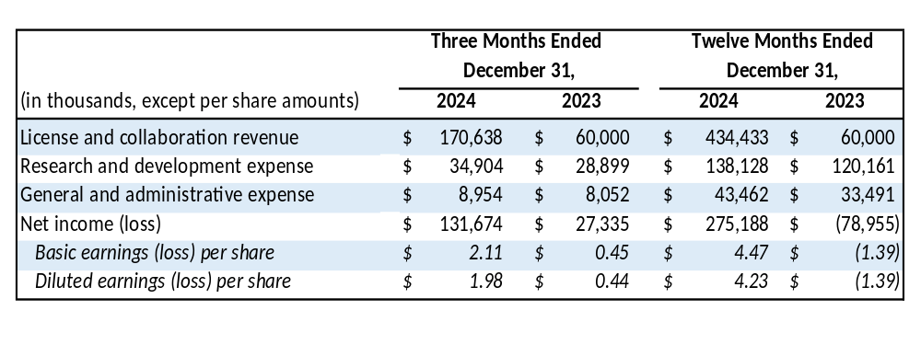
Revenue: License and collaboration revenue is derived from the Company’s License and Collaboration Agreement with JNJ, as amended in November 2024 (the “JNJ Agreement), and its Worldwide License and Collaboration Agreement for Rusfertide with Takeda which became effective in March 2024 (the “Takeda Agreement”). Total License and collaboration revenue increased by $374.4 million from $60.0 million for the year ended December 31, 2023, to $434.4 million for the year ended December 31, 2024. The increase was attributable to:

- Revenue recorded during the year ended December 31, 2024, pursuant to the Takeda Agreement, of 269.4 million; and
- Revenue from the JNJ Agreement which increased by $105.0 million for the year ended December 31, 2024, as compared to the prior year. The revenue reflects the achievement of non-refundable milestones of $165.0 million and $60.0 million for the years ended December 31, 2024, and 2023, respectively.

Research and Development ("R&D") Expenses: Increased by $6.0 million and $18.0 million for the fourth quarter and full year 2024, respectively, from the prior year periods. The increases were due primarily to increases in drug discovery and pre-clinical research expenses.

General and Administrative ("G&A") Expenses: Increased by $0.9 million for the three months ended December 31, 2024, from the prior year period primarily due to an increase in stock-based compensation. The increase of $10.0 million for the full year 2024 as compared to the prior year was primarily due to $4.6 million in one-time advisory and legal fees related to the Takeda Collaboration Agreement and an increase of $4.4 million in stock-based compensation and other personnel-related expenses.

Net Income (Loss): Net income was $131.7 million, or $2.11 per basic share and $1.98 per diluted share, for the fourth quarter of 2024 as compared to net income of $27.3 million, or $0.45 per basic and $0.44 per diluted share, for the fourth quarter of 2023. Net income was $275.2 million, or $4.47 per basic share and $4.23 per diluted share, for the full year 2024, as compared to a net loss of $(79.0) million, or ($1.39) per share, for the full year 2023.

About Protagonist
Protagonist Therapeutics is a discovery through late-stage development biopharmaceutical company. Two novel peptides derived from Protagonist’s proprietary discovery platform are currently in advanced Phase 3 clinical development, with New Drug Application submissions to the FDA potentially in 2025. Icotrokinra (formerly, JNJ-2113) is a first-in-class investigational targeted oral peptide that selectively blocks the Interleukin-23 receptor (“IL-23R”) which is licensed to J&J Innovative Medicines (“JNJ”), formerly Janssen Biotech, Inc. Following icotrokinra’s joint discovery by Protagonist and JNJ scientists pursuant to the companies’ IL-23R collaboration, Protagonist was primarily responsible for development of icotrokinra through Phase 1, with JNJ assuming responsibility for development in Phase 2 and beyond. Rusfertide, a mimetic of the natural hormone hepcidin, is currently in Phase 3 development for the rare blood disorder polycythemia vera (PV). Rusfertide is being co-developed and will be co-commercialized with Takeda Pharmaceuticals pursuant to a worldwide collaboration and license agreement entered into in 2024 under which the Company remains primarily responsible for development through NDA filing. The Company also has a number of pre-clinical stage oral drug discovery programs addressing clinically and commercially validated targets, including IL-17 oral peptide antagonist PN-881, oral hepcidin program, and oral obesity program.

More information on Protagonist, its pipeline drug candidates and clinical studies can be found on the Company's website at https://www.protagonist-inc.com/.

Cautionary Note on Forward-Looking Statements
This press release contains forward-looking statements for purposes of the safe harbor provisions of the Private Securities Litigation Reform Act of 1995. Forward-looking statements include statements regarding the potential benefits of icotrokinra and rusfertide, the timing of icotrokinra and rusfertide clinical trials, and timing of developments and announcements in our discovery programs. In some cases, you can identify these statements by forward-looking words such as "anticipate," "believe," "may," "will," "expect," or the negative or plural of these words or similar expressions. Forward-looking statements are not guarantees of future performance and are subject to risks and uncertainties that could cause actual results and events to differ materially from those anticipated, including, but not limited to, our ability to develop and commercialize our product candidates, our ability to earn milestone payments under our collaboration agreements with Janssen and Takeda, our ability to use and expand our programs to build a pipeline of product candidates, our ability to obtain and maintain regulatory approval of our product candidates, our ability to operate in a competitive industry and compete successfully against competitors that have greater resources than we do, and our ability to obtain and adequately protect intellectual property rights for our product candidates. Additional information concerning these and other risk factors affecting our business can be found in our periodic filings with the Securities and Exchange Commission, including under the heading "Risk Factors" contained in our most recently filed periodic reports on Form 10-K and Form 10-Q filed with the Securities and Exchange Commission. Forward-looking statements are not guarantees of future performance, and our actual results of operations, financial condition and liquidity, and the development of the industry in which we operate, may differ materially from the forward-looking statements contained in this press release. Any forward-looking statements that we make in this press release speak only as of the date of this press release. We assume no obligation to update our forward-looking statements, whether as a result of new information, future events or otherwise, after the date of this press release.

Investor Relations Contact
Corey Davis, Ph.D.
LifeSci Advisors
cdavis@lifesciadvisors.com
+1 212 915 2577

Media Relations Contact
Virginia Amann
ENTENTE Network of Companies
virginiaamann@ententeinc.com
+1 833 500 0061
PROTAGONIST THERAPEUTICS, INC.
Consolidated Statements of Operations
(Amounts in thousands except share and per share data)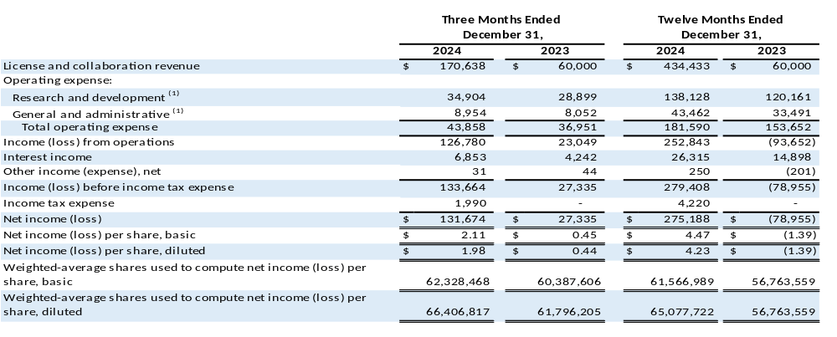

(1) Amount includes non-cash stock-based compensation expense.

Stock-based Compensation
(In thousands)

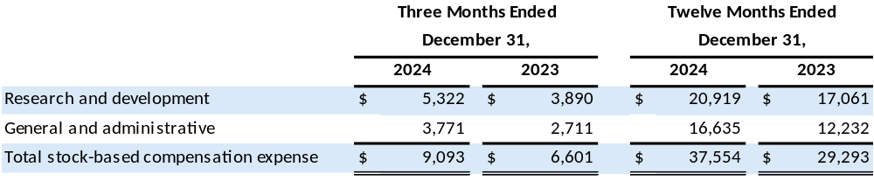

PROTAGONIST THERAPEUTICS, INC.
Selected Consolidated Balance Sheet Data
(In thousands)

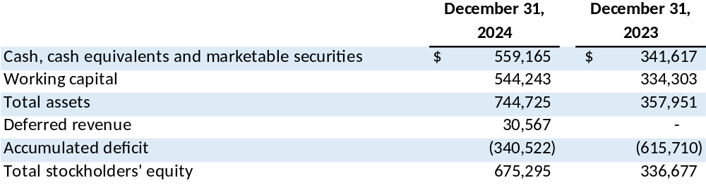

ICONIC-LEAD (NCT06095115) and ICONIC-TOTAL (NCT06095102)
VERIFY (NCT05210790)
ANTHEM (NCT06049017)
ICONIC-ADVANCE 1 (NCT06143878) and ICONIC-ADVANCE 2 (NCT06220604)

