

ASX ANNOUNCEMENT
FOR IMMEDIATE RELEASE TO THE MARKET
Li-S Energy Limited – ASX Code: LIS
Monday 28 October 2024
Li-S Energy achieves close to 500Wh/kg lithium-sulfur cell performance

Li-S Energy (ASX:LIS) is pleased to announce that it has substantially improved the performance of its lithium sulfur battery technology.
From its Phase 3 automated pouch cell production facility, LIS has manufactured full size 10Ah semi-solid-state cells delivering an energy density of 498Wh/kg on first discharge, and an industry leadingi 456Wh/kg after formation cyclingii, with the cells continuing to cycle in ongoing testing.
LIS is targeting the rapidly growing markets of drones, defence and electric aviation where weight is critical. For LIS partners and target customers, the higher energy density means an even lighter battery, further improving potential range, payload and operating time for partner products.
The cells delivering this breakthrough performance incorporate the LIS GEN3 semi-solid- state cell chemistry first announced in April 2023, which the Company has continued to enhance and develop.
In September, the Company delivered test cells to the first of its key partners to validate performance for aerospace battery packs integrating LIS cells and the new LIS developed intelligent battery management system.
Commenting on the impact for the drone and aerospace industries, Mr Mark Xavier, CEO of LIS partner V-TOL Aerospace said:
“V-TOL would like to congratulate LIS on this significant milestone achievement that has exceeded our expectations and initial requirements for our joint development of the Pegasus uncrewed air system.
We anticipate cell performance at this level will generate substantial global interest and opportunity for LIS across the drone, aerospace and defence sectors.“
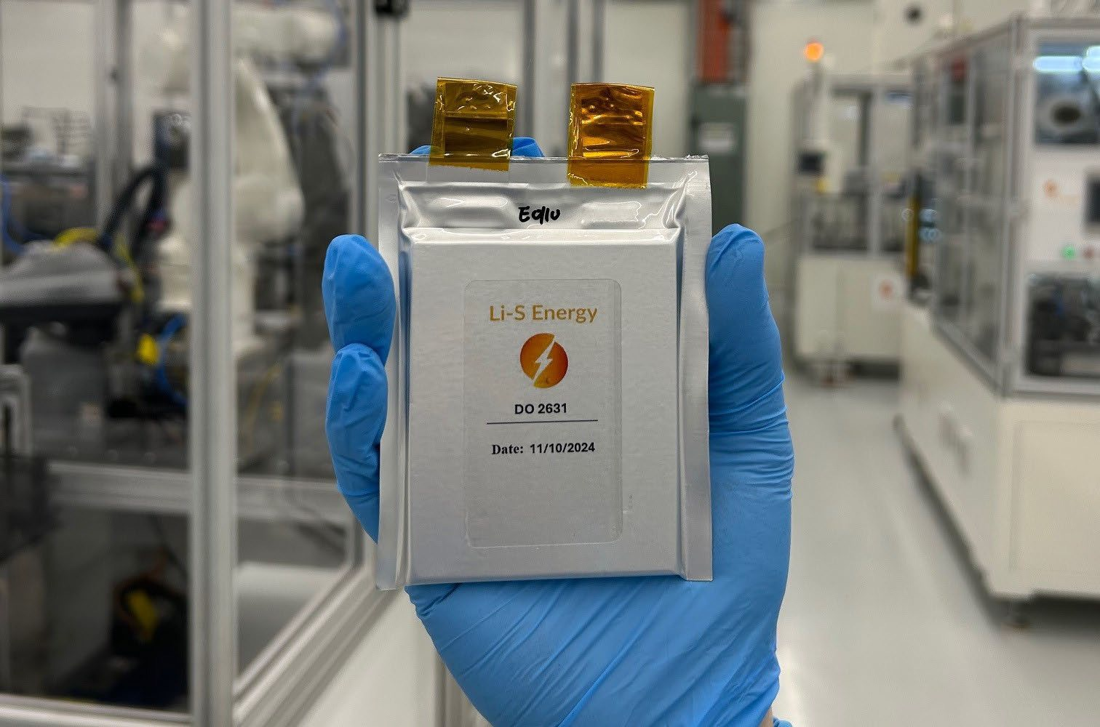
Li-S Energy 10Ah lithium sulfur cells are achieving breakthrough performance and have been delivered to the first of our key partners for battery pack testing
Dr Steve Rowlands, CTO of LIS commented:
"These results represent an important breakthrough for lithium sulfur cell chemistry. Reaching 456Wh/kg from 10Ah cells post formation places LIS at the global forefront of lithium sulfur performance.iii
Many R&D institutions and battery start-ups test performance on coin cells or very small pouch cells and publish energy density results from the cell’s first discharge, which is always significantly higher than its practical performance in the field.
At LIS we have taken a far more pragmatic and commercial approach, testing full size 10Ah and 20Ah pouch cells produced on our automated production line and reporting performance after formation cycling, which more faithfully represents the true cell performance when delivered to a customer.”
Dr Lee Finniear, CEO of LIS commented:
"This is a significant breakthrough for the nascent lithium sulfur battery industry.
Our partners in the aerospace, drone and defence industries have been clear that they need the highest possible energy density for their applications, plus reliable, high-quality cell production and a pathway to scale as demand grows.
Our strategy has been to deliver to this requirement, including building and commissioning Australia’s largest pouch cell production facility, which we refer to as Phase 3, that employs automated manufacturing processes that can scale to gigawatt hour production and beyond.
Today’s results are an early vindication of this strategy, setting a new benchmark in lithium sulfur performance. The Phase 3 facility empowers our team to innovate at pace, being able to rapidly iterate cell design, material optimisation and production processes at scale. Our partners appreciate not only our industry leading cell performance, but also our investment in the manufacturing infrastructure required to deliver the reliable, high quality cell production vital for their future success.
Over the coming months we expect to sign up more partners and assist them to integrate our cell and BMS technologies into their applications.”
With the Phase 3 production line now commissioned, LIS R&D and engineering teams are engaged in continuous production development to further enhance cell reliability, production accuracy and throughput, while our battery integration team is working with current partners on BMS and battery pack design.
For further information contact:
Ben Henri
Partner, Media and Capital Partners
M: +61 473 246 040
E: ben.henri@mcpartners.com.au

i Based on published test results from other companies on the performance of commercial-sized lithium sulfur cells produced using automated manufacturing processes.
ii “Formation cycling” is the process of charging and discharging a battery cell to activate its electrochemical components, during which energy density is permanently reduced due to the formation of a solid electrolyte interphase (SEI) layer that consumes lithium ions.
iii Based on published test results from other companies on the performance of commercial-sized lithium sulfur cells produced using automated manufacturing processes.

