
FOR IMMEDIATE RELEASE: 5/16/2022
LikeFolio Launches TickerTree – The “Rosetta Stone” For Financial Content
The database service allows client applications to connect brand names to company and ticker, empowering rich content tagging and stock discovery.
[Louisville, KY] Today LikeFolio launched TickerTree, a brand-to-company database service. The TickerTree database connects products and brands to their parent company. These connections help data-miners, content creators, and financial platforms accurately “tag” any content to the appropriate company and stock market ticker symbol.
“We built this tool for one reason: It doesn't exist elsewhere, and having it is critical to unlocking the hidden insights contained in the mountains of data we are ingesting.” says Andy Swan, Co-founder of LikeFolio. “For the first time, we are now making this ‘Rosetta Stone’ available outside of our walls.”

Features and benefits of TickerTree include:

- Content Tagging – TickerTree allows clients to tag any piece of content with each of its associated ticker symbols by identifying all of the mentioned brands and products.
- Reverse Stock Look Up – Reverse Stock Lookup enables a financial platform’s end-users to discover stock ticker symbols by searching for a brand or product name.
- Many more applications are possible with our flexible API returning results on over 100,000 keywords tied to 11,000+ brands in the growing brand-to-company database.

TickerTree is available now under an annual subscription model. For more information, visit tickertree.com.

About LikeFolio: LikeFolio, a Louisville-based company founded by Andy Swan and Landon Swan, uses social data to understand consumer behavior. It discovers and analyzes shifts in consumer preferences, buying habits, and sentiment by scanning social media for mentions of the brands, products, and major trends.
Contact information:
Andy Swan
LikeFolio
andy@likefolio.com
Reverse Stock Look Up
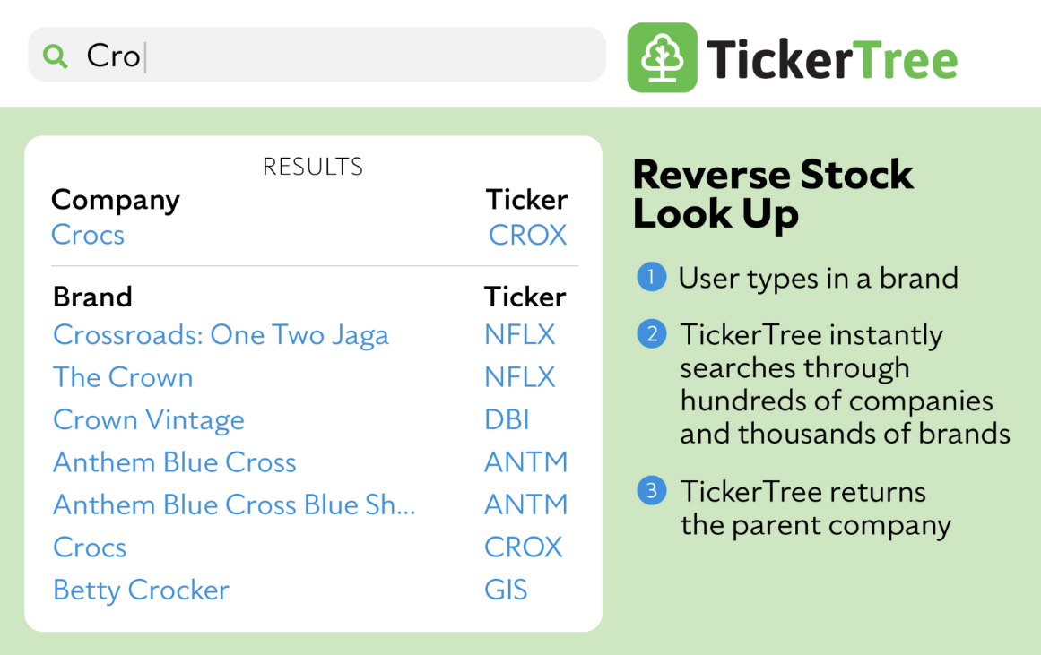

Tickerize Any Content
TickerTree allows you to tag any piece of content with all its associated ticker symbols.

