FOR IMMEDIATE RELEASE NEWS November 13, 2024 OTCQB: FTCO

FORTITUDE GOLD DRILLS 4.57 METERS GRADING 2.26 G/T GOLD AND 12.19 METERS GRADING 1.06 G/T GOLD AT COUNTY LINE

Colorado Springs, Colorado – November 13, 2024 – Fortitude Gold Corp. (OTCQB: FTCO) (the “Company”) announced multiple oxide gold drill intercepts at and near surface from the East Pit located on the County Line Property. Intercepts include 12.19 meters grading 1.06 grams per tonne (g/t) gold, 4.57 meters grading 2.26 g/t gold, and 0.67 meters grading 11.90 g/t gold. Fortitude Gold is a gold producer, developer, and explorer with operations in Nevada, U.S.A. offering investors exposure to both gold production and dividend yield.

East Pit drill highlights include (m=meters, g/t=grams per tonne) (full drill table below):

Hole# CLSN-24-004:
- 11.73 m of 0.81 g/t gold from surface
incl.
- 4.54 m of 1.23 g/t gold

Hole# CLSN-24-005:
- 17.53 m of 0.83 g/t gold from 0.76 meters
incl.
- 1.45 m of 2.48 g/t gold &
- 2.06 m of 1.50 g/t gold

Hole# CLRC-408:
- 16.76 m of 0.90 g/t gold from surface
incl.
- 1.52 m of 2.19 g/t gold &
- 3.05 m of 1.18 g/t gold

Hole# CLRC-409:
- 18.29 m of 0.67 g/t gold from surface
incl.
- 1.52 m of 1.16 g/t gold
- 4.57 m of 2.26 g/t gold
incl.
- 1.52 m of 4.69 g/t gold

Hole# CLRC-412:
- 12.19 m of 1.06 g/t gold

These latest County Line East Pit drill results build on previous results including 3.05 meters of 2.11 g/t gold within 38.10 meters of 0.75 g/t gold. This most recent program intercepted multiple intervals of oxide gold mineralization at and near surface. The East Pit is located approximately 500 meters southeast of the main County Line historic open pit. The Company targets 2025 County Line gold production from both pits, subject to federal Bureau of Land Management permit approval timing.

The County Line project is located approximately 26 kilometers northwest of the Company’s operating flagship Isabella Pearl gold mine via paved Nevada State Route 361. The Company targets County Line ore feed for its Isabella Pearl operation. The proximity of the two properties is expected to allow the trucking of ore from the County Line property to the Company’s Isabella Pearl Project with its existing heap leach pad and gold processing facilities. The Company targets the County Line project as its second Nevada gold mine as it moves the project through the permitting phase

“This latest County Line East Pit drill program consistently intercepted oxide gold mineralization at and near surface,” stated Mr. Allan Turner, Vice President of Exploration for Fortitude Gold. “Gold mineralization at the East Pit remains open to more exploration in multiple directions. We look forward to future drill programs to not only build on these results, but also to test undrilled nearby targets with a goal of adding additional gold resources at the County Line property.”

“It is exciting to see our County Line East Pit continue to deliver near surface and surface oxide gold mineralization which include gold pockets as high as 11.90 grams per tonne gold,” stated Mr. Jason Reid, CEO and President of Fortitude Gold. “We continue to push the project through the permitting phase and eagerly await permit approval to build our second mine. The Biden-Harris administration was brutal for business, and I am thrilled with the recent federal election results and the emanate return to a business-friendly federal administration. Our plan to leverage our nearby Isabella Pearl processing facilities and mine County Line as an aggregate operation, trucking ore a short distance down the highway, should allow us to move this project into production on an expedited basis once we receive all regulatory approvals.”

COUNTY LINE EAST PIT
NOVEMBER 2024 DRILL SUMMARY HIGHLIGHTS
Hole # | Angle |  | From | Interval | Au
Hole # | deg |  | Meters | Meters | g/t
CLSN-24-001 | -90 |  | 0.00 | 9.75 | 0.76
CLSN-24-001 | -90 | incl. | 2.13 | 0.91 | 2.32
CLSN-24-001 | -90 |  | 16.22 | 2.53 | 1.06
CLSN-24-0002 | -90 |  | 0.00 | 9.22 | 0.63
CLSN-24-0002 | -90 | incl. | 8.11 | 0.70 | 1.68
CLSN-24-0002 | -90 |  | 14.57 | 0.67 | 11.90
CLSN-24-0002 | -90 |  | 23.39 | 1.75 | 2.14
CLSN-24-003 | -90 |  | 0.00 | 1.52 | 0.54
CLSN-24-003 | -90 |  | 2.13 | 1.19 | 0.35
CLSN-24-004 | -90 |  | 0.00 | 11.73 | 0.81
CLSN-24-004 | -90 | incl. | 0.00 | 4.54 | 1.23
CLSN-24-004 | -90 |  | 12.68 | 2.96 | 0.36
CLSN-24-004 | -90 |  | 17.07 | 10.36 | 0.56
CLSN-24-005 | -90 |  | 0.76 | 17.53 | 0.83
CLSN-24-005 | -90 | incl. | 11.00 | 1.45 | 2.48
CLSN-24-005 | -90 | incl. | 13.18 | 2.06 | 1.50
CLRC-405 | -74 |  | 0.00 | 12.19 | 0.40
CLRC-405 | -74 |  | 19.81 | 6.10 | 0.32
CLRC-406 | -55 |  | 0.00 | 22.86 | 0.54
CLRC-407 | -68 |  | 0.00 | 18.29 | 0.63
CLRC-407 | -68 | incl. | 0.00 | 1.52 | 1.05
CLRC-407 | -68 | incl. | 16.76 | 1.52 | 1.11
CLRC-408 | -78 |  | 0.00 | 16.76 | 0.90
CLRC-408 | -78 | incl. | 7.62 | 1.52 | 2.19
CLRC-408 | -78 | incl. | 12.19 | 3.05 | 1.18
CLRC-409 | -68 |  | 0.00 | 18.29 | 0.67
CLRC-409 | -68 | incl. | 0.00 | 1.52 | 1.16
CLRC-409 | -68 |  | 21.34 | 4.57 | 2.26
CLRC-409 | -68 | incl. | 21.34 | 1.52 | 4.69
CLRC-410 | -43 |  | 0.00 | 27.43 | 0.50
CLRC-411 | -90 |  | 0.00 | 6.10 | 0.50
CLRC-411 | -90 |  | 9.14 | 4.57 | 0.46
CLRC-411 | -90 |  | 18.29 | 1.52 | 1.16
CLRC-411 | -90 |  | 41.15 | 1.52 | 1.08
CLRC-412 | -75 |  | 0.00 | 7.62 | 0.42
CLRC-412 | -75 |  | 10.67 | 12.19 | 1.06
Assays by American Assay Laboratories, Sparks, Nevada, USA.
Meters downhole, not true width.

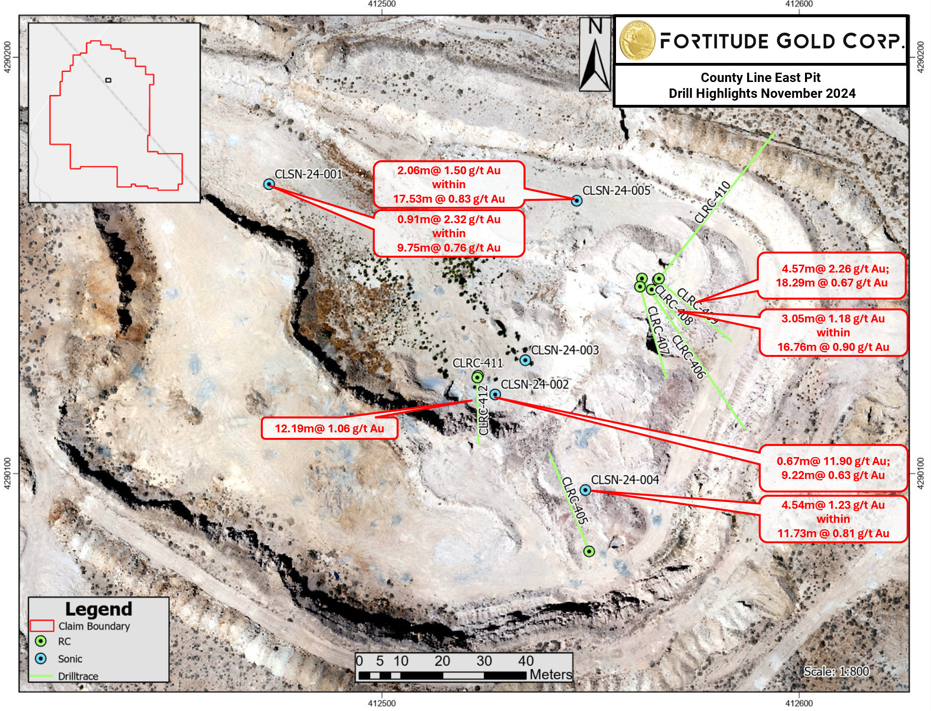

About Fortitude Gold Corp.:

Fortitude Gold is a U.S. based gold producer targeting projects with low operating costs, high margins, and strong returns on capital. The Company’s strategy is to grow organically, remain debt-free and distribute substantial dividends. The Company’s Nevada Mining Unit consists of seven high-grade gold properties located in the Walker Lane Mineral Belt and an eighth high-grade gold property in west central Nevada. The Isabella Pearl gold mine, located on the Isabella Pearl mineralized trend, is currently in production. Nevada, U.S.A. is among the world’s premier mining friendly jurisdictions.

Cautionary Statements: This press release contains forward-looking statements that involve risks and uncertainties. If you are risk-averse you should NOT buy shares in Fortitude Gold Corp. The statements contained in this press release that are not purely historical are forward-looking statements within the meaning of Section 27A of the Securities Act of 1933 and Section 21E of the Securities Exchange Act of 1934. When used in this press release, the words “plan”, “target”, "anticipate," "believe," "estimate," "intend" and "expect" and similar expressions are intended to identify such forward-looking statements. Such forward-looking statements include, without limitation, the statements regarding the Company’s strategy, future plans for production, future expenses and costs, future liquidity and capital resources, and estimates of mineralized material are forward-looking statements. All forward-looking statements in this press release are based upon information available to the Company on the date of this press release, and the Company assumes no obligation to update any such forward-looking statements. Forward looking statements involve a number of risks and uncertainties, and there can be no assurance that such statements will prove to be accurate. The Company's actual results could differ materially from those discussed in this press release.

Contact:
Greg Patterson
719-717-9825
greg.patterson@fortitudegold.com
www.Fortitudegold.com

