Guest Speakers at “Fall Into Balance” – August 27, 2016


Kelly Hill


Sarah Calhoun

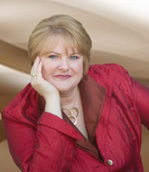
Cynthia Stott

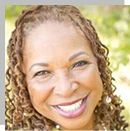
Brandy Jones

