Celebrity marketing as the most successful way to boost your business

Pros and cons of celebrity marketing
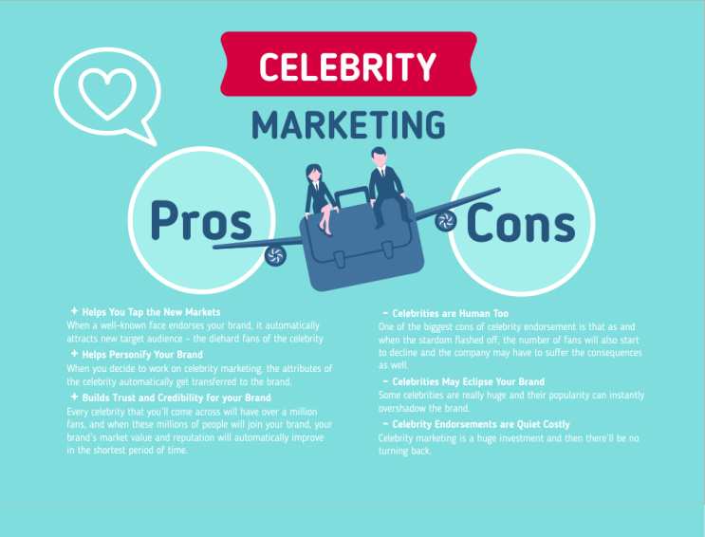
The 21st century is an era of gift suite. Everybody tries to sell his own services as beneficial as possible. That’s why a trademark has to be reliable, bright and competitive if the purpose is to be a success in business. So what’s the secret of the wealth and prosperity? It’s a celebrity marketing!
How does this mechanism work? Nothing difficult. People believe their celebrities, especially if these persons are down-to-earth and really enjoy speaking to the community. If the idea is to make a beneficial deal with such star, the goods will be advertised by him and an entrepreneur will get a lot of new clients, who adore their idol and are ready to follow him everywhere and in everything. But the customer shouldn’t forget about the negative side of the deal too. First of all, if the high-level celebrity was chosen, a lot of money will be paid for his service. Very seldom are stars ready to collaborate for free. For sure they’ve become famous in order to earn a lot of money, so this fact will be kept in mind. In addition to this, the glory of celebrity is not a stable thing, so there is nothing surprised if the percent of sales will fall down one day. So, this sphere of marketing shall be used with care and try to get as much benefits as possible.

Trustworthiness to the superstar
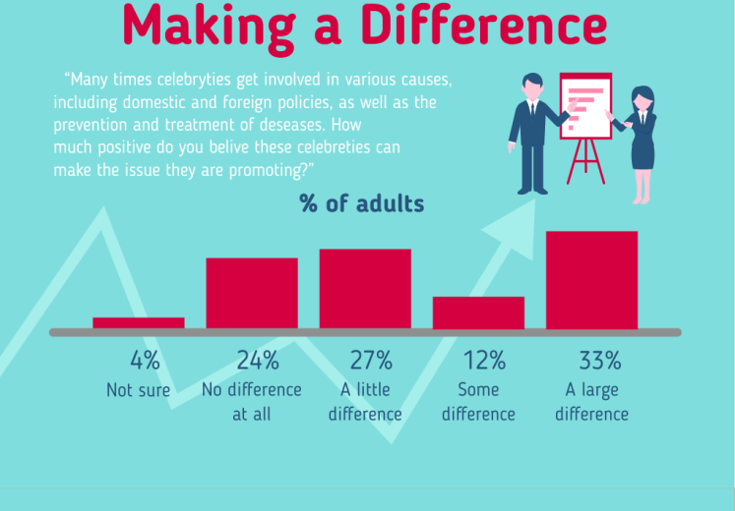
But, while dealing with celebrity marketing, it’s common knowledge that the final appraiser of the result is the customer. So the businessman can pay a lot of money to Sylvester Stallone, for example, in order to advertise whiskey, but nobody can guarantee the success of the deal. So, before signing any contracts everybody thinks about the various possibilities. So, before subscribing a contract should be considered carefully. Let’s look and see what the research data tells us. Only a small percentage, 4%, is uncertain that the presence of a celebrity in an advertisement really makes a difference. About 24% of people think that there is no difference between advertisement with superstars and without them. Sometimes this is true, particularly in local advertising. Approximately 12% of adults think that the difference can be found, but they can’t estimate the importance of it – is the difference big or not. Probably such kind of people just watches TV seldom and they just have nothing to compare with. And finally, 33% of customers are sure that the difference between an advertisement with celebrities and without them exists, and this difference is really huge. And they are true! Let’s observe an example, the advertising company of celebrities “Don’t vote” in 2008. Such superstars as Will Smith, Harrison Ford, Snoop Dog, Sarah Jessica Parker and etc. were trying to convince people not to vote. Of course it was done sarcastically and the focus was actually to get people to vote and they used the “Don’t vote” to suggest such thinking was silly. They were not trying to convince people to not vote but in fact to get out and vote. Though they were supposed to say “don’t vote” they said that was stupid and ended up telling people to get out and vote. Here’s the point which everybody really might want to make here. They used their celebrity status to make the point that not voting was the wrong thing to do and they went so far as to not follow the instructions of the director. As we have see proved, celebrity marketing is a real power.

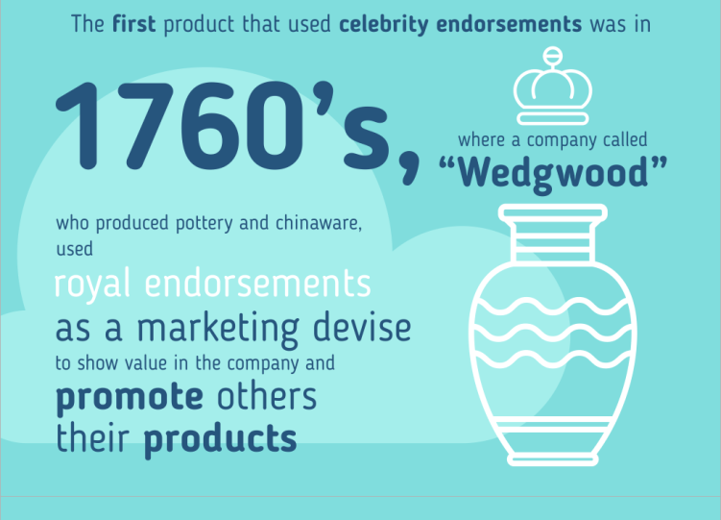
The history of celebrity marketing
Celebrity marketing is so effective that the history of usage of this hint is rather long. Only few people know when celebrity endorsement, the peculiarity of modern advertisement, was used for the first time. In 1760! Now this company is a conventional leader in its sphere of production. The name of it is… Wedgwood! In the second half of 18th century “Wedgwood” was producing pottery and chinaware. In order to declare himself, Josiah Wedgwood decided to use royal endorsements as a sort of marketing device in order to demonstrate a value of his company and promote others their products. So, was this trick of marketing successful? Yes! Great Britain was a powerful empire, and the huge part of Earth was covered with its net of influence. Citizens of all the colonies knew about the goods of “Wedgwood” and could buy them for beneficial conditions. And now imagine the abilities of the 21st century when the Earth is covered with the Internet and your advertisement in the sphere of celebrity marketing can be seen everywhere!

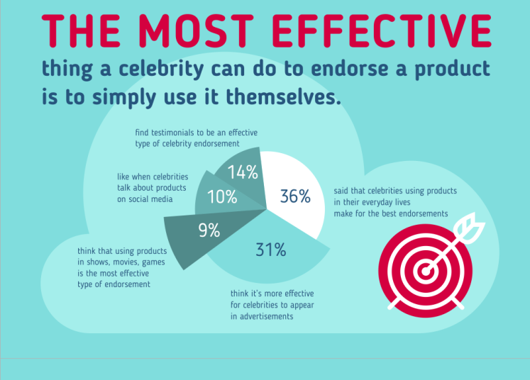
How to endorse your product?
So, the entrepreneur has strongly decided to use celebrity marketing strategy in your advertisement. It’s easy to predict that everybody’ll be shocked by the number of approaches to the deal. It’s common knowledge that the most effective and simple way is the use of the good by the celebrity himself. For sure the product must be qualitative and must correspond to the strict requirements of the beau monde, but the result is really terrific! Only 9% of customers think that the most effective way of endorsement is using your products in various shows, events, etc. About 10% of customers like it when celebrities are talking about products in social media. Approximately 14% of customers think that testimonials are the guarantee of high-qualified advertisement. And finally, 36% of customers said that when celebrities use the product in their daily life, that makes for the best advertisement of a product. Firstly, if a superstar uses a pan, the pan works! Secondly, if the pan is used every day, it means that this product is convenient, because nothing can make us use products which are out of favor. Moreover, a target audience will see the product with the star everywhere, on different events and in daily business. And finally, if a significant percentage of people believe in the success of this feature, it means that this hint can be used successfully.

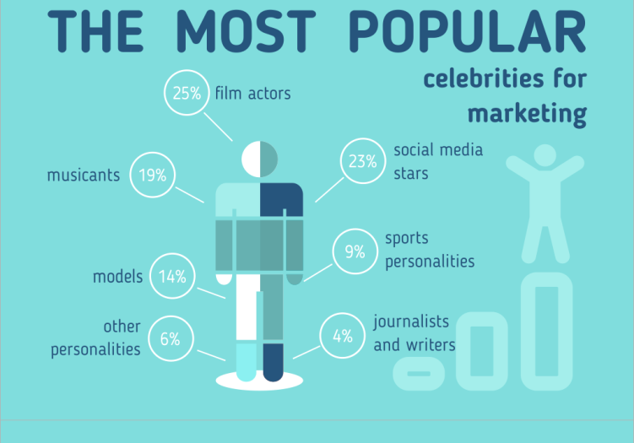
Who is the most popular?
Now it’s the time of the discussion of the financial question and imagine that the budget is big enough. In which sphere can be found a future partner for the advertisement? It’s difficult to argue with the 25% of customer who believe that actors are the best choice for celebrity marketing because such charismatic and talented people like Leonardo DiCaprio, Jim Carrey, Gordon Levitt can rivet an attention. If the quality of the product is high enough, it can become a success in a minute! About 23% of customers think that the popularity belongs to social media stars. They are right again, because the influence of social media nowadays is even wider and brighter than TV. Successful YouTube streamers, social media influencers and others can share their emotions in Facebook, Twitter and, of course, Instagram. The third position with 19% belongs to the musicians. And they receive it by right! The moment when your heart and soul are subdued by the charming sounds of saxophone can not be described by the words. About 14% of adults are sure that models are the only thing what is needed in the sphere of advertisement. Sports play a great role too. The USA is powerful and competitive on the international scene, the USA has even won the Olympic games in Brazil! That’s why sport personalities are very popular in the country, and a lot of money can be earned with their help.

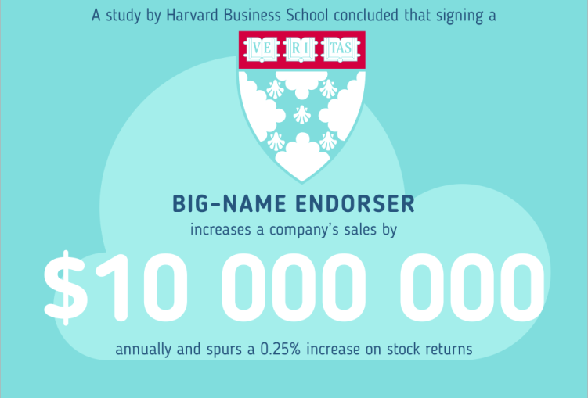
The end justifies the means.
The financial part of the deal is very important, and an entrepreneur has to spend a lot of money in order to make his advertisement unforgettable and qualitative. Some statistics taken from the Harvard Business School state that the use of big-name endorser increases a companies’ sales by $ 10, 000, 000 annually! The mountains of dollars! And even more, stock returns will be also spurred a 0.25% increase. In this sphere of business the end justifies the means and a businessman has to spend in order to grow.

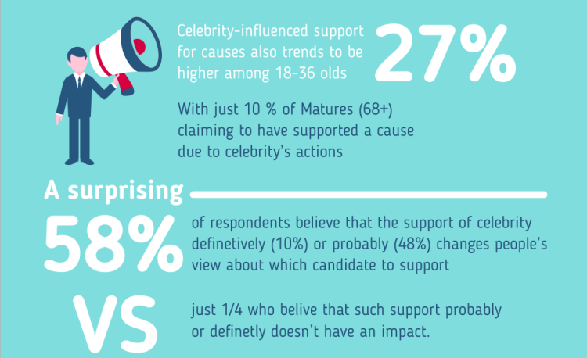
Thinking about the audience is the key to success
Every businessman is interested to widen the audience as much as possible. But this task is rather difficult. All the humans can be subdivided into various groups according to the various things, and the most important is the age. Advertisers who want to be successful attempt to create advertisements, which are interesting to children, teens and older adults. The percent of satisfied matures cannot be high, because in total their interests are very peculiar – only 10% of 68+ are supported by the advertisement. So, the sphere must not be broaden a bit, because nobody cannot be powerful everywhere – the power must me concentrated. Among 18-36 year olds, celebrity marketing is effective about 27% of time, which is very significant. Such celebrities could be anything from beautiful model or majestic film starts. In order to make a product competitive, a lot of money should be spent for advertisement and a great celebrity as a partner shall be found. About 58% of respondents believe that celebrities change their life a lot.

