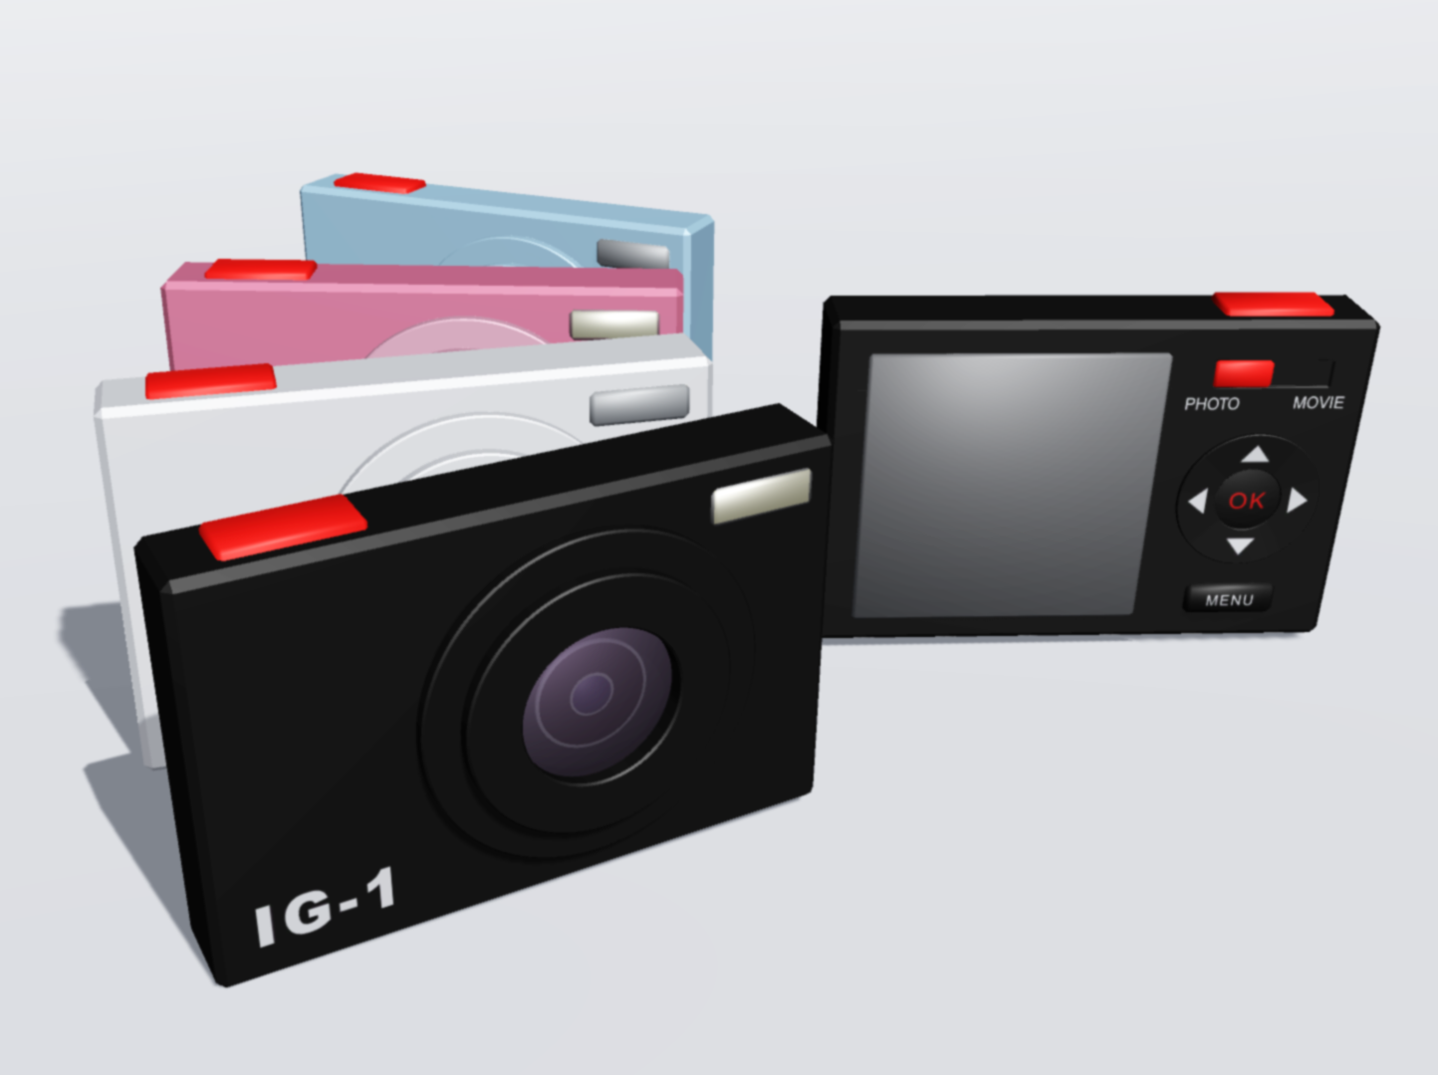
IG-1
The world's first digital camera that can upload its works DIRECTLY to Instagram

IG-1 is the world's first digital camera that can directly upload photos and videos to Instagram on its own. It does not require a smartphone to share your favorite photos or videos on Instagram. IG-1 features a built-in SIM Card Slot and Wi-Fi. This camera connects to Instagram directly the same way as smartphones up to 3G, 4G networks or Wi-Fi.

Compared to smartphones, IG-1 can provide:
- overwhelming higher quality images
- easier viewing and user friendly interfaces specialized in shooting photos and movies
- more shooting mode options to capture a variety of scenes in the best way possible
- additional processing effects not provided by Instagram

The latest version of the Android operating system (OS) is installed in this camera. Posting images on Instagram from IG-1 is as simple as doing it by smartphone. There is a Touch Panel LCD Screen on the back of the camera. You can operate it by touching the LCD panel or a Navigation Ring located on the right side of the LCD panel.

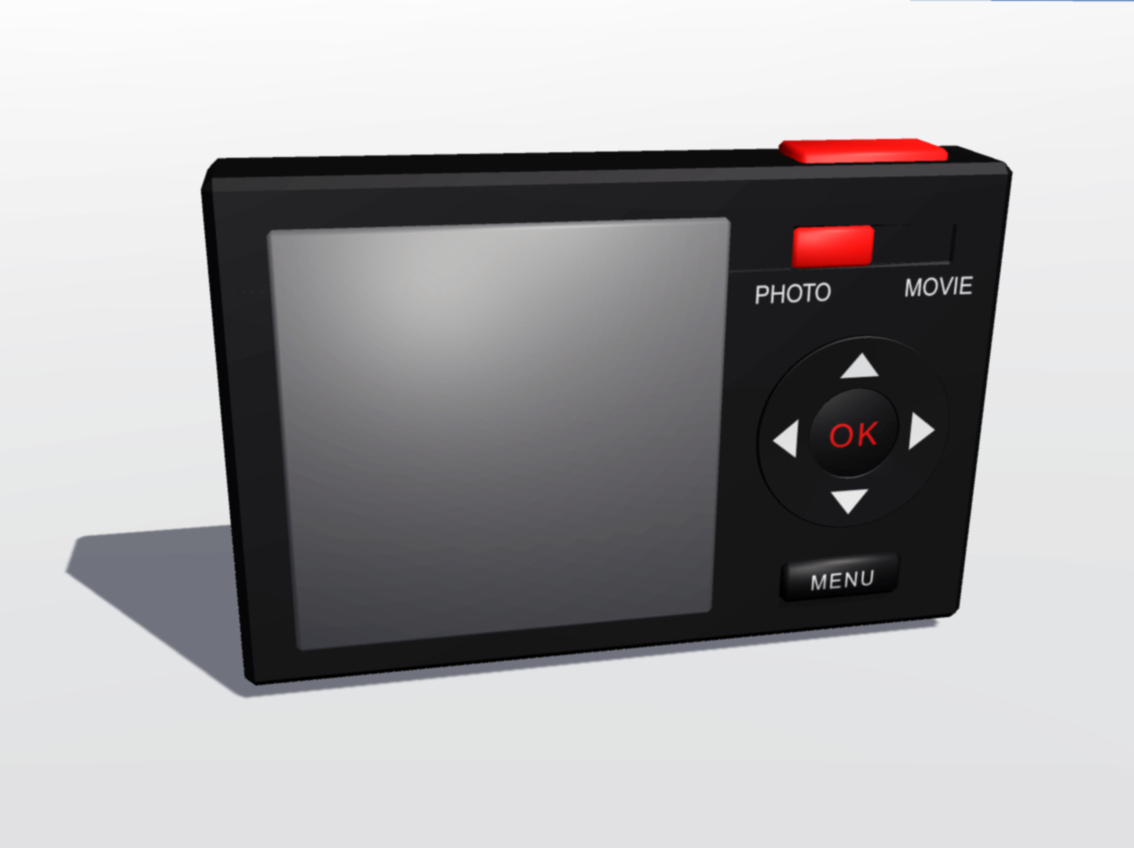
NOTE: Actual product may vary slightly from these images.

Why use the IG-1 instead of a smartphone?

The latest smartphones are equipped with a built-in camera comparable to a digital camera but those models of smartphones are high-priced. Their camera functionalities are only accessories. IG-1 users can access the full functions of the latest digital cameras. So, you can enjoy making beautiful pictures to the fullest extent along with adjustments including composition, level/direction of light, weather situations and more.

IG-1 offers you a better Instagram experience. This is also a great opportunity for those who are using an older-model smartphone which has insufficient camera functions and/or slow data speeds. IG-1 is $499 (USD). (The special price of $299 (USD) is available during this campaign!) Since IG-1 is so inexpensive, you can have the latest camera functions and upload environments for Instagram with lesser expense than buying the newest-model smartphone.

More Features and Functions of IG-1

- Cinematography functions at 4K (resolution) with the number of pixels exceeding the newest-model smartphone cameras.
- The high-brightness LCD panel is easy to see even exposed to bright outdoors including direct sunlight.
(Haven't you ever had difficulty viewing a photo you’ve just taken on your smartphone because of its low-brightness LCD?)
- Pure and simple interfaces are easy to understand for everyone. Unnecessary functions are eliminated and focused on the Instagram use.
(For instance, asking someone to take anniversary photos won't be a problem because it is easy to use and not complicated for anyone!)
- A bright large aperture lens and wide-angle optical zoom (allows capturing a much wider range).
- The LED flash with high brightness.
- A big and solid shutter button is easy to press. Shooting becomes very easy with this design.
- The advanced technology of the Anti-Shake feature helps you to take steady photos and movies.
- Compatible mounting adaptation to standard camera tripods.
(Is there any smartphone that can be mounted on a standard camera tripod? Unfortunately, there are none so far.)
- In addition to sharing your photos and videos on Instagram, IG-1 can save them to its built-in microSD card. You can also save them on your PC and easily print your favorite photos by your own printer at home.
- Convenient functions including the self-timer for taking anniversary photos and Selfies.
- The compact design is lightweight, convenient and easy to carry.
- An all-day lasting durable battery.
- Four options of camera body-color (choose from Black, White, Pink, and Sky-blue)
(Please note; Pink and Sky-blue are only available through an exclusive pre-order sale in limited quantities during this campaign.)
- Although there is a built-in SIM card slot, this device is not compatible with phone calls.
(If we receive heavy demands, we may consider adding a phone call function which will require the use of Earset Microphone and Skype. However, we are dedicated to offering you the very best experience in making photographs and/or movies through this digital camera "IG-1".
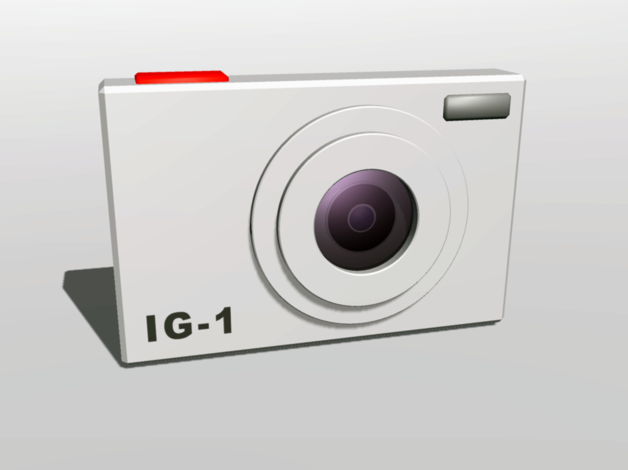
NOTE: Actual product may vary slightly from these images.
We the team Japan will provide "IG-1" with amazing features in the supreme quality along with Japan's digital camera manufacturing technology.

IG-1 release is scheduled to be at the end of this year (2016).
Please consider IG-1 as an organization for your Instagram Life!

About Us：
Our company, HM-Labo LLC, is involved in digital product research, development and marketing. Primarily, we are focusing on the research and development of artificial intelligence and robotics, including the development of gaming and robotic technologies. We provide digital products that can make people's lives more prosperous and convenient.

In order to conduct the development and sales of the digital camera "IG-1" which is specifically for Instagram, we will start this campaign via Indiegogo from the April 25th (Monday).

As a special offer for early participants of this campaign, we provide quantities of 100 units in Pink or Sky-blue each of the special color IG-1. This special offer is available on a first-come-first-served basis while supplies last.

