BLUETTI'Gift Ideas for Mother's Day
Flowers and chocolates are never a bad choice for this Mother's Day (Sunday, May 8), but if you want something special, you're in luck. BLUETTI has rounded up some gift ideas on this day to make her smile from ear to ear.
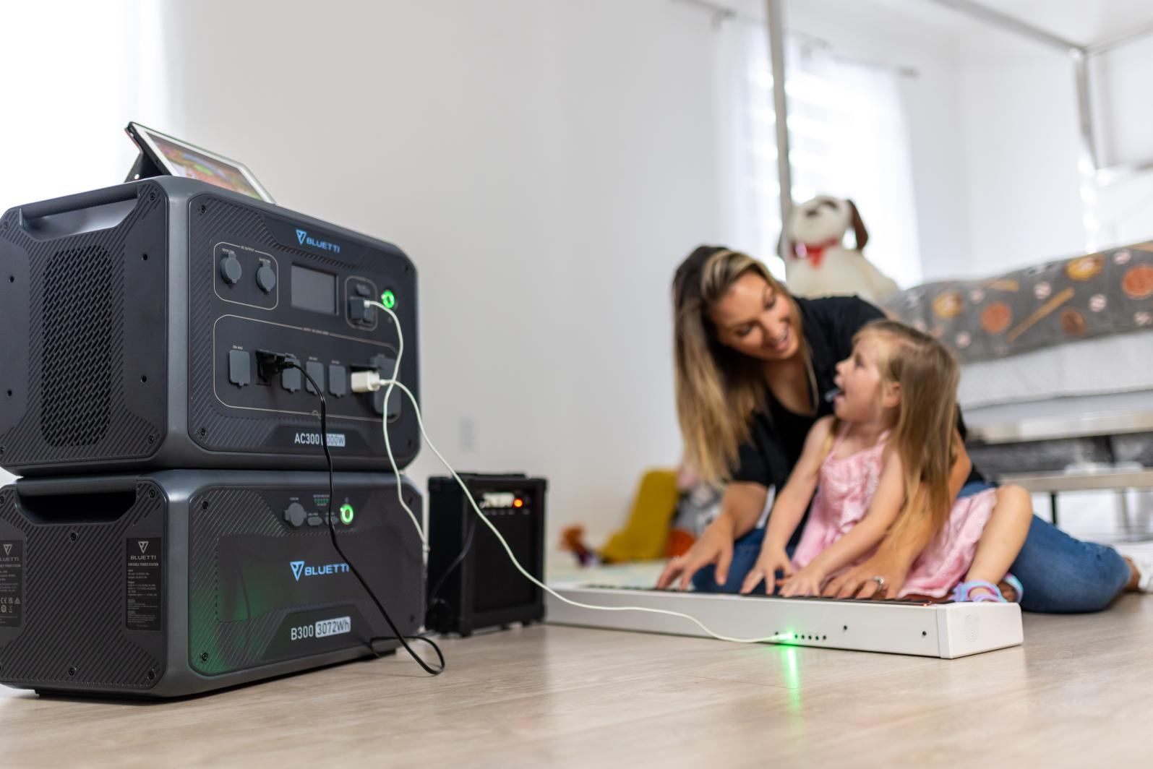
AC300+B300 Combo- An Expandable Power Center
($3,499, was $3,798)
If you've got a mom who likes RV trip or camping, she definitely loves this combo. AC300 is 100% modular without built-in battery and can be connected with up to 4 B300 battery packs to reach a 12,288Wh capacity. The 3000W Pure Sine AC inverter is built for running high-load devices. The BLUETTI Fusion Box Pro can combine 2 such units in series and even boost to a massive 24,576Wh/ 6000W/ 240V, covering all her power needs along the road.

EP500/EP500Pro-The New Era of Home Power Backup
(EP500-$4,399, was $4,599; EP500Pro-$4,999, was $5,999)
Mom does most housework at home. Unexpected power failure will drive her crazy. The EP500/EP500Pro solar generator should be on the top list when choosing a residential emergency power supply. Give mom convenience to enhance her woman power. By connecting with Bluetooth or WiFi, remote control can be easily done on cellphone! Release mom's stress and prepare for outage anytime.

AC200MAX-Versatile Power Monster
($1,899, was $1,999)
Mother's Day is a chance to set aside time and have a family gathering. Place an AC200MAX by the table to make the happy hour with mom last longer. The AC200MAX is one of the most popular models in BLUETTI Store. It features 16 outputs to run multiple devices at once. The upgraded LifePO4 battery provides 3500+ life cycles and it can be recharged in 7 ways, the maximum 1400W input rate allows it to top up to full within 2 hours!

EB70S-Pack Lighter, Travel Further
($549, was $599)
It's highly competitive in terms of portability, which will surprise her at the first glance. The easy-to-carry handle is ergonomically constructed to save her hassle when moving from one place to another. Simply hook up with BLUETTI solar panels PV120 or PV200 to make it a remarkable power source with endless green energy. An ideal gift to splurge on mom.

Plus, BLUETTI will launch a #BLUETTIwithMom campaign on Mother's Day, inviting members to share photos and the sweetest moment/story with their mom, and to win a free BLUETTI power station. Follow BLUETTI on Instagram to learn more.

About BLUETTI
With over ten years of experience in the energy storage industry, BLUETTI is committed to building the world's best power stations for van dwellers, explorers, and off-grid life. For more information, please visit https://www.bluettipower.com/

Press Contact
amanda@bluetti.com
Other Enquiries
service@bluettipower.com

