FOR IMMEDIATE RELEASE:
Contact:
David Chalker – President, Sun BD Corporation
2028 Leader Rd.
Waterloo, New York 13165
www.sunbdcorp.com
sunbdcorp@gmail.com
Phone: 1-315-651-8821

Waterloo, NY – Effective February 1, 2018

The Sun BD Corporation, the largest U.S.A. manufacturer of hybrid solar electric ovens, announced today its latest innovation, the UGLI™ hybrid solar electric oven. “What’s really special about the UGLI™ hybrid solar electric oven is that its outer case is made entirely from cardboard. It is a first of its kind design for hybrid solar electric oven.” said David Chalker, Sun BD Corporation’s President.

“Our goal for the UGLI™ hybrid solar electric oven was foremost safety, secondly superior cooking capability and last affordability and the UGLI™ hybrid is all of that and more, said Chalker”.

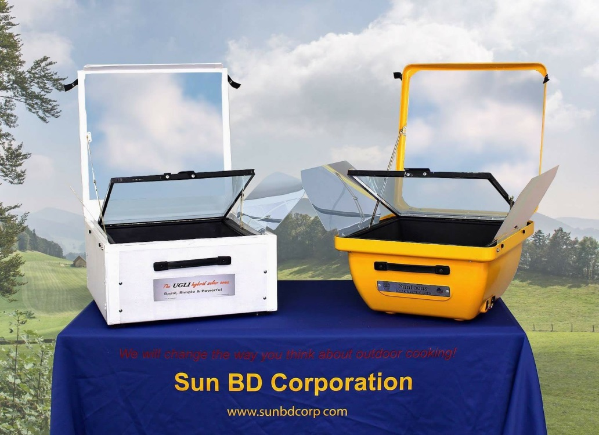

Inside every UGLI™ hybrid is the same proven technology used in our World-class SunFocus® hybrid solar electric oven that Sun BD Corporation’s customers have been enjoying since 2010. The Sun BD Corporation is located in the Finger Lakes Region of New York State and has been selling and manufacturing hybrid solar electric ovens for North America markets since 2004.

