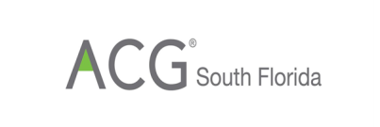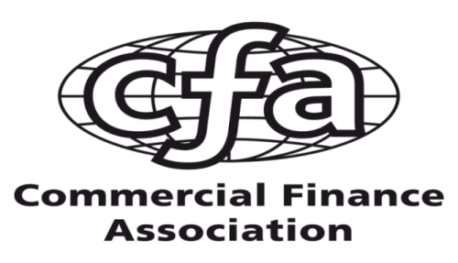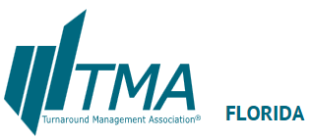

The South Florida Chapter of the Commercial Finance Association Invites you to
Vitner Talks Economy
A special luncheon presentation - Mark Vitner, Managing Director,
Sr. Economist, Wells Fargo Securities LLC

Wednesday April 18, 2018
11:30am registration, with program commencing at 12:00pm
Lauderdale Yacht Club
1725 SE 12th. Street
Ft. Lauderdale FL 33316

$40 CFA, ACG, TMA Members in advance
$55 Non Members and all at door

Event Sponsorship Available
$175, includes 3 entries to event
(contact Roger Welker - rwelker@merchantfactors.com or 954-441-1453)

DIRECT LINK TO REGISTRATION PAGE HERE
www.cfa.com/florida

Mark Vitner, Managing Director, Sr. Economist, Wells Fargo Securities LLC

The Program
11:30 Registration and networking
12:00 seating for luncheon
12:15-1:00 Panel Discussion
1:00-1:30 Q&A and networking

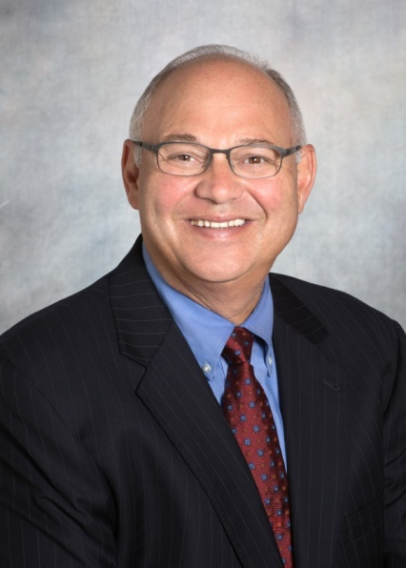Mark Vitner
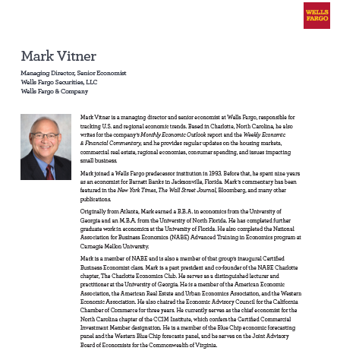

What are the Commercial Finance Association and its South Florida Chapter?
The Commercial Finance Association's South Florida Chapter is the trade group for commercial finance companies, factors, banks and other financing agencies engaged in the lending and financial services industry. We are a Regional Chapter of the Commercial Finance Association; the CFA serves the financial services industry on an international, national, regional, and local basis. The Commercial Finance Association's South Florida Chapter is comprised of professionals with great insight and experience. Each member brings their expertise to the Chapter providing excellent stewardship, information, and valuable experience for association members. Our members take pride in bringing their quality programs, precious contacts and more to the financial services industry.
South Florida Chapter Annual Sponsors
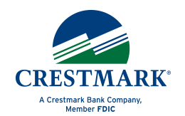

CFA South Florida Chapter is the trade group for commercial finance companies, factors, banks and other financing agencies engaged in the asset-based financial services industry of South Florida (Palm Beach, Broward and Miami-Dade Counties). We are a Regional Chapter of the Commercial Finance Association, serving the asset-based financial services industry on an international, national, regional, and local basis.

Become A Member - Join CFA Today

As a member of the CFA you are able to stay connected, educated, & informed in the asset-based lending and factoring industries. Members also have access to numerous tools and resources that allow you to connect and network with industry leaders. Join CFA Florida for 2017.
CFA Chapters offer individual membership to professionals working, associated, or interested in the asset-based lending or factoring industry. Membership benefits include:
- Discounted registration to CFA Chapter events
- Subscription to The Secured Lender, CFA's Industry leading magazine
Employees of CFA Corporate members are eligible for a discounted membership rate. Our current membership dues are: Corporate Members: $125; All others: $150. Your membership gives you member pricing for all CFA South Florida events.
https://cfa.connectedcommunity.org/floridachapter/events/eventdescription?CalendarEventKey=ced1fd3e-7a3f-46a8-9aa3-ed5e7f6428dd&Home=/floridachapter/home
After clicking "Register" please select a regional affiliation South Florida.
Tentative Remaining 2018 CFA Event Schedule:
May 8 – Lauderdale Yacht Club – Happy Hour prior to IFA
July 11 – Marlins baseball at Marlins Stadium
August 14 – to be announced
Sept. 11 – Lauderdale Yacht Club luncheon - Cryptocurrencies
Oct 25 – Mizner Park Happy Hour before Crossroads Golf
Nov. 7-9 – CFA National Convention – San Diego Marriott Marquis
Nov 14 – tba at Lauderdale Yacht Club
Dec 5 – CFA TMA Holiday Party at Lauderdale Yacht Club


