

05 OCTOBER 2022
FOR IMMEDIATE RELEASE
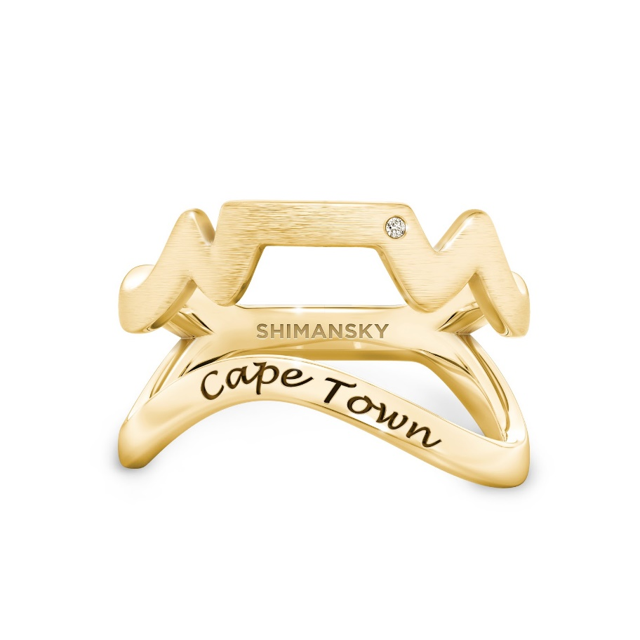
[HEADING] A world first – Cape Town Ring just launched
[Blurb] Say “I DO” to Cape Town – the only city in the world with its own dedicated ring.

Representing the majestic Table Mountain and the sea shoreline – The Cape Town Ring, specially designed by Yair Shimansky, founder of the Shimansky diamond and jewelry brand, is a ring like no other. The ring is a brand ambassador for the City of Cape Town, capturing the essence of this beautiful South African city.
The Cape Town Ring is an iconic jewelry piece and an instant conversation starter, designed to celebrate Cape Town – a declaration of love for this city’s unique energy, and an item that will instantly capture the hearts of whoever visits.

“It offers you the opportunity to share your visit and experiences with friends and family who will be drawn to follow in your footsteps and experience Cape Town for themselves.”, says Shimansky

Each ring is crafted in silver or gold and packaged in fully recyclable materials. The ring is also accompanied by a complimentary coffee table book showcasing the unique diversity of Cape Town’s natural beauty, its people, cuisines and so much more.

About Shimansky
The Shimansky legacy began over two decades ago with Founder and CEO Yair Shimansky. Respected worldwide for innovative design, superior artistry and quality gemstones, Shimansky is responsible for introducing platinum to jewelry making in South Africa and boasts more than 10 jewelry design patents as well as over five international diamond cut patents. Shimansky’s expanding footprint includes several jewelry stores in South Africa and a newly opened boutique on New York City’s iconic 5th Avenue. The quest for perfection is never-ending, and Shimansky believes that the best is yet to come.

Contact us for more information:

MEDIA:
DEIDRE DAVIDS – +27 82 377 4521
DEBORAH FRANCIS – +27 71 686 2740
EMAIL: admin@d2connect.co.za

STOCKISTS:
Shimansky

-ENDS-
MEDIA NOTES:

- The World Travel & Tourism Council (WTTC) recently reported optimistic results for the growth of travel and tourism in South Africa - forecasting growth at an average rate of 7.6% annually over the next decade for the industry. They predict that by 2032, the sector’s contribution to GDP could reach nearly 7.4% of the total economy. As a significant employer, the travel and tourism sector is also expected to create more than 800,000 jobs over the next decade, to reach more than 1.9 million by 2032. And not all contributors to this sector are conventional. Some are, as you can see, jewelry designers who have a passion for the city.
- Reports indicate that both Domestic and International travel has recovered well for the first half of the year with Domestic passengers improving by 50% compared to the same period last year and just over 785 000 international passengers moving through Cape Town International Airport – an increase of 380% compared to the same period last year. This air access is key to ensure the city recovers in a post Covid world where the choice for travel will be increasingly competitive.
- The Cape Town Ring was launched in August 2022 and is available in silver, gold and platinum. There are different diamond options depending on the customer’s preference.
- It has been designed to be a talking point among friends, a statement wherever you go and a sure sign that the wearer has a deep love for Cape Town.
- The ring will be affordable so that locals can also enjoy it. Pricing will start just below $165 for Silver with diamond from and $825 for 14K Gold with diamond.
- You can purchase the ring online at the www.capetownring.com website, Shimansky stores, and other trade partners across Cape Town.
- In the beginning, Yair Shimansky crafted his pieces to sell at sea-side flea markets. But it wasn’t too long before he was able to open his own store. Today, the Shimansky brand is one of the most recognisable and desired brands for those wanting timeless pieces.

Sources:
World Travel & Tourism Council - Economic Impact Report (EIR)
https://wttc.org
WESGRO – Air Route Network Update

