
News for Immediate Release

UL2580 Recognition for Electrovaya’s Lithium Iron Phosphate Infinity Cell

Toronto, Ontario – December 16, 2024 – Electrovaya Inc. (“Electrovaya” or the “Company”) (Nasdaq:ELVA, TSX:ELVA), a leading lithium-ion battery technology and manufacturing company, is proud to announce that its Infinity Series Lithium Ion Phosphate (LFP) based cell have successfully achieved UL2580 recognition. This milestone underscores the exceptional safety and reliability of Electrovaya's battery technology, meeting the rigorous safety standards set by UL2580, including the stringent external fire test (projectile test).

UL2580 is a globally recognized safety standard for rechargeable lithium-ion batteries in electric vehicles. The successful completion of UL2580 certification demonstrates that Electrovaya’s LFP based Infinity cells have passed a comprehensive series of safety tests, ensuring they meet the highest safety benchmarks. Electrovaya’s NMC based cells also have previously achieved the same certification.

“Safety is a paramount aspect of all Electrovaya cell technology,” said Dr. Raj DasGupta, CEO of Electrovaya. “Achieving UL2580 recognition for our latest LFP based Infinity cells is a testament to our unwavering commitment to delivering the safest and most reliable battery solutions for energy storage and electric vehicle applications. Our latest LFP cells not only meet but exceed industry safety standards, providing peace of mind to our customers and stakeholders.”

Electrovaya’s LFP cells will be produced in parallel with its NMC based products at its planned cell manufacturing facility in Jamestown, New York.

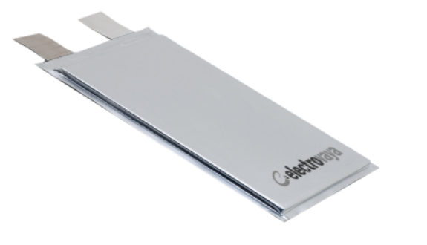
Image of the EV-FP-44

For more information, please contact:

Jason Roy
VP, Corporate Development and Investor Relations
Electrovaya Inc.
905-855-4618
jroy@electrovaya.com

About Electrovaya Inc.
Electrovaya Inc. (NASDAQ:ELVA) (TSX:ELVA) is a pioneering leader in the global energy transformation, focused on contributing to the prevention of climate change by supplying safe and long-lasting lithium-ion batteries without compromising energy and power. The Company has extensive IP and designs, develops and manufactures proprietary lithium-ion batteries, battery systems, and battery-related products for energy storage, clean electric transportation, and other specialized applications. Electrovaya has two operating sites in Canada and a 52-acre site with a 135,000 square foot manufacturing facility in Jamestown New York state for its planned gigafactory. To learn more about how Electrovaya is powering mobility and energy storage, please explore www.electrovaya.com.

Forward-Looking Statements

This press release contains forward-looking statements relating to announcements regarding cell performance, cycle life, longevity, projected performance, extrapolated cycle life, relative performance compared to competitors, planned production in Jamestown New York, ability to start production in Jamestown in the expected timeframe, planned implementation of the LFP cell in product lines in 2025 and 2026, use in commercial vehicle and energy storage applications, energy density, cell performance, safety, cost of ownership, life cycle cost, and can generally be identified by the use of words such as “may”, “will”, “could”, “should”, “would”, “likely”, "possible", “expect”, “intend”, “estimate”, “anticipate”, “believe”, “plan”, “objective”, “seed”, “growing” and “continue” (or the negative thereof) and words and expressions of similar import. Although the Company believes that the expectations reflected in such forward-looking statements are reasonable, such statements involve risks and uncertainties, and undue reliance should not be placed on such statements. Certain material factors and assumptions are applied in making forward-looking statements, and actual results may differ materially from those expressed or implied in such statements. Statements with respect to solid state batteries, battery technologies and production roadmaps, are based on an assumption that the Company’s customers and users will deploy its products in accordance with communicated intentions, and the Company has investment capital to deploy. Important factors that could cause actual results to differ materially from expectations include but are not limited to macroeconomic effects on the Company and its business and on the Company’s customers, including inflation and tightening credit availability due to systemic bank risk, economic conditions generally and their effect on consumer demand and capital availability, labour shortages, supply chain constraints, the potential effect of health based restrictions in Canada, the US and internationally on the Company’s ability to produce and deliver products, and on its customers’ and end users’ demand for and use of products, which effects are not predictable and may be affected by additional regional outbreaks and variants, and other factors which may cause disruptions in the Company’s supply chain and Company’s capability to deliver and develop its products. Additional information about material factors that could cause actual results to differ materially from expectations and about material factors or assumptions applied in making forward-looking statements may be found in the Company’s Annual Information Form for the year ended September 30, 2023 under “Risk Factors”, and in the Company’s most recent annual Management’s Discussion and Analysis under “Qualitative And Quantitative Disclosures about Risk and Uncertainties” as well as in other public disclosure documents filed with Canadian securities regulatory authorities. The Company does not undertake any obligation to update publicly or to revise any of the forward-looking statements contained in this document, whether as a result of new information, future events or otherwise, except as required by law.

