
News for Immediate Release
Electrovaya Reports Fiscal Year 2024 Results

Revenue of $44.6M with $4M Adjusted EBITDA¹ (6th Consecutive Positive Quarter)

Historic Positive Cash Flow from Operations and Improved Gross Margins

Approval of $51million direct loan from The Export-Import Bank of the United States expected to fund Electrovaya’s lithium ion cell and battery manufacturing facility in Jamestown, New York

Removal of Going Concern note in the financial statements due to improved financial performance

Toronto, Ontario – December 12, 2024 – Electrovaya Inc. (“Electrovaya” or the “Company”) (Nasdaq: ELVA, TSX: ELVA), a leading lithium-ion battery technology and manufacturing company, today reported its financial results for the fourth quarter and fiscal year ended September 30, 2024 (“Q4 2024” & “FY 2024”, respectively). All dollar amounts are in U.S. dollars unless otherwise noted.

Financial Highlights:
- Revenue for FY 2024 was $44.6 million, compared to $44.1 million in the fiscal year ended September 30, 2023 (“FY 2023”). Gross margin was 30.7% in FY 2024, an improvement of 377 basis points compared to FY 2023. Battery system margins remained strong at 31.3% for the fiscal year.
- Adjusted EBITDA¹ was $4.1 million, a significant improvement of $0.8 million compared to $3.3 million in FY 2023. Q4 2024 was the Company’s sixth consecutive quarter of positive Adjusted EBITDA¹.
- The Company generated positive cash from operating activities of $1.0 million for FY 2024, compared to cash used in operating activities of $5.2 million in FY2023, a significant improvement in operating cash flow of $6.2 million.
- Given the improved financial performance of the Company, management and the Company’s auditors concluded that the going concern note in the company's financial statements is no longer required.

Key Operational and Strategic Highlights - Q4 FY 2024 & Subsequent Events:
- Added New Global Construction Equipment OEM customer: The Company announced the receipt of its first purchase orders from a global Japanese-headquartered manufacturer of construction equipment. Electrovaya will be powering an electric excavator product line with an estimated scaled production start in 2026. The initial shipments are expected to be delivered in Q2 FY2025 to a manufacturing site in Japan. Sumitomo Corporation Power and Mobility is the trading company partner.

- Received Follow-On Orders from Global Aerospace & Defense Company: The Company announced repeat orders following significant validation testing for its high voltage battery systems from a Global Aerospace and Defense company. The Company believes that its products and technologies provide mission critical sectors, including defense applications, key competitive advantages due to inherent safety and performance benefits.

- Received Direct Loan Approval from Export-Import Bank of the United States: On November 14, 2024, the Company announced that it had secured approval for a direct loan in the amount of US$50.8 million from the Export-Import Bank of the United States (“EXIM”) under the bank's “Make More in America” initiative. This financing is expected to fund Electrovaya's battery manufacturing buildout in Jamestown, New York including equipment, engineering and setup costs for the facility. Electrovaya is currently in the process of finalizing loan documentation and terms with an anticipated funding date in CY Q1 2025.

- Continued Growth from Leading End-Customers: The Company recently announced new orders from its two largest end customers, including a Fortune 100 e-commerce company and a leading Fortune 500 retailer. These orders are significant due to both the renewed demand and in the case of the Fortune 500 retailer, an intention to revamp its significant existing warehouse infrastructure.

Management Commentary:

"Electrovaya, with its core technology advantages and proven performance, is poised to lead mission-critical and heavy-duty energy storage solutions,” said Dr. Raj DasGupta, Electrovya’s CEO. “With growing demand from existing and new customers, we expect robust growth in 2025 and onwards. This includes increasing revenue, enhancing profitability, and expanding domestic lithium-ion cell manufacturing in the U.S."

"Reaching record revenue, achieving six consecutive quarters of positive adjusted EBITDA¹, generating positive cash flow from operations, and removing the going concern note are pivotal milestones for Electrovaya,” stated John Gibson, Electrovaya’s CFO. “These achievements solidify our financial position and set the stage for anticipated revenue growth exceeding $60 million with profitability in Fiscal 2025, driven by strong demand from key end users. Finally, the approved $51 million direct loan by the Export-Import Bank of the United States will support building up additional domestic manufacturing capacity and vertical integration to support our anticipated growth beyond 2026. "

Positive Financial Outlook & Fiscal 2025 Guidance:

The Company anticipates strong growth into FY2025 with estimated revenues to exceed $60 million driven by renewed demand from the Company’s largest end users of material handling batteries. This guidance considers its existing purchase orders, along with anticipated orders in its pipeline from key end users and customers. This guidance also takes into consideration a percentage of anticipated revenue that may be deferred to FY 2026 (please see Forward Looking Statements for further clarification).

Selected Annual Financial Information for the Years ended September 30, 2024, 2023 and 2022:

Results of Operations
(Expressed in thousands of U.S. dollars)

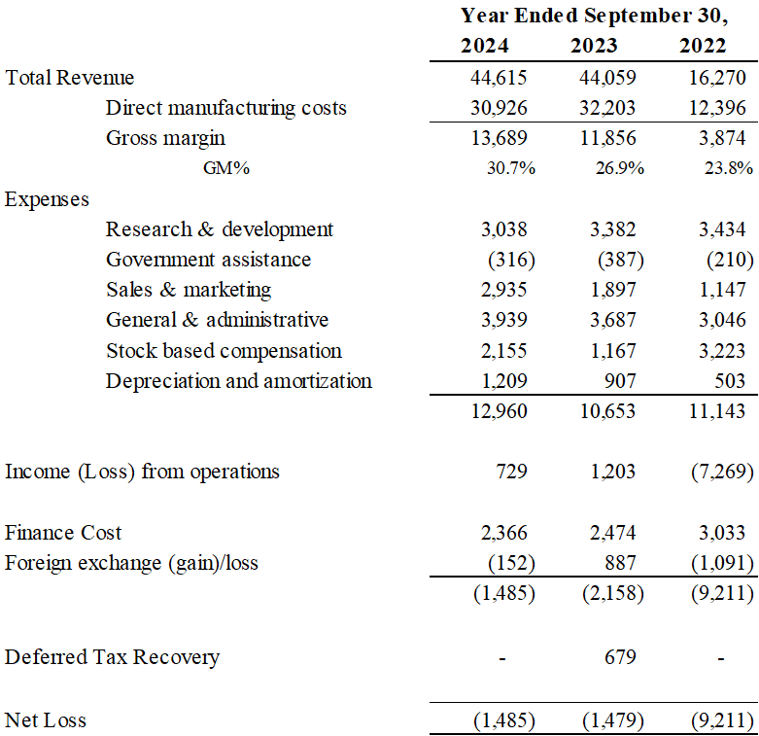

Summary Financial Position
(Expressed in thousands of U.S. dollars)

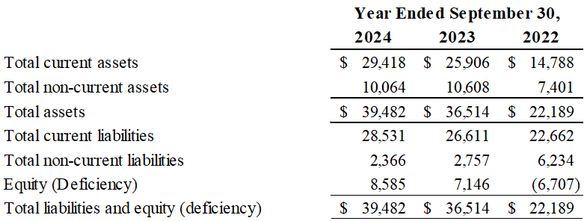

Cash flow statement
(Expressed in thousands of U.S. dollars)

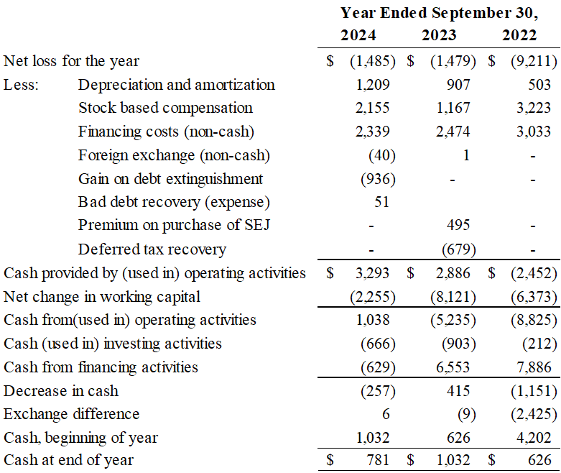

Quarterly Results of Operations
(Expressed in thousands of U.S. dollars)
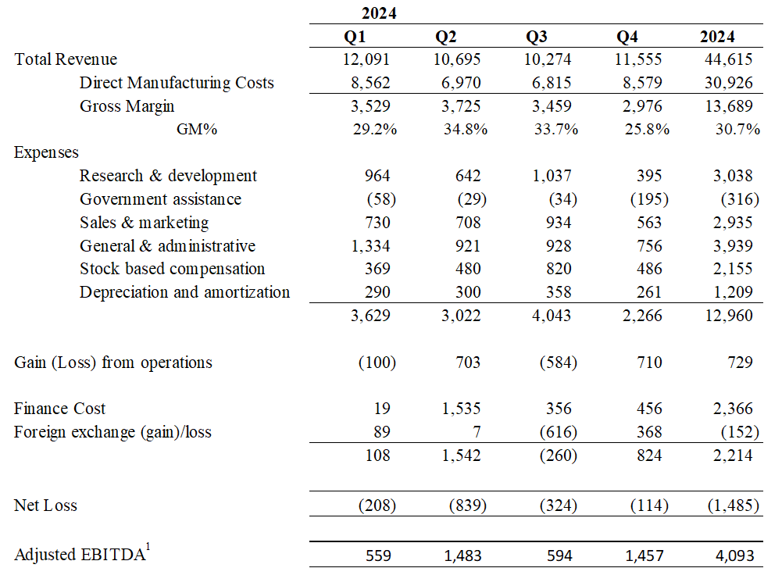

¹ Non-IFRS Measure: Adjusted EBITDA is defined as income/(loss) from operations, plus stock-based compensation costs and depreciation and amortization costs. Adjusted EBITDA does not have a standardized meaning under IFRS. Therefore it is unlikely to be comparable to similar measures presented by other issuers. Management believes that certain investors and analysts use adjusted EBITDA to measure the performance of the business and is an accepted measure of financial performance in our industry. It is not a measure of financial performance under IFRS, and may not be defined and calculated in the same manner by other companies and should not be considered in isolation or as an alternative to IFRS measures. The most directly comparable measure to Adjusted EBITDA calculated in accordance with IFRS is income (loss) from operations.

The Company’s complete Financial Statements and Management Discussion and Analysis for the fourth quarter and fiscal year ended September 30, 2024 are available on SEDAR+ at www.sedarplus.ca and on EDGAR at www.sec.gov, as well as on the Company’s website at www.electrovaya.com.

Conference Call & Webcast details:

- Date: Thursday, December 12, 2024
- Time: 5:00 pm. Eastern Standard Time (EST)
- Toll Free: 888-506-0062
- International: 973-528-0011
- Participant Access Code: 193374
- Webcast: https://www.webcaster4.com/Webcast/Page/2975/49582

To help ensure that the conference begins in a timely manner, please dial in 10 minutes prior to the start of the call.
For those unable to participate in the conference call, a replay will be available for two weeks beginning on December 13, 2024 through December 27, 2024. To access the replay, the dial-in number is 877-481-4010 and 919-882-2331. The replay access ID is 49582.
Investor and Media Contact:
Jason Roy
Director, Corporate Development and Investor Relations
Electrovaya Inc.
jroy@electrovaya.com
905-855-4618

Brett Maas
Hayden IR
elva@haydenir.com
646-536-7331

About Electrovaya Inc.
Electrovaya Inc. (NASDAQ:ELVA) (TSX:ELVA) is a pioneering leader in the global energy transformation, focused on contributing to the prevention of climate change by supplying safe and long-lasting lithium-ion batteries without compromising energy and power. The Company has extensive IP and designs, develops and manufactures proprietary lithium-ion batteries, battery systems, and battery-related products for energy storage, clean electric transportation, and other specialized applications. Electrovaya has two operating sites in Canada and a 52-acre site with a 135,000 square foot manufacturing facility in Jamestown New York state for its planned gigafactory. To learn more about how Electrovaya is powering mobility and energy storage, please explore www.electrovaya.com.

Forward-Looking Statements
This press release contains forward-looking statements, including statements that relate to, among other things, revenue growth and revenue guidance of approximately $60 million in FY 2025, other financial projections, including projected sales, cost of sales, gross margin, working capital, cash flow, and overheads anticipated in FY 2025, the expected timing of deliveries of pre-production battery modules in Japan, anticipated cash needs and the Company’s requirements for additional financing, purchase orders, mass production schedules, funding from EXIM and the ability to satisfy the conditions to drawing on any facility entered into with EXIM,, use of proceeds of the EXIM facility,, ability to deliver to customer requirements. Forward-looking statements can generally, but not always, be identified by the use of words such as “may”, “will”, “could”, “should”, “would”, “likely”, “possible”, “expect”, “intend”, “estimate”, “anticipate”, “believe”, “plan”, “objective” and “continue” (or the negative thereof) and words and expressions of similar import. Although the Company believes that the expectations reflected in such forward-looking statements are reasonable, such statements involve risks and uncertainties, and undue reliance should not be placed on such statements. Certain material factors and assumptions are applied in making forward looking statements, and actual results may differ materially from those expressed or implied in such statements. In making the forward-looking statements included in this news release, the Company has made various material assumptions, including but not limited to assumptions with respect to the Company’s customers deploying its products in accordance with communicated intentions, the Company’s customers completing new distribution centres in accordance with communicated expectations, intentions and plans, anticipated new orders in FY 2025 based on customers’ historical patterns and additional demand communicated to the Company and its partners, but not yet provided as a purchase order together with the Company’s current firm purchase order backlog totaling approximately $80 million, a discount of approximately 25% used in the revenue modeling applied to the overall expected order pipeline to account for potential delays in customer orders, expected decreases in input and material costs combined with stable selling prices in FY 2025, delivery of ordered products on a basis consistent with past deliveries, and that the Company’s customer counterparties will meet their production and demand growth targets, ]the Company’s ability to successfully execute its plans and intentions, including with respect to the entry into new business segments and servicing existing customers, the availability to obtain financing on reasonable commercial terms, including any EXIM facility. Factors that could cause actual results to differ materially from expectations include but are not limited to customers not placing orders roughly in accordance with historical ordering patterns and communicated intentions, macroeconomic effects on the Company and its business, and on the lithium battery industry generally, not being able to obtain financing on reasonable commercial terms or at all, including not being able to satisfy any condition of drawdowns under any EXIM facility if entered into, that the Company’s products will not perform as expected, supply and demand fundamentals for lithium-ion batteries, the risk of interest rate increases, persistent inflation in the United States and Canada and other macroeconomic challenges, the political, economic, and regulatory and business stability of, or otherwise affecting, the jurisdictions in which the Company operates, including new tariff regimes. Additional information about material factors that could cause actual results to differ materially from expectations and about material factors or assumptions applied in making forward-looking statements may be found in the Company’s Annual Information Form for the year ended September 30, 2023 under “Risk Factors”, and in the Company’s most recent annual and interim Management’s Discussion and Analysis under “Qualitative And Quantitative Disclosures about Risk and Uncertainties” as well as in other public disclosure documents filed with Canadian securities regulatory authorities and filed or furnished with the SEC.. The Company does not undertake any obligation to update publicly or to revise any of the forward looking statements contained in this document, whether as a result of new information, future events or otherwise, except as required by law.
Revenue guidance for FY2025 described herein constitute future‐oriented financial information and financial outlooks (collectively, “FOFI”), and generally, is, without limitation, based on the assumptions and subject to the risks set out above under “Forward‐Looking Statements”. Although management believes such assumption to be reasonable, a number of such assumptions are beyond the Company’s control and there can be no assurance that the assumptions made in preparing the FOFI will prove accurate. FOFI is provided for the purpose of providing information about management’s current expectations and plans relating to the Company’s future performance, and may not be appropriate for other purposes.
The FOFI does not purport to present the Company’s financial condition in accordance with IFRS, and it is expected that there may be differences between audited results and preliminary results, and the differences may be material. The inclusion of the FOFI in this news release disclosure should not be regarded as an indication that the Company considers the FOFI to be a reliable prediction of future events, and the FOFI should not be relied upon as such.

