A Wind Energy Plan That Fits America’s Resources
By Drew Devitt, New Way Air Bearings
ddevitt@newwayairbearings.com (484) 767-2311

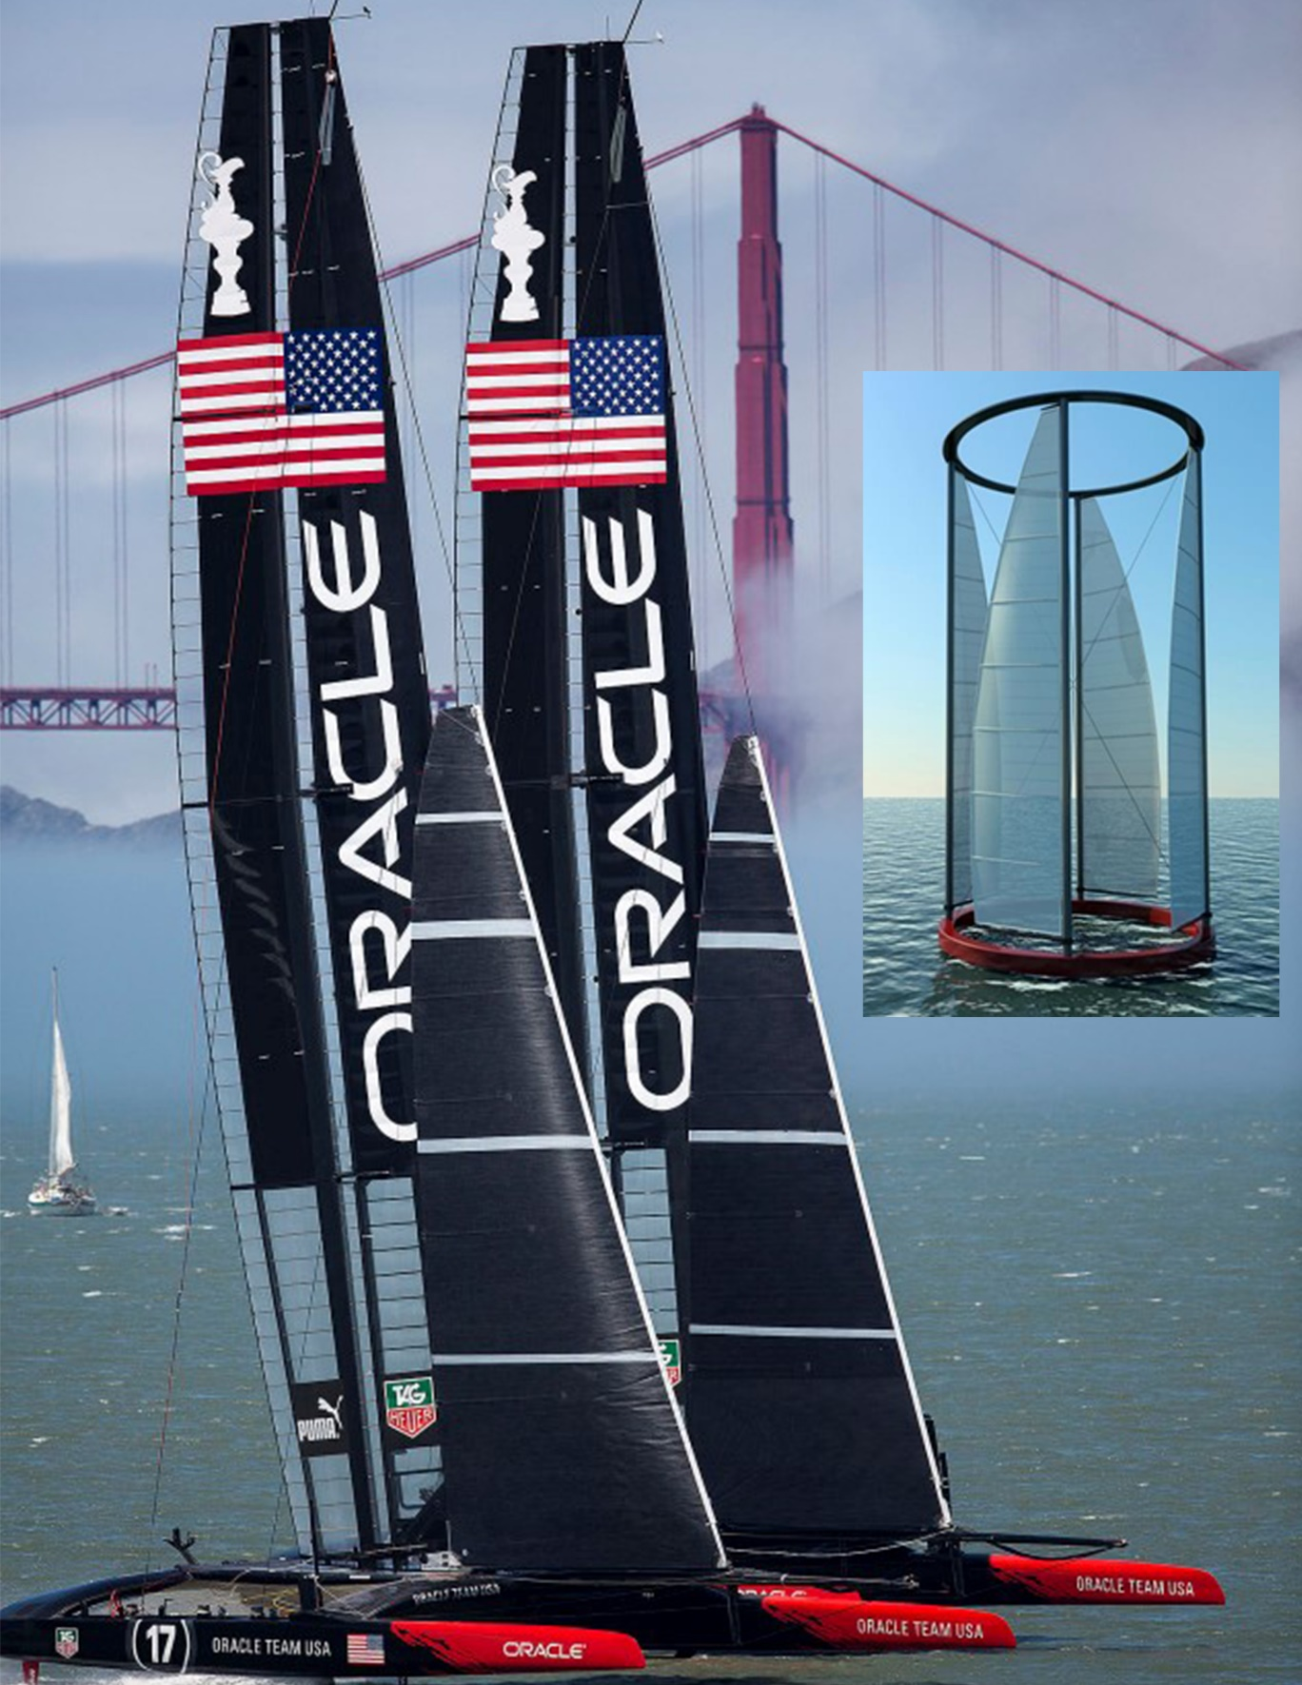
A Wind Energy Plan That Fits America’s Resources
America is blessed with long coastlines and relatively deep water. Ironically this has been a disadvantage to the US offshore wind industry. Comparatively, in England, there are over 1000 turbines already operating in the relatively shallow waters around the English Isles, and many other European countries have significant offshore wind turbine generating capacity. Yet, there is only one offshore wind farm operating in the United States (1). This is in no small part because our shallow water is relatively close to the shoreline, meaning that it is close to people, migratory bird patterns, and within State Jurisdictions. Wind turbines for offshore electrical generating capacity are still a new industry to the United States.
In the beginning of any new industry it is a good idea to take a big picture view of the circumstances and objectives. When it comes to renewable wind energy it is desirable to have the generation be relatively close to the demand, yet not in someone's backyard. There are several technical trends that are symbiotically conspiring to avoid NIMBY issues and dramatically change the offshore wind model that has been developed by the English and Europeans. These trends include; 1. The development of floating wind turbines in contrast to sea floor supported designs, 2. Using the deep ocean water near American coasts as an effective head for utility scale energy storage and 3. High Voltage Direct Current (HVDC) deep-water cables for energy transmission technology. This article shows how the technologies could work together in the context of America's natural resources and political landscape.

America’s Wind Resource
In the case of offshore wind turbines, floating structures have the potential to reach a much larger and significantly more energetic wind resource than sea floor mounted turbines, while increasing social acceptance by keeping turbines far away from people and birds. Seventy percent of our electricity demand is close to our Coasts and Great Lakes. Our best wind resources are only 30 miles offshore. Sandy Butterfield and his colleagues at the National Renewable Energy Laboratory have published papers confirming the huge potential advantages of floating wind turbines, noting; “The NREL has estimated the offshore wind resource to be greater than the 1,000 GW of the continental United States. The wind blows faster and more uniformly at sea than on land. A faster steadier wind means less wear on turbine components and more electricity generated per turbine. The wind increases rapidly with distance from the coast, so excellent wind sites exist within reasonable distances from major urban load centers reducing the onshore concern of long-distance power transmission.”
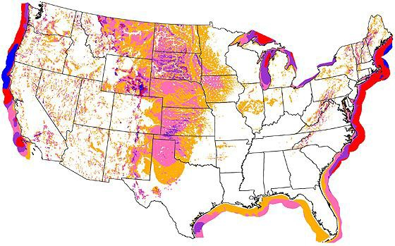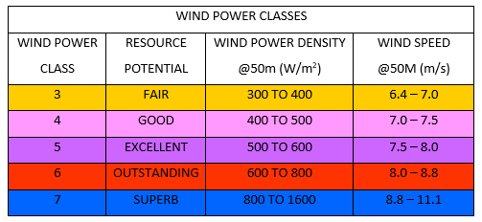
Figure 1
Figure 1 – This NERL wind resource map for the continental United States includes the wind resources over the Great Lakes and along the coast lines. Looking at just the terrestrial 48 states the best wind appears to be over the Midwest. The problem this raises is that most of the demand is along the coasts and Great Lakes and so one option is to build power transmission lines to bring the power to load centers, but this has proven difficult to permit. Alternatively, we could design wind turbines so that they may float, locate them in our strongest wind resource (class 6 wind provides 33% more power than class 4 wind) and which is also close to demand centers. This could solve most of the technical and policy issues damping the growth of our domestic the wind turbine industry.
First, to emphasize his point regarding transmission see Figure 1 above. The best winds on the continental United States are class 3 and 4 winds in the Great Plains and Mountain States which are 1,500 miles from major load centers, Yet, just 30 miles offshore major metropolitan areas we have class 6 winds. Over 75% of the electricity consumed is along the coasts and great lakes which are very near to the best wind resources available to us. Obviously the 30 to 50-mile run is significantly shorter than the 1,500-mile run from the mid-west wind power and ocean power cables are possible to permit.
It is important to add to his comments that the power in the wind increases as a cube function of its velocity, so a class 6 wind provides 33% more power than a class 4 wind. Notice also that this rating is for 50m above the surface. Power classes vary by elevation, the higher the elevation, the better the wind resource on land. This is because the land causes boundary layer effects that slow the wind. The most significant is solar heating of the land which heats the boundary air, causing hot slow-moving air, to rise reducing the power available for land-based wind turbines. Unfortunately, this is just when the demand for air conditioning is at its high. East coast offshore wind turbines within eyesight will still be subject to the effect, due to prevailing wind from the east. Twenty miles out to sea though over consistently cool waters wind currents aloft sink and reattach to the ocean surface becoming trade winds. In fact, in high atmospheric pressure conditions, the sinking air makes locating the turbine on the water surface advantageous. This reduces the need to elevate the turbine into the air and improves its capacity factor.
Types of Wind Turbines
Wind turbines can have either a horizontal (HAWT) or a vertical axis is of rotation (VAWT). Another important point of differentiation is that wind turbines employ two basic principles to capture energy from moving air – aerodynamic turbines use low pressure lift (like an airplane wing) and Impulse turbines which use drag (like a water wheel). The differentiating factor is that the blade tip speed of aerodynamic turbines is a multiple of the wind speed, but an impulse turbine will not spin faster than the wind. An anemometer, an often-used device for measuring wind speed, is an example of an impulse type device.
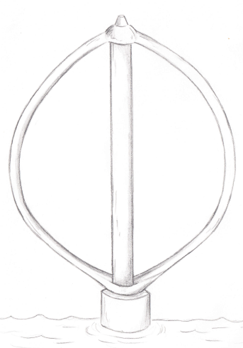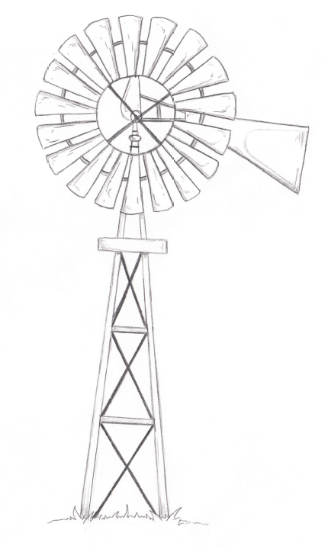
Notice that it has a vertical axis of rotation. There are horizontal axis anemometers, but they are sensitive to being pointed directly into the wind. Most anemometers are vertical axis because they do not need to be pointed into the wind, an important simplicity factor. Conventional horizontal axis wind turbines that need to be pointed into the wind are an example of aerodynamic turbines with tip speeds today exceeding 100 meters per second (360 kph or 225mph).

Turbine Efficiency by Type
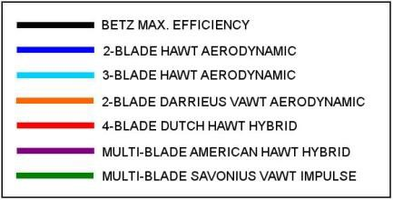
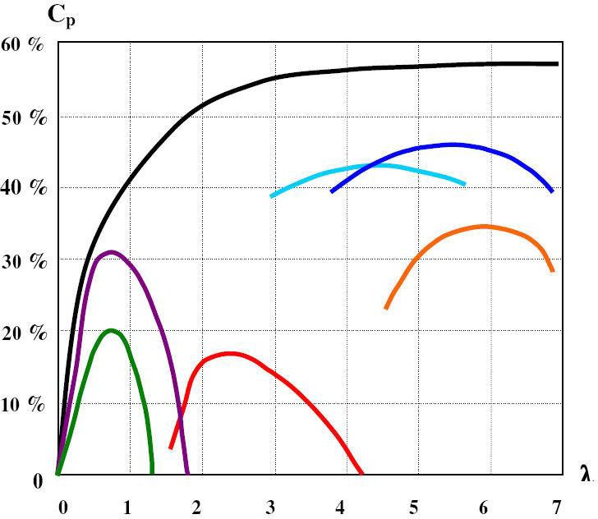
Figure 2
Figure 2 – This is a classic chart describing the efficiency of different types of utility scale wind turbines. The vertical axis on the left represents the turbines efficiency as a percentage of the total energy in the wind. The horizontal axis along the bottom represents the relationship between wind speed and turbine tip speed, aerodynamic turbine types having tip speeds of four to seven times the wind speed and impulse turbines with tip speeds on the order of the wind speed. Aerodynamic turbines are favored because they have roughly twice the efficiency of impulse type turbines. Impulse turbines have historically been used whenever cost, reliability or capacity factor is more important than efficiency.

The old Dutch wind powered mills and water pumps which used cloth covered, four bladed wooden framed blades as well as the iconic wild west American multi blade wind turbines are almost impulse type systems when considered against today's modern aerodynamic horizontal axis turbines. A lot of engineering and technical development has gone in to modern horizontal axis wind turbines in order to drive their efficiencies to 45% at the high end. The theoretical maximum efficiency is limited by "Betts Law" to 59%. A wind turbine cannot be 100% efficient as this would imply that the air exiting the turbine would have zero velocity and so would prevent other air from flowing through the turbine.
Like the anemometer, wind turbines can have a vertical axis of rotation. Vertical axis wind turbines (VAWT) may also be of an aerodynamic or impulse design. Again, aerodynamic designs can be more efficient. Many studies have been done over the past decades indicating HAWT aerodynamic-based wind turbines have the highest efficiencies. This is reinforced by the fact that almost all utility scale wind turbines manufactured today are of the aerodynamic HAWT design.
Efficiency factors can be misleading though, in that they presume a certain wind speed which is usually not noted. For instance, a horizontal axis wind turbine may have 45% efficiency for the wind speed of 14 meters per second, but will not even spin, meaning it would have zero efficiency with a 5 meter per second wind. HAWT are a logical optimization of the wind turbine specifications. Wind power is a cubed function of its velocity and so optimizing wind turbine efficiencies for high wind speed results in large megawatt ratings. This works very well for the sales team when they are selling the turbine based on its megawatt rating. This is also the number that is used to describe how big a wind farm is, as in it is a 200mw or a 400mw wind farm. We read the newspaper reporter obligatorily write how many homes would be powered by the wind farm based on this rating.
What needs to be considered though are capacity factors. Capacity factors are based on the power curve for the wind turbine and wind speed data from the proposed site that the turbine will be placed on. Capacity factors for land-based wind turbines are typically claimed to be 25 to 35%, remember that gas or steam turbine capacity factors approach 100%.
So, in the current paradigm, HAWT have the highest efficiencies in the higher wind speed ranges. This makes sense being the most efficient when there is the most energy to harvest. This results in high megawatt ratings for the turbines but low capacity factors, meaning that the turbine will generate its rated capacity only a small fraction of the time. This is “Spiky Power”, that is, much of the power is made over a relatively short period of time, see Figure 3.
Energy in the Wind vs. Time
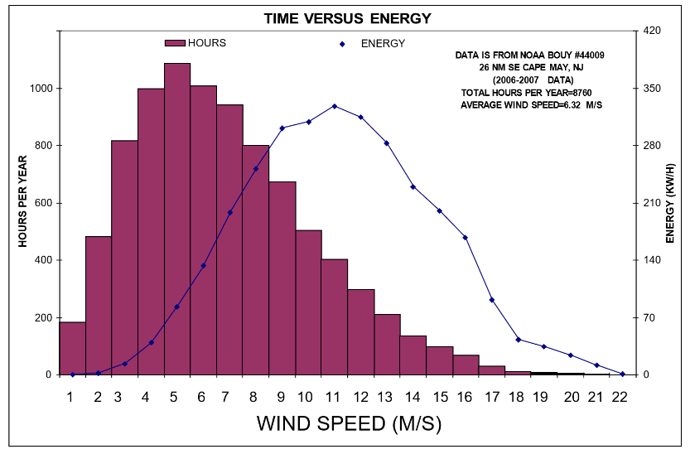
Figure 3
Figure 3 – This chart plots two years’ worth of wind speed data from a buoy at the mouth of the Delaware Bay. To show the distribution of wind speeds with respect to time, it shows the total hours that the wind blew at each of the speeds as a bar chart. In order to show the energy that is contributed at each of the wind speeds, we have taken the power in the wind (which is a cubed function it's velocity) and multiplied that by the time that the wind blew at that speed. Notice that the maximum energy was at 11 m/s, but the wind blew at this speed only 4% of the time and half of the total energy for the year occurred on high-speed side of the energy peak in 15% of the total hours. Therefore, wind turbine electricity is considered spiky and needs to be associated with storage in order to be considered for base load. No matter how good a turbine manufacture says the turbine is, it is subject to the nature of the wind.
The ISOs controlling our national grids need smooth, dependable power. Their experience is almost entirely with fossil fuel, hydro and nuclear energy sources which have very predictable outputs of electricity. As the percentage of electricity generated by wind power increases so will the amount of variability that they need to account for. The needed spinning reserve turbines which can be energized as the wind dies represent an inefficiency and direct cost that reduces the marginal value of wind generated electricity.
To maximize the capacity factors for wind energy, the focus of the offshore wind industry may change from the megawatt rating of the turbine to useful load matching, with more interest in turbines optimized for higher capacity factors in average wind speeds. Vertical axis wind turbines in an impulse configuration have a relatively high efficiency in lower wind speeds because of their higher blade areas as a percentage of swept area. This could be thought of as the barn door method of collecting energy from the wind. Although not as efficient in higher wind speeds, this design will make power most of the time the wind is blowing. This is more consistent with the desires of the power companies and mitigates the need for time shifting or storing wind generated electricity. Still utility scale energy storage would be a benefit to any electrical grid if it could be done cost effectively.
Ocean Energy Storage
There has been much invested in trying to develop energy storage technologies, as this would be a way to align the availability of renewable power to when power is demanded. So far though only compressed air storage and pumped hydro-storage have the capacity to practically time shift utility scale energy, and they require specific geological features that are not found close to major load enters. If the electrical generation is occurring over deep ocean water though, energy storage becomes much more convenient. So floating wind turbines 30 miles offshore have better wind and 300-700 feet of water for energy storage. Energy storage is not practical in the 50, 70-foot-deep waters that are possible for sea floor mounted wind turbines.
This is another significant advantage for floating wind turbine technology, that the pressures of the deep ocean waters under the turbines can be used for utility scale energy storage. There are a number of different engineering approaches to this using both air or water, for instance Bright Energy Storage of Denver, Co. has a plan to pump air into huge bags in deep water, and from Dr. Slocum of MIT suggests pumping the water out of concrete spheres (made from fly ash) that are ballasted of their own weight to the sea floor (Figure 4). The spheres double as anchors for floating wind turbines and a sphere with a 25m ID can store up to 10Mhrs of power depending on depth.
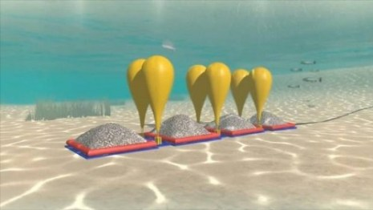
Figure 4
A key advantage of deep-water wind generation and energy storage is that it could make wind energy the most flexible of all energy sources. A one-megawatt wind turbine able to produce 10 MWh over 24 hours could sell all 10 MWh during the heat of the next day, when demand (and price) is the highest. Wind farm operators could even begin bidding in the frequency regulation market where the price per kilowatt hour is 5 to 10 times the price that can be negotiated in power purchase agreements. This would improve returns for investors and environmentalists would also be happy because the turbines that provide frequency regulation now are the smaller more flexible ones with the least pollution controls. It is good for everyone when clean flexible power is worth more.
To accomplish frequency regulation from the deep ocean, transmission capabilities are obviously required and there have been developments in this area. Trans Elect had proposed the Atlantic Wind Connection (AWC), a 6,000 MW high-voltage direct current (HVDC) transmission Backbone running from Southern Virginia to Northern New Jersey some 30 to 50 miles out in the Atlantic Ocean. The $5 billion plan attracted over $500 million in investments from companies including Google, Good Energies, and Marubeni. Trans-Elect received government approvals and was proceeding without oppositions. Unfortunately, these plans have been put on the back burner as this would have made a transmission backbone for deep water wind turbines.
Interestingly, Trans-Elect, which was the nation’s first independent transmission company, was betting on HVDC cables. Markian Melnyk developed the AWC concept while researching offshore renewable energy. Among other things he found is that undersea cables require shielding and this can cause issues for AC transmission. Trans-Elect was betting HVDC would have cost and technical advantages. In recent years, most European offshore wind farms have been connected to land via HVDC cables.
HVDC transmission could be a significant advantage for upstart US turbine companies. Today almost all commercially available wind turbines generate asynchronous AC current that is rectified to DC and then the DC is inverted back to three-phase AC at 60 Hz Digitally (as a sign wave in little steps). There are capital costs, efficiency losses, cooling systems, power quality problems and maintenance headaches that must be borne with this method. Wind turbines designed to generate DC current would still need a transformer to step up the voltage but would avoid even having to sync with the rest of the grid making them simpler to implement by reducing the balance of plant which is especially important at sea.
Although undersea cables are a technical challenge, they are at least possible to permit. When California needed to transmit power from the wind turbines on the high plains to San Francisco the only permittable route included a rather circuitous 53-mile path under the bottom of the Sacramento River. Even in the name of renewable energy, plans for transmission along highways, railroads and new high-tension wire lines were all denied permitting.
Many retired power plants are located on rivers or near coast lines for cooling water and access to coal and they still have grid connections. Bring transmission cables ashore at old power plants would be “utility scale smart grid recycling”. Old power plants are often located directly in major load centers, making them perfect locations for injection of high current frequency regulation and reactive power services to keep the grid running efficiently.
The HAWT has proven itself the clear leader in utility scale generation on land. HAWTs have a lot of inertia based on current designs of turbine manufacturers, their supply chains, and government funding programs. Most of the “Floater” programs in development are designed to employ HAWT. The leading US research Consortium DeepCwind, which is led by the University of Maine’s Habib Dagher have launched the first and only floating offshore wind turbine off the coast of Maine. A 1/8 scale “Volturn” which is generating electricity and synced to the grid, see Figure 5.
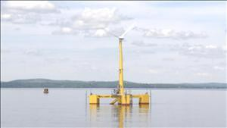
Figure 5
The problem is that it is difficult to make conventional horizontal axis wind turbines float. They are cantilevered structures, reaching high off their base support with large masses attached at the top. This is a fundamentally unstable structure in the context of floatation, but horizontal axis wind turbines are the mainstay of the wind energy industry. Almost all utility scale wind turbines employ three blades connected to a horizontal spindle which is mounted on top of a pole. There is no debate that this design can be the most efficient at capturing energy from wind, but a big picture, smart grid, objective look should consider all the issues and constraints involved, not just the turbines maximum efficiency.
Other structures are possible, light weight structures can be achieved by using tension and compression design principles rather than the bending of a cantilevered structure. Examples of such structures would include bicycle wheels, suspension bridges and sailboat masts. It should be noted that almost all sailboats use tension (stays) and compression (mast) principles rather that a cantilevered mast. It is used because tension and compression are stronger per pound than cantilevered designs. A cylinder of masts, stays, and spokes comprising a cylinder and used as a VWAT would need to be supported at its perimeter at sea level. This could be done with hydrostatic bearings using sea water, air bearings, foiling technology, or truck tires. The advantage is the broad support base. Electrical generation done near the bearing is at the perimeter, so the surface speed is fast enough for power generation, trading radius for gearbox. Eliminating the gearbox using tension and compression, doing support and generation near sea level is rational regarding making a structure that floats and can be serviced at deck level.
I draw your attention to the sailboat pictured in fig.5 which won the previous 33rd America's Cup race. It is a trimaran 30 m long, 30 m abeam and 60 m in height. The total structure weighs 30 tons and the aerodynamic rig, that is everything above the Deck, weighs 8 tons. If constructed as a VAWT, as illustrated in the accompanying fig 6, by adding three more sail plans and a mast head ring, it would weigh another 30 tons. This would be a 60-ton floating structure with 1800 m² of projected area. The foundation, tower, and nacelle of a 3mw offshore wind turbine weights 6000 tons. The 3mw state oil floating turbines weights 6000 tons.
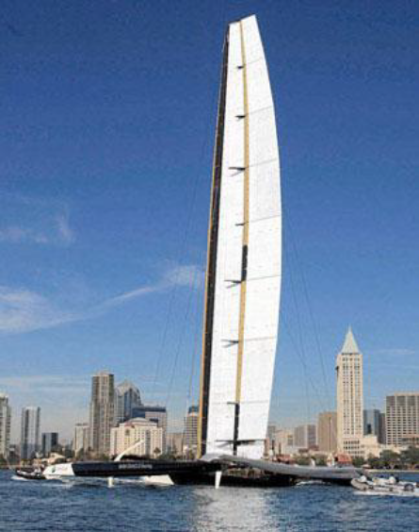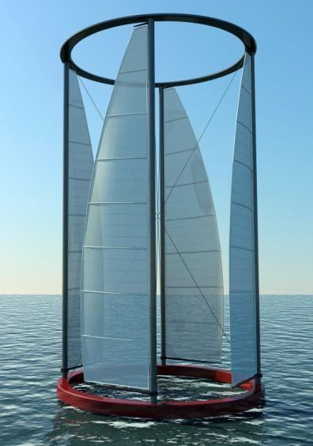
Figure 6 Figure 7
The floating VAWT solves many of the technology and policy problems of marine-based HAWT. Because the turbines solve the flotation problem, no foundation is required on the sea floor, this is a huge reduction in marine siting costs, making them cheaper to site then land-based turbines. The VAWT would be built on shore, towed out to a field of mooring anchors, tied up and plugged in. No crane or assembly would be required at sea, again this is a significant cost-reduction.
The bearings and generator are near sea level for easy on-site service and if necessary, the turbine could be towed back to land in a day for major service. This dramatically reduces the risks of offshore wind power and transportation and maintenance costs are dramatically reduced. Ocean transportation and sighting combined with low turbine speed enable scalability to huge size.
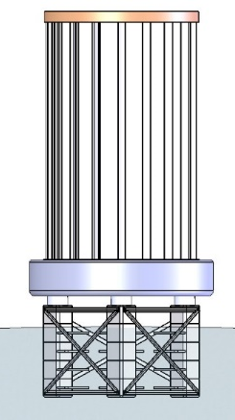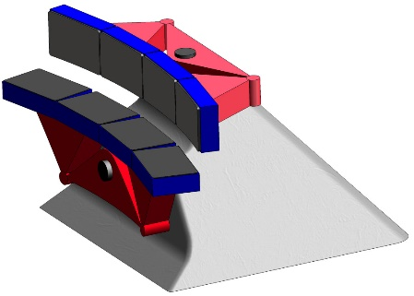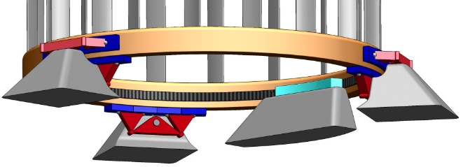
Figure 8
A 200-foot-tall vertical axis wind turbine would be completely hidden by the horizon at 30 miles offshore. So, the turbines would not be visible or audible from the land, this dramatically reduces arguments and legal bickering which delay and increase the costs of wind farms. There are no bats and few birds 30 miles offshore and the vertical axis wind turbine having a high degree of solidity and low rotation speed will not chew up birds and provides excellent horizontal radar reflection for maritime visibility with little vertical reflections. An additional advantage is that the turbines are well outside the 12-mile state control zones, this further minimizes the theaters in which legal action may be taken against a proposed wind farm.
What about the occasional hurricane and rogue storms that can wreak havoc with wind turbines? This is another advantage for the VAWT, because it has no gearbox, it has no oil reservoir. All the components on the turbine are waterproof and rustproof. So, the turbines could be easily sunk by remote control, allowing them to ride out the storm safely beneath the ocean surface. When the storm has passed turbines may be again raised via remote control compressed air cylinder and re-commissioned with little effort.
The broad support base and low center of gravity in the vertical axis wind turbine conveniently enables flotation of the turbine. Floating VAWT enable a host of advantages that dramatically improve the return- on-investment, the reliability of the energy stream and the ability to usefully locate the turbine. Because the VAWT would have a completely different supply chain then conventional HAWT they represent a scalable jobs potential in the heart of our industrial areas. Why buy foreign turbines if we care about jobs?
Transformational Policy Impact
Although the United States leads the world in installed terrestrial wind turbine capacity, we currently have only one operating offshore wind farm. England has almost one half of the 3 GW total worldwide installed offshore-wind generation and has ambitious plans for even more offshore wind farms. Bloomberg New Energy Finance though, has noted that because England has a limited supply chain for offshore wind turbines, 80 Pence of every Pound that England spends on wind technology has gone to foreign contractors or turbine suppliers. Jim Lanard, past President of the US Offshore Wind Development Coalition, is quick to point out that if we are going to gain and keep US legislative support for the offshore wind industry, we will have to generate domestic jobs buying foreign made turbines using contractors for erection (if the Jones Act gets repealed) does not maximize US job creation.
The floating VAWT has numerous significant advantages regarding job creation; first, the capital-intensive supply chain needed to manufacture large roller bearings, gears, forgings and castings would not be required. Steel fabrications and fiberglass components with relatively low capital equipment needs are all that would be required and so a supply chain based on these components would scale much more quickly. The labor skill sets could also be filled quickly and practically deployed in many more seaside locations putting Americans to work at a faster rate.

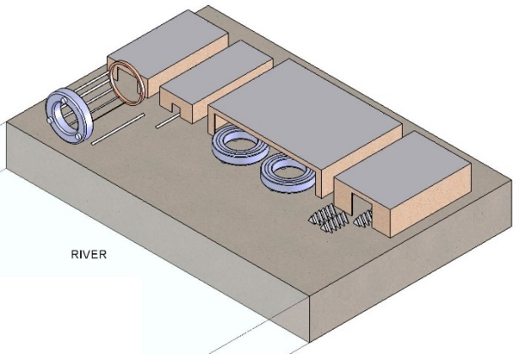
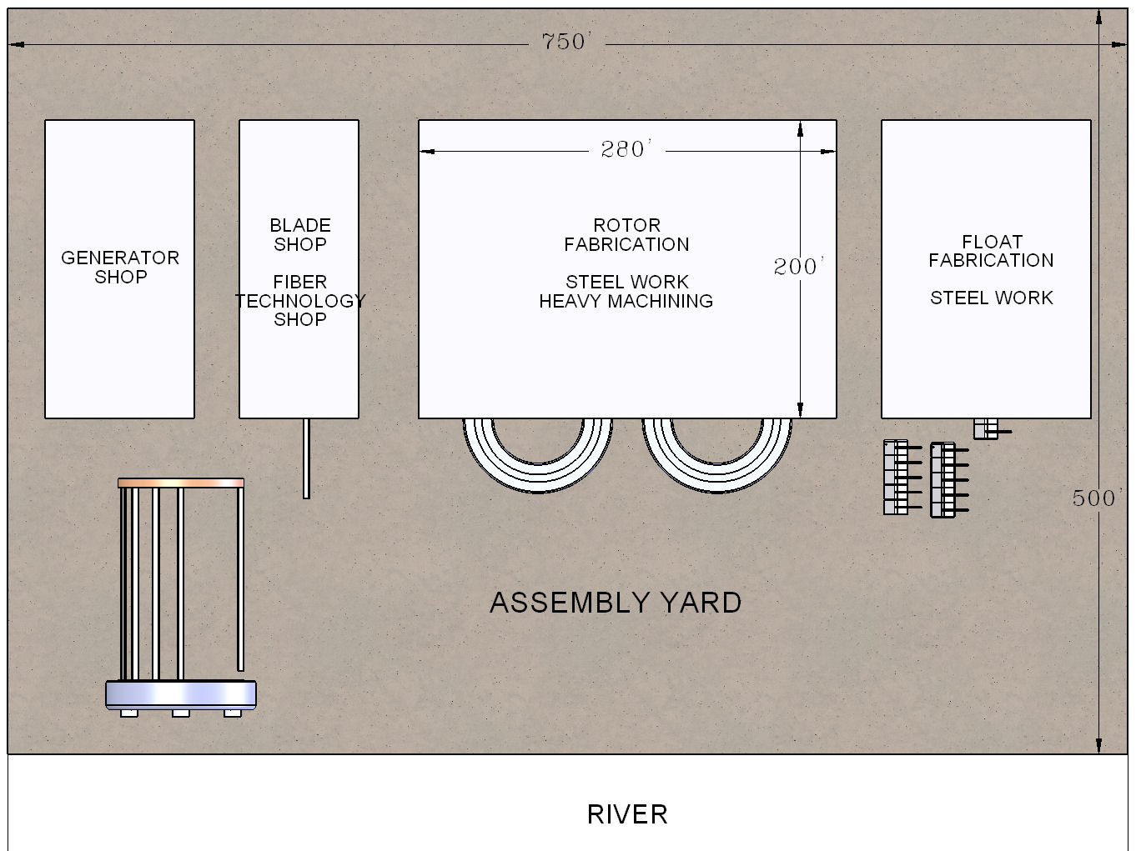
Figure 9

This means that all our old shipbuilding sites and cargo transfer ports become excellent candidates for wind turbine manufacturing sites. Once one successful manufacturing facility has been developed it could be replicated using a franchise model. Half a dozen of these sites could be in operation quite quickly on each of our coasts and though the great lakes. This is a great way to make useful clean energy jobs using our old manufacturing infrastructure. This would also dramatically speed our capability to reach aggressive RPS goals and leapfrog our European and Asian competitors in a technology that suits our resources.
Floating VAWTs will also eliminate the need for the purpose-built ships to assemble sea floor mounted HAWT. This is very important because having never installed a foundation based offshore wind turbine, the US lacks a fleet of the jack up ships that are necessary. Unlike England we cannot hire foreign flagged ships to work in US territorial waters as the Jones Act (an old piece of legislation meant to protect US maritime jobs) does not allow it. We do have a ready fleet of US flagged and owned ships capable of towing floating turbines out to mooring fields though.
By eliminating a seafloor foundation, the cost structure of supply-chain issues and the costs-to- assemble and service turbines at sea, are dramatically improved. As noted previously, the farther away from NIMBY issues and state jurisdictions the better the wind resource becomes. But still, the ability to tow a turbine back to the factory in a single day mitigates risk, reducing both insurance and banking costs for projects.
Conclusion
Our nation’s strongest wind resources are located close to major load centers but are today unreachable because they are in deep water and conventional horizontal axis wind turbines are fundamentally unstable structures in the context of floatation. Other designs are more practical for floatation, light weight structures can be achieved using tension and compression design principles. Huge cylinders for floating VWATs could be constructed using a combination of bicycle and sailboat mast technology. Such a design would reduce; cost per megawatt for turbines, total COE, deployment time, NIMBY resistance, supply chain and Jones act issues, insurance and capital costs, while providing franchise scalability to develop manufacturing sites around the country that put Americans to work quickly, and profitability in jobs where we already have the required infrastructure.

References
United States, Congress, Office of Energy Efficiency and Renewable Energy, et al. “Large-Scale Offshore Wind Power in the United States: Executive Summary.” Large-Scale Offshore Wind Power in the United States: Executive Summary, National Renewable Energy Laboratory, 2010.
United States, Congress, Office of Energy Efficiency and Renewable Energy, et al. “Assessment of Offshore Wind Energy Resources for the United States.” Assessment of Offshore Wind Energy Resources for the United States, 2010.
Viseelli, Anthony. “VolturnUS - Advanced Structures & Composites Center - University of Maine.” VolturnsUS - Advanced Structures & Composites Center, University of Maine, 2015, composites.umaine.edu/research/volturnus/.
National Renewable Energy Laboratory. United States Wind Resource Map. 2004.
http://theliquidgrid.com/the-tech-pool/marine-energy-storage/
Menet, Jean-Luc, and Nachida Bourabaa. "Increase in the Savonius rotors efficiency via a parametric investigation." European Wind Energy conference & exhibition. 2004.
Devitt, Drew. “Making a Case for Flywheel Energy Storage.” Renewable Energy World, 1 Mar. 2010, www.renewableenergyworld.com/articles/print/rewna/volume-2/issue-1/storage/making-a-case-for-flywheel-energy-storage.html.

