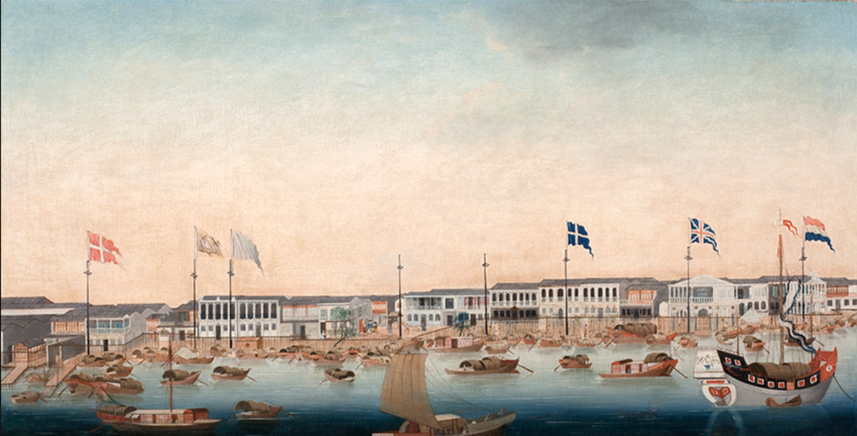
Flags originated during ancient times, approximately 1046 BCE, with political, social and utilitarian use.


The conservation of the Star-Spangled Banner was a 10-year project that began in

The Original Star-Spangled Banner, the flag that inspired America's National Anthem, is on permanent display at the Smithsonian National Museum of American History in Washington, D.C.


June 14 is Flag Day - Do You Know Where Your Flag Is?

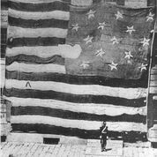
The Star-Spangled Banner, the flag that inspired Francis Scott Key to write America's National Anthem, has been conserved by the Smithsonian's National Museum of American History where it is on permanent exhibit.

