Spectacular Spider Silk
The Strongest Most Versatile Material on Earth
10.06.2020 Los Angeles, California.

Spidey Tek, Inc. is addressing worldwide climate change by helping reduce the emissions from cars, trucks and SUV’s through its lightweight spider silk based technologies

Spidey Tek’s Real Spider Silk fibers and proteins can be the super strong, light weight component needed to aid the transportation industry in improving the weight-to-fuel economy in their entire fleet of vehicles.

There is a keen interest in weight reduction in all type of transportation, this directly impacts a big boost in fuel/energy economy, thereby reducing air-polluting emissions. Every country in the world has set new air quality standards in an effort to battle climate change. Building all types of vehicles that use significantly less fuel/energy is the most attainable answer to this problem. The rule of physics behind this is; the less a vehicle weights, the less fuel/energy is required to power it, thereby reducing total fuel/energy consumed, which reduces air pollution.

How do you accomplish this without sacrificing performance and safety?.....by using Spidey Tek as a strong, light-weight component to replace heavier metal parts used in the construction of these vehicles.

Spidey Tek is developing a new supercar, The Spidey, mainly constructed using our proprietary light-weight material SPIDEY, which is lighter and stronger than steel. “This new vehicle will be lighter, stronger and safer than any production vehicle on the market today. The Spidey will be modeled after the Formula 1/LeMans race cars. When you see a racer hit the wall at 200 miles per hour and the driver walks away from the car, it is because of the chassis and the way it collapses and absorbs the energy of the impact of the crash. We can do the same thing for regular passenger cars without the staggering costs of a F1 car”, He concluded.

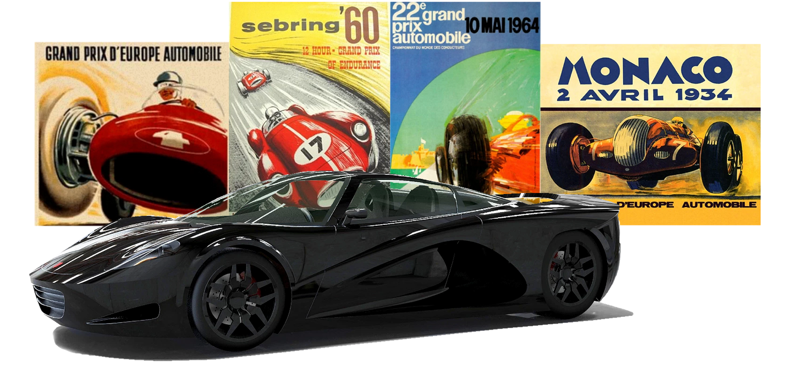

In the example depicted below in the Velozzi Spidey Super Car, it is apparent that there are many other ways to increase strength, reduce weight and increase mileage by incorporating Spidey Tek into the manufacture of many other parts and components of every car, truck and SUV. The Velozzi Spidey is the only car in world designed to utilize Real Spider Silk in its construction. This technology can be incorporated into consumer production cars, trucks and SUV’s by every auto manufacturer.

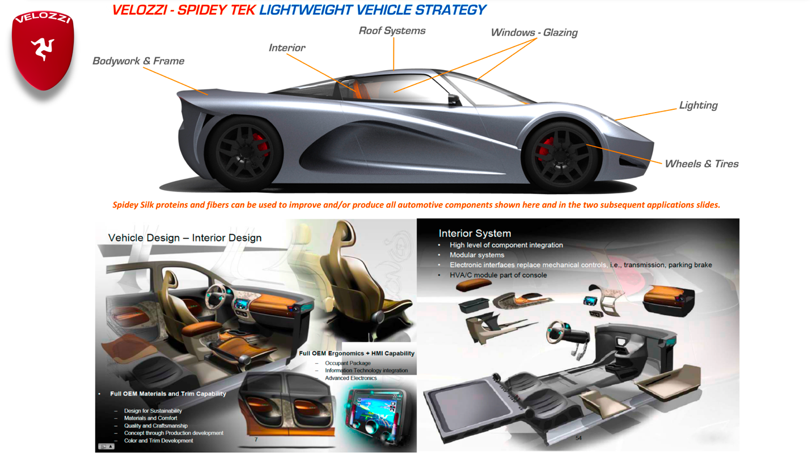

Spidey Tek will build the award winning Velozzi Spidey Super Car using our spider silk based technologies throughout the car. Spidey Tek will only build a few of these one of a kind, exotic cars for a handful of fortunate collectors. Visit www.spideytek.com to get more details regarding the Velozzi Spidey Super Cars and the many other applications of the Spidey Tek technology.

Spidey Tek, Inc. is seeking collaboration and joint development with additional automotive companies, as well as other manufacturers across multiple platforms and industries.

