CFA Education Program


Retailing and Technology – 2017 Update and Outlook

CFA (Commercial Finance Association) November 14, 2017
Lauderdale Yacht Club, 1725 SE 12th Street, Fort Lauderdale, FL, 33316, USA
Registration 11:30 am; Program and Lunch 12:00 noon

Guest Fees:
$35/member; $45 non-members and walk-up guests
Sponsorships Available:
$250 includes three attendees and logo in event program, public relations initiatives, and signage

Register online through CFA link. Call 954 415 6369 for sponsorships.
https://community.cfa.com/floridachapter/events/eventdescription?CalendarEventKey=51adb375-ed3e-43bd-a421-82631b24f10c&CommunityKey=826c674b-90ab-4cd2-857f-7fa08f5bd943&Home=%2ffloridachapter%2fhome



The experienced panel knows retailing
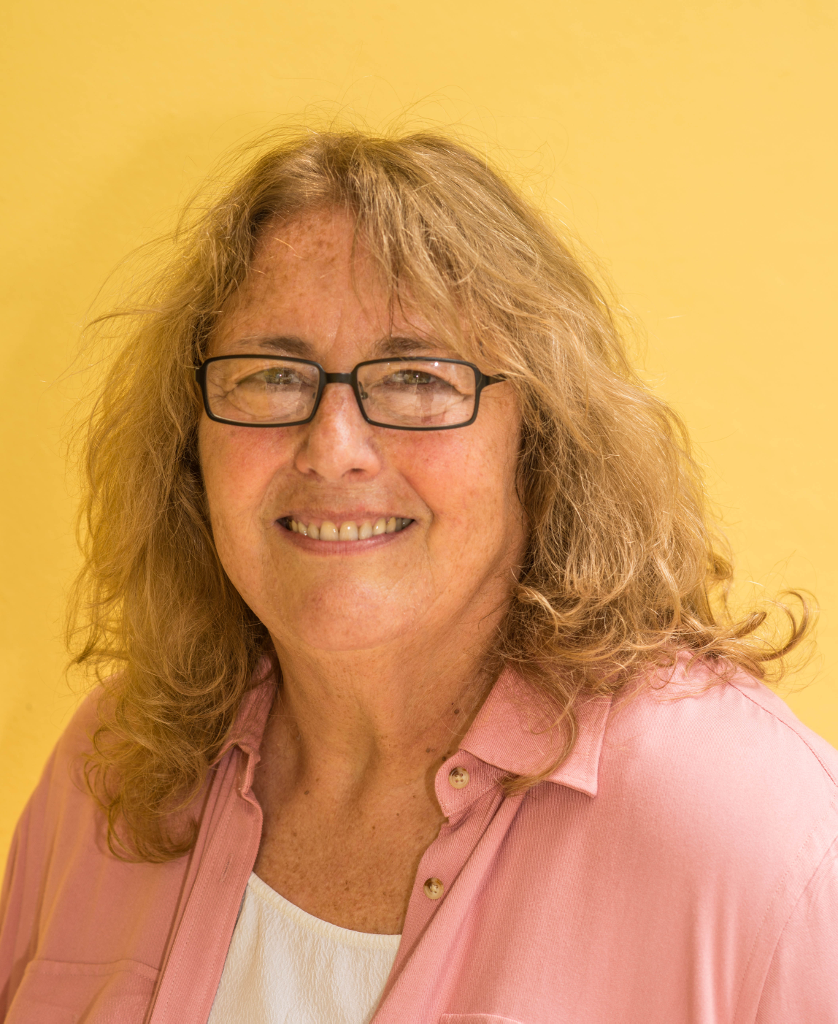
Paula Rosenblum is co-founder and Managing Partner at RSR Research and is widely recognized as one of the industry’s top retail technology analysts. She has been selected as one of the “Top 50 Retail Technology Influencers” from 2014 -2016. She also writes a weekly blog for Forbes and is frequently quoted in other major media outlets including the Wall Street Journal, Washington Post, LA Times, NPR Marketplace and many others. She serves on the advisory board of three consumer goods importers companies.

Previous to her years as an analyst, she spent over 20 years as a retail technology executive and CIO at companies including iParty, Hit or Miss, Morse Shoe, Domain Home Fashions and others.
Paula received her MBA in 1991 from Northeastern University, with a major in management of High Technology firms and was nominated to the Beta Gamma Sigma honor society. She’s active in a variety of organizations supporting human growth and development, and in particular has been involved with the RetailROI charity since its earliest days.
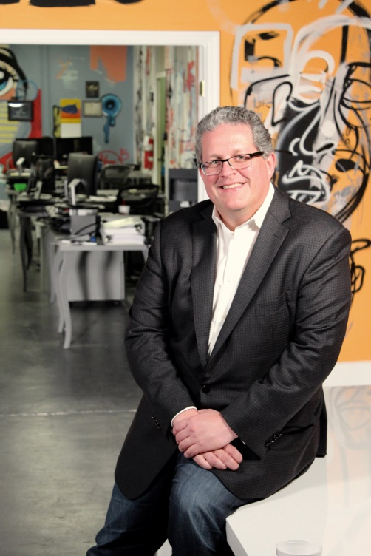
Sam Zietz is the founder and CEO of the financial technology company TouchSuite® and its affiliated companies. Prior to Touchsuite, Mr. Zietz was a corporate attorney specializing in Structured Finance with the New York based law firm Skadden, Arps, Slate, Meagher and Flom, LLP. Prior to Skadden, Mr. Zietz worked in the Business Tax Planning Department at PricewaterhouseCoopers.

Sam earned his Bachelor of Science degree from the University of Michigan then went on to on receive his JD from St. Thomas University School of Law in Miami, Florida where he graduated first in his class. Mr. Zietz then earned his LLM in Taxation from New York University School of Law.

In 2015, Sam received the EY Entrepreneur of the Year Award in Florida. In 2014 he was named one of South Florida's Ultimate CEO's by the South Florida Business Journal. Zietz sits on the board of several educational and entrepreneur-focused organizations, including the Palm Beach chapter of the Young Presidents Organization (YPO), Chief Executives Organization (CEO), Florida Council of 100 and the Orange Bowl Committee. He speaks regularly at professional events and at universities and most recently, testified before Congress on Entrepreneurship and gave a TED talk on achieving success on the entrepreneurial path. Sam is an active speaker, mentor and sponsor of the Young Entrepreneurs Academy (YEA) which teaches students the process of starting and running a real business over the course of a full academic year. He is also an active angel investor with a number of investments under management.

Thanks to Sam’s leadership, the company has been the recipient of numerous awards and accolades, including eight appearances on Inc. Magazine’s “Inc. 500” list of the fastest growing private companies in America. Two years ago, TouchSuite was named the fastest growing privately held company in South Florida, as well as the fastest growing technology company in the entire state, by the Business Journals of Florida. Sam has appeared on the South Florida Business Journal’s list of Top 100 Power Leaders for the last three years. Sam was also presented with the Governor's Business Ambassadors award that centered on TouchSuite’s growth and significant contributions to Florida’s economy.

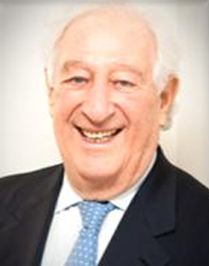
Raymond Zimmerman is the CEO of online retailer Service Merchandise LLC. He was previously the Chief Executive Officer of 99 Cent Stuff, Inc., a company he founded (formerly 99 cent Stuff, LLC). He founded Service Merchandise Co. Inc. ("Service Merchandise") and served as its Chief Executive Officer from October 1981 to April 1997, President from July 1984 to November 1994 and also from 1981 to October 1983 and Non-Executive Chairman from January 1999 to November 2000. Zimmerman also served as Chairman and Chief Executive Officer of iVideoNow Inc. He has been a Director of The Limited Inc. since 1984 and a Non-Independent Director of L Brands, Inc. since 1984.
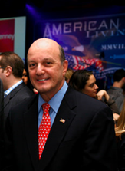
Joe Pennacchio has enjoyed a long and successful career in the retail industry. Raised in New Jersey and a U.S. Army veteran with service in Vietnam as an engineer, Pennacchio then served in merchandising positions at leading U.S. retailers Federated Department Stores, Macy’s, Abraham & Straus and Jordan Marsh, where he was President. Pennacchio is experienced in global sourcing, was head of the Textiles Group at Federated/Macy’s, and subsequently applied his merchandising/marketing and cost reduction skills to retail/consumer products turnarounds as CEO of Aurofin Corporation (jewelry manufacturer) and President of WestPoint Home where he was instrumental in acquiring Manam Textiles in Bahrain.

Joe is best known as an innovator and cost effective builder of profitable volume and teams. His business experience has recently been applied as President of the non-profit Florida Standardbred Breeders and Owners Association where he has been effective in dealing with the Florida legislature in seeking to preserve jobs in the significant Florida equine/agriculture sector. He also heads Joe P Racing LLC and has earned over 150 victories as an amateur driver of standardbred horses.
Pennacchio embraces change, saying “In today’s business world, one has to embrace change ad use it over those who are afraid of it. Agility and innovation are ongoing and a key to success tomorrow!”


THE CFA COMMUNITY
Leaders Who Grow The Economy

The Commercial Finance Association (CFA), is the international trade association dedicated to the secured finance industry focusing on asset-based lending, factoring and supply chain finance industries world-wide. Founded in 1944, the CFA has nearly 250 member companies and a 15,000 person active community with 20 chapters located throughout the United States, Canada and Europe. We engage the international community through our active work with the United Nations, WorldBank, Asia-Pacific Economic Cooperation (APEC) and the Organization of American States (OAS).

The CFA Community Is Vibrant & Growing
It’s very simple, really. We engage industry leaders who actually provide the capital that grow thousands of businesses and create and sustain millions of jobs in the US and around the world. We do this through world-class events bringing together thought leaders shaping our future. We offer education for the industry, inform regulators, legislators and the international community, and shape the NextGen of Commercial Finance professionals. We offer unique and powerful industry data, news and analysis which give critical insights into our dynamic industry.

The Commercial Finance Association's Chapters are the trade group for commercial finance companies, factors, banks and other financing agencies engaged in the asset-based financial services industry. The CFA serves the asset-based financial services industry on an international, national, regional, and local basis. CFA Chapters offer membership to individuals. Organizational membership is offered at National Level. If you work for a CFA member organization you can join a chapter at a discounted price.
The Commercial Finance Association's Chapters are comprised of professionals with great insight and experience. Each member brings their expertise to the Chapter providing excellent stewardship, information, and valuable experience for association members. Our members take pride in bringing their quality programs, precious contacts and more to the asset-based financial services industry.
There are 16 US Chapters, one in Canada and one in Europe, covering major finance centers for two continents. Each provides a program of education and networking to complement the global CFA programs. Contact Florida CFA leader if you wish to join CFA and to participate in its events.
Roger S. Welker
Merchant Financial Corporation
305.495.9824
rwelker@merchantfactors.com

Event Sponsors


Chapter Sponsors
Gold Sponsors Silver Sponsors​
 
www.frazierdeeter.com www.whhlaw.com
Bronze Sponsors


Future Event
2017 Florida CFA - TMA Holiday Extravaganza
Wednesday Evening December 13, 2017
Lauderdale Yacht Club
5:30 PM - 7:30 PM
Members $60
Non-Members $80
2018 Membership Promotion - renew/join for 2018 and attend $150

Registration link: https://community.cfa.com/floridachapter/events/empages/registration/selectregistrants?RegistrationKey=2ce3c0a5-dbff-4186-8324-c7246ceab2d3&StepNumber=0

