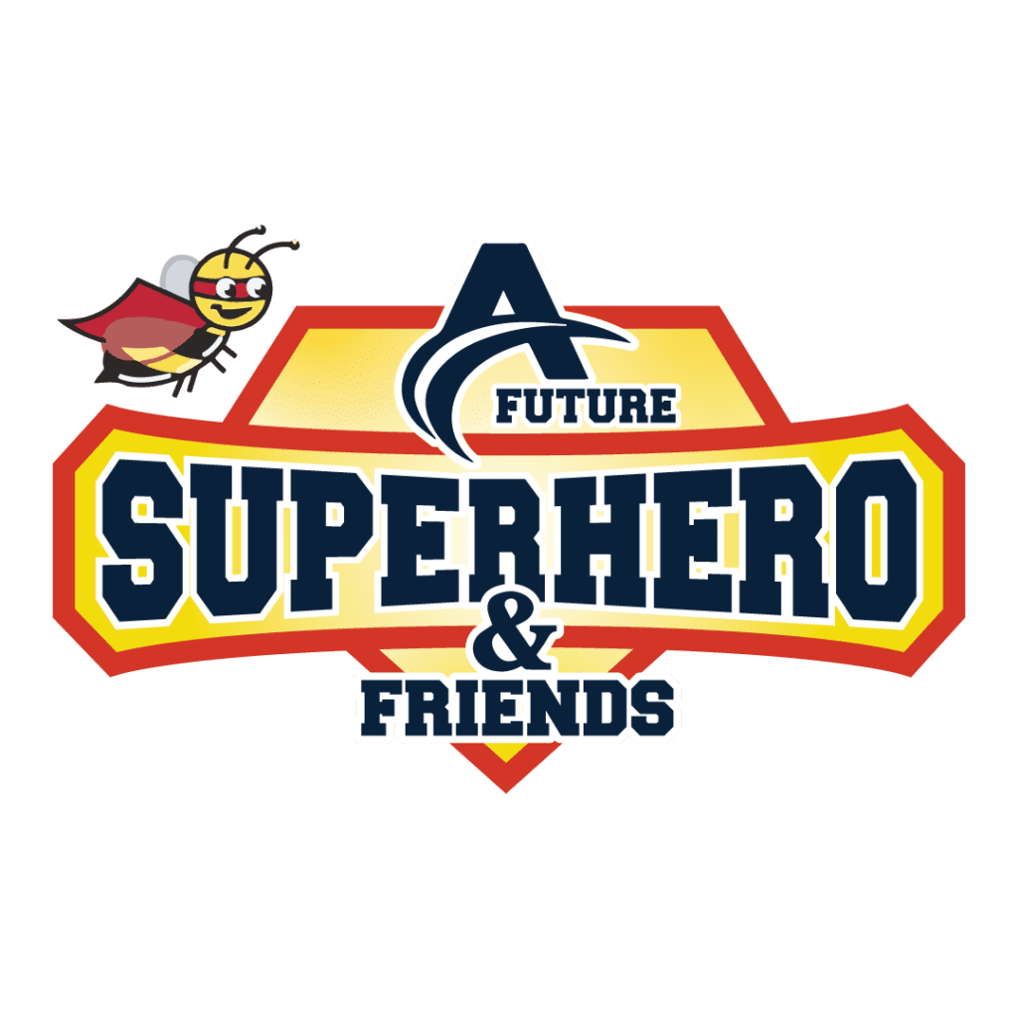

FOR IMMEDIATE RELEASE

AFutureSuperHero And Friends and Rodney Smith, Jr., Partner for “Hope 4 The Holidays” U.S. Tour
Together, they will bless one individual or family in each state across America

CALIFORNIA, UNITED STATES, NOVEMBER 18, 2022 - AFutureSuperHero And Friends is excited to partner with Rodney Smith, Jr., for “Hope 4 The Holidays”, a nationwide tour in which one person or family in each state will be chosen to receive donations, special visits, and more.
Yuri Williams, founder of AFutureSuperHero And Friends, has become well-known for his efforts in helping those in need. He dons a superhero costume and goes to hospitals, homes, and special events, where he also gives back. Often, he partners with others who have the same mindset.

Rodney Smith, Jr., is the creator of Raising Men Lawn Care Service and the “50-yard challenge”, in which he encourages kids and teens to mow lawns for charity.

Now, the two are partnering for their 4th annual “Hope 4 The Holidays” tour. They will be traveling across the United States and blessing one family or individual from each state around the nation.

Williams will be dressed as a “Santa’s biker scout elf”, and Smith will be dressed as a “Santa’s helper”. Together, the two will perform acts of kindness, gifting the houseless, visiting the elderly, visiting ill and disabled children, and saving Christmas for families in needs.

The non-profit is looking for nominations from people across the country who know someone they’d like to see blessed in such a way. These nominations can be made by simply messaging AFutureSuperHero And Friends via social media or e-mail.

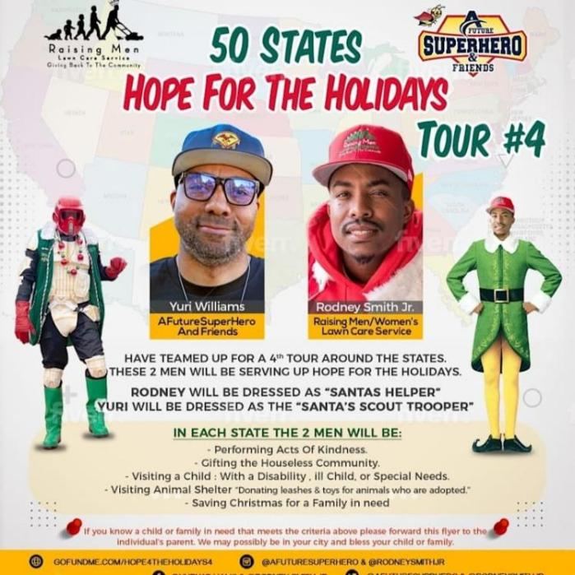
This year, as more and more people are struggling to make ends meet, Williams and Smith are committed to making the holidays brighter for those in need. Both of these men have become well-known for their passion for giving back, and as part of this, they are also giving others the opportunity to give back. Anyone wishing to donate to this cause can do so at the ASuperHero And Friends website.

On November 25, 2022, the two will embark on the 4th annual “Hope 4 The Holidays” tour. Their travels will begin in Kentucky. Further details can be found at https://afuturesuperhero.com/ .

ABOUT AFUTURSUPERHERO AND FRIENDS

AFutureSuperHero And Friends is a non-profit organization that gives back to the houseless, veterans, ill children, elderly, and animals.

CONTACT

Yuri Williams
AFutureSuperHero And Friends
Phone: 562-999-1304
- mail: AFutureSuperHero@gmail.org
Facebook: @afuturesuperheroandfriends
Instagram: @afuturesuperhero
Website: https://afuturesuperhero.com/

###

