Executive Summary

Most children born today are likely to be alive in the year 2100.

Imagine a world 50 years before then—2050—when the majority of the world could be augmented geniuses inventing their workday, every day, with new people, ideas, and experiences to make life worth living, and civilization could be far better than what we know today. However, without making good decisions, we can all imagine a future far worse than today. This State of the Future 19.0 offers you data, information, intelligence, and some wisdom to provide a context or framework to help make better decisions than is commonly offered today.

Artificial intelligence will drive the development of quantum computing, and then quantum computing will further drive the development of artificial intelligence. This mutual acceleration could grow beyond human control and understanding. Scientific and technological leaders, advanced research institutes, and foundations are exploring how to anticipate and manage this issue.

Meanwhile, human life expectancy has increased from 46 years at birth in 1950 to 72 years now. Child mortality, poverty, contagious disease, and illiteracy have all decreased. The global nervous system of humanity is on the road to completion: 52% of the world—over 3.8 billion people—are now connected to the Internet, about two-thirds of the world has a mobile phone, and over half have smart phones. The Millennium Project’s State of the Future Index shows the world is expected to continue improving over the next 10 years (see Chapter 2); however, environmental conditions, armed conflicts, terrorism, and organized crime are getting worse.

The IMF expects growth of the world economy to increase from 3.1% percent in 2016 to 3.5% in 2017 and then 3.6 % in 2018. Given population growth at 1.11%, global income per capita is growing 2.39% annually.

Although extreme poverty fell from 51% in 1981 to 13% in 2012 and to less than 10% today, the concentration of wealth is increasing, income gaps are widening, jobless economic growth seems the new norm, and return on investment in capital and technology is usually better than labor. As labor costs go up and robot costs go down, manufacturing unemployment rates will increase. Hence, new forms of economics seem inevitable if we are to avoid the social disasters of large-scale worldwide structural unemployment that have been forecast by many. Three alternative Future Work/Technology 2050 Global Scenarios in Chapter 4 show how different outcomes might evolve from these trends, along with 100 suggestions to address these issues from The Millennium Project national workshops held in 17 countries in 2016 and 2017. Other national workshops are being planned; taken together, they are intended to broaden and deepen the future of work conversation around the world, leading to improved long-range national policies.

The current world population of 7.6 billion is expected to grow another 2.2 billion in just 33 years (by 2050), putting pressure on food production, environmental management, and financial support systems. Although the world is aging, biological breakthroughs could dramatically extend the lives of healthy, mentally alert people way beyond what is believed today. Future migrations from low-income, high-youth-employment regions to high-income aging societies seem inevitable.

Eco-smart Cities are being built around the world, and older cities are being retrofitted with intelligent systems. China’s One Belt, One Road initiative could lend up to $8 trillion for infrastructure in 68 countries to better connect China to Central Asia, the Middle East, and Europe, making it one of the greatest infrastructure project in history, hopefully incorporating the latest eco-smart systems with AI. It may be that global urbanization is becoming too complex to manage without artificial intelligence. Moving workers to jobs creates massive traffic jams around the world. New technologies will make it increasingly easy to move jobs to workers. Recent calls for a “Fourth Industrial Revolution” that uses AI for all elements of production from market research to manufacturing and sales that are all connected in the cloud is expected to extend to everything from transportation and water management to power production and use.

Although over 90% of the world now has access to improved drinking water, water tables are falling on all continents, and nearly half of humanity gets its water from sources controlled by two or more countries. E-waste pollution is growing with poisonous effects on groundwater worldwide. As the developing world expands, its industries, agriculture, population growth, and GDP per capita income all rise and water consumption per capita will increase, making it impossible to avoid serious water crises and migrations unless major changes occur.

Increased atmospheric CO₂ that led to the Great Permian Extinction, killing 97% of life, could happen again if changes in food production, energy, and lifestyles do not occur. A trillion-ton chunk of ice twice the size of Luxembourg separated from the Antarctic ice shelf. The global cost of weather disasters increased from $94 billion in 2015 to $175 billion in 2016, according to SwissRe.

Although the vast majority of the world is living in peace and although armed conflicts fell dramatically from 1990 to 2010, conflicts have increased since then, and half the world is potentially unstable. The nature of warfare has morphed into transnational terrorism, international intervention into civil wars, as well as publicly denied cyber and information warfare. Information warfare (as distinct from cyber warfare that attacks computers, software, and command control systems) manipulates information trusted by targets without their awareness, so that the targets will make decisions against their interest but in the interest of the one conducting information warfare. Fake news via bots, videos, and other forms of information warfare are increasingly manipulating perceptions of truth, while the public does not know how to defend itself. Although the Internet has increased participation in governance and exposed corruption, press freedoms have decreased over the past several years, and anti-democratic forces are increasingly using new cyber tools to manipulate democratic processes.

Nuclear proliferation has not stopped, and future lone wolf terrorists may one day be able to make and deploy a weapon of mass destruction. Families and communities have to raise a new generation of more ethical people because government technical means and public mental health and education systems are not enough to guarantee a future free of the potential for individually active massively destructive technologies.

Organized crime takes in over $3 trillion per year, which is twice that of all the military annual budgets combined. An estimated $1.5 trillion in bribes is paid per year; corruption is a major impediment to development for countries that are home to over 5 billion people. Distinctions among organized crime, corruption, insurgency, and terrorism have begun to blur, increasing threats to democracies, development, and security. A global strategy to counter this growth is needed in addition to the current nation-state, sectoral approaches.

Transnational and intercultural collaborations have reduced disease, created safer transportation systems around the world, and produced a global Internet that shares most of the world’s knowledge at no or little coast. Neuroscience is showing how brain performance can be improved, and AI is being developed to figure out the best ways for you to learn and what you should, need to, and/or want to learn.

The percentage of women in parliaments, corporate boards, and other executive positions has increased slowly but steadily, although not fast enough to meet the UN Sustainable Development Goal to achieve gender equality and empower all women and girls by 2030. Some 50% of 10-year-olds live in countries with high levels of gender inequality.

The Paris Agreement is expected to reduce fossil fuel consumption and increase the use of renewable sources of energy. Coal use saw a dramatic reduction in 2016. Solar and wind energy are now cost-competitive with coal (especially when the cost of externalities are considered), and massive lithium-ion battery production plants are in construction to help renewables’ ability to provide baseload electricity.

The speed of scientific breakthroughs and technological applications to improve the human condition is being accelerated by computational science and engineering, artificial intelligence, common database protocols, Moore’s law, and Nielsen’s law of Internet bandwidth (50% speed increase per year). Future synergies among synthetic biology, 3D/4D printing, artificial intelligence, robotics, atomically precise fabrication and other forms of nanotechnology, tele-everything, drones, augmented and virtual reality, falling costs of renewable energy systems, and collective intelligence systems will make the last 25 years of S&T change seem slow compared to the next 25.

Increasingly, decisions are being made by AI; since their algorithms are not ethically neutral, the future of ethics—in part—will be influenced by auditing ethical assumptions in software. Meanwhile, political spin masters drown out the pursuit of truth worldwide.

The moral will to act in collaboration across national, institutional, political, religious, and ideological boundaries that is necessary to address today’s global challenges requires global ethics. Global ethics is emerging around the world through the evolution of ISO standards and international treaties that are defining the norms of civilization.

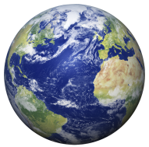

So, taken all together, how are we doing? Is the future in general getting better or worse?

To answer this, The Millennium Project with our Nodes around the world and the experts Nodes select have tracked progress and regress on 15 Global Challenges (see Chapter 1) for over 20 years and created a State of the Future Index (see Chapter 2).

The 2017 SOFI in Figure 1 shows that the world continues to improve in general, although at a slower pace than over the past 27 years. The rate of global improvement in SOFI for the coming decade will be 1.14%, versus 3.14% for the period 1990 to 2017. This is mostly due to the slow recovery after the 2008 financial crises and world recession in 2009. One of the variables that has a large impact on the 2017 SOFI projection is the number of terrorist attacks, which is very uncertain. If terrorism could be contained, the SOFI would appear considerably better. Chapter 4 provides experts’ views from around the world on the future of terrorism and its deterrence.

Figure 1 State of the Future Index 2017
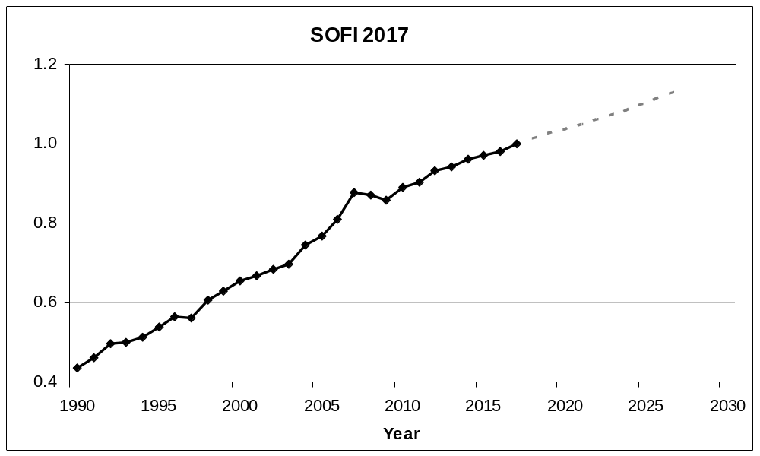

One of the advantages of computing the SOFI is the identification of the areas where we are winning, losing, or stagnating—thereby helping to set priorities. Figure 2 shows the trends of where humanity is winning and Figure 3 shows where we are losing or there is little progress. These are further analyzed in Chapter 2 by assessing the individual variables and their potential trajectories.

Figure 2 Where we are winning
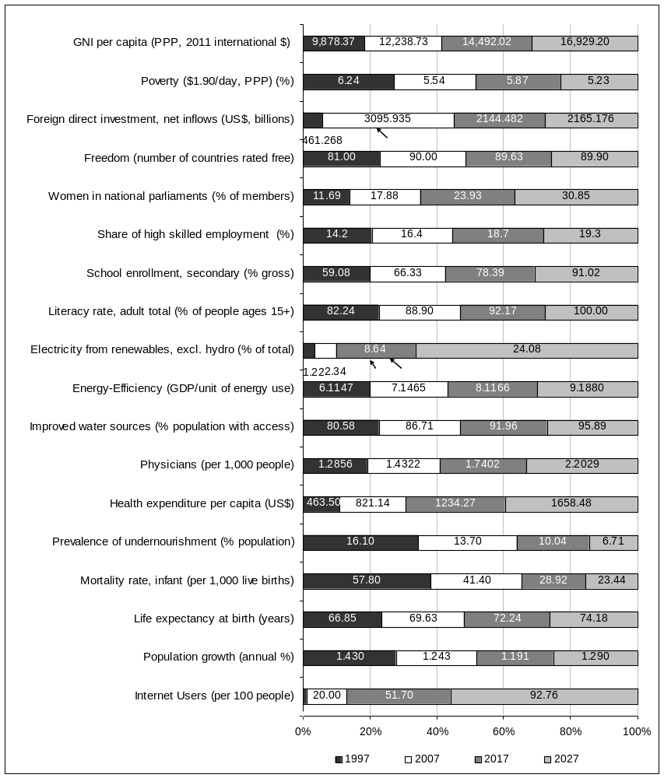

Figure 3 Where we are losing or there is no progress
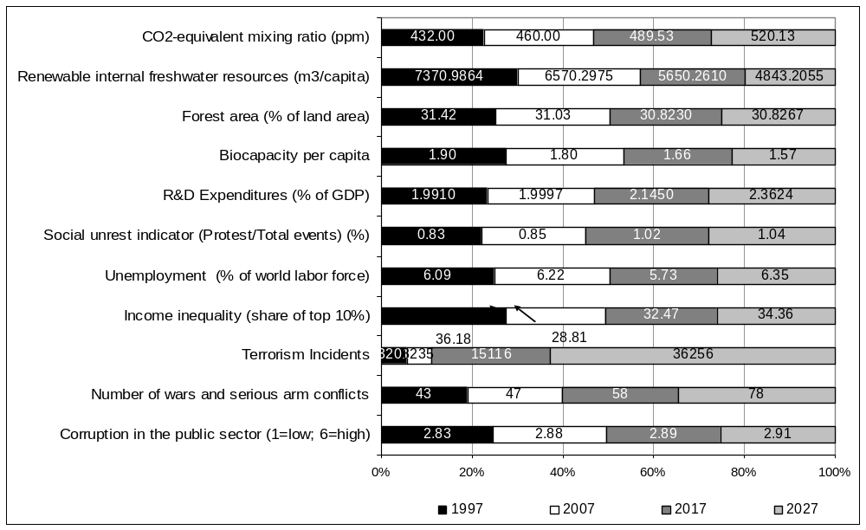
Although we are winning more than losing, where we are losing is very serious. “Business as usual” trend projections for water, food, unemployment, terrorism, organized crime, and pollution could create complex future disasters. Humanity has the means to avoid these disasters and build a great future, but too many of the necessary decisions and cultural changes to improve our prospects are not being made.
Even though the most significant of the world’s challenges and solutions are global in nature, global foresight and global-scale decisionmaking systems are rarely used. Global governance systems are not keeping up with growing global interdependence.

However, global decisionmaking may show signs of improvement with the implementation of the Paris Agreement on Climate Change, the UN 2030 Agenda for Sustainable Development, and advances in the International Organization for Standardization, the World Health Organization, and other international bodies.

“The United Nations Sustainable Development Goals (SDGs) and the Paris Climate Agreement provide the most powerful common agenda the world has ever seen for achieving peace and prosperity on a healthy planet.”
—The UN Global Compact

http://www.who.int/gho/mortality_burden_disease/life_tables/situation_trends/en/ and slight variation https://data.worldbank.org/indicator/SP.DYN.LE00.IN?end=2015.
https://www.reinsurancene.ws/2016-global-insured-losses-54-billion-swiss-re/.
http://www.systemicpeace.org/conflicttrends.html.
Millennium Project workshop on future terrorism and counter strategies workshop presentations are available at http://www.millennium-project.org/millennium/NATO-PredetectionWorkshop.html#agenda and the results are found in the NATO publication Identification of Potential Terrorists and Adversary Planning: Emerging Technologies and New Counter-Terror Strategies, edited by Theodore J. Gordon, Elizabeth Florescu, Jerome C. Glenn, and Yair Sharan, ISBN 978-1-61499-747-4, which can be ordered from IOS Press http://www.iospress.nl/book/identification-of-potential-terrorists-and-adversary-planning/.
2017 World Bank estimate, http://www.worldbank.org/en/topic/governance/brief/anti-corruption.

