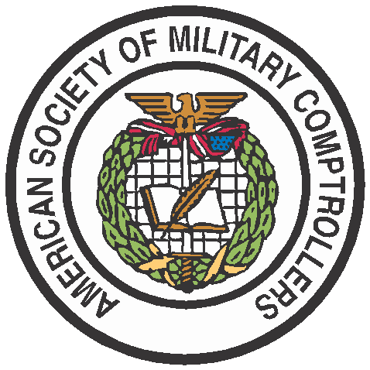




PRESS RELEASE
FOR IMMEDIATE RELEASE Media Contact: Melissa Blacketer
(703) 549-0360
blacketer@asmconline.org

ASMC Adds Three Additional Members to its Planning, Programming, Budgeting, and Execution (PPBE) Reform Task Force

Alexandria, VA (September 28, 2022) –The American Society of Military Comptrollers (ASMC) welcomed its newest members to join its PPBE Reform Task Force:

- Steve Spear, Senior Lecturer, MIT Sloan School of Management
- Jason Kaufman, President, Chertoff Group
- Derren Burrell, President, Veteran Ventures Capital

The new members will bring to the Task Force their expertise from the fields of academia and venture capitalism, contributing innovative and bold ideas that will support the Task Force’s mission and work plan. Venture Capital / Private Equity firms are the engine of innovation in the US economy today and an area that can be further leveraged by the Department of Defense in developing its acquisition strategies to support capability development.

“We are excited to have these distinguished experts and business leaders join the PPBE Reform Task Force,” said Rich Brady, ASMC CEO. “PPBE reform is the most important effort in defense resourcing in a generation, which not only impacts military readiness and advantage but also defense industry competitiveness.”

The PPBE Reform Task Force is responsible for increasing awareness and fostering public discussion on PPBE reform in the Department of Defense. Operating independently and in parallel with the Legislative Commission on PPBE Reform, the Task Force works to define a set of fundamental principles and policy actions to reimagine PPBE to meet the needs of the Executive Branch, the Legislative Branch, and industry in the 21st century. Task Force members represent expertise across all areas of PPBE, as well as technology, change management, contract and acquisition management, and data science in government and the private sector.

About ASMC:
ASMC, established in 1948, is the non-profit educational and professional organization for persons, military and civilian, involved in the overall field of defense financial management. ASMC promotes the education, training, and certification of its members, and supports the development and advancement of the defense financial management profession. The Society provides professional programs to keep members abreast of current issues and encourages the exchange of information, techniques, and approaches.
###

