NEWS RELEASE

First Mining Further Defines Expansion Opportunity and
Adds Second Drill Rig at the Duparquet Gold Project

- Drilling at Valentre target intersects 3.98 g/t Au over 8.7m and 1.82 g/t Au over 14.35m
- Confirms continuity of mineralization between Central Duparquet pit and Dumico pit and demonstrates resource expansion opportunity

August 28, 2024 – Vancouver, Canada – First Mining Gold Corp. (“First Mining” or the “Company”) (TSX: FF) (OTCQX: FFMGF) (FRANKFURT: FMG) is pleased to announce new drilling results from the 2024 Phase 3 diamond drilling program at its Duparquet Gold Project (“Duparquet Project” or the “Project”) located in Quebec, Canada. These new drill results further define resource expansion opportunities at an under-tested area termed the Valentre target (“Valentre”), where follow-up drilling is now taking place. Drilling continues on priority targets at the Project where a second drill rig is planned to mobilize in September, allowing First Mining to test regional exploration targets while concurrently advancing recent exploration discoveries at the North Zone (see news release dated June 18, 2024), Buzz (see news release dated February 22, 2024) and Valentre.
Recent drilling at Valentre has returned positive drill intercepts from an area of 175 m of strike length that is under tested and envisioned to establish mineralization continuity within a key area of the project. Highlights of the recent drilling include 3.98 g/t Au over 8.70 m (DUP24-026), and 1.82 g/t Au over 14.35 m (DUP24-027), demonstrating both encouraging grades and widths within an area of potential resource growth and further exploration opportunities.
“We continue to execute on an exploration plan that clearly demonstrates the resource growth potential at Duparquet, already one of the largest undeveloped gold projects in Canada” stated Dan Wilton, CEO of First Mining. “The success at Valentre is a tangible result of the hard work our exploration team has put into understanding the geology at Duparquet over the past two years and gives First Mining confidence in continued exploration success at this robust project.”
The Phase 3 drill program commenced in April with a total of approximately 5,700 m completed to date. This program aims to test priority targets focusing on multiple potential resource expansion zones across the Duparquet Project. The initial results returned from the Phase 3 campaign are from select holes at Valentre, which tests an area between the Central Duparquet and Dumico resource pit shells which was previously not drilled due to a historical property boundary. Further Phase 3 drilling has continued at the Buzz Zone and the North Zone Expansion target areas, with additional results expected for future release. Further drill testing is ongoing, focusing on other brownfields opportunities with the aim of identifying higher-grade zones and targeted resource expansion opportunities.
A plan map of the Valentre and Central Duparquet drill holes is presented in Figure 1, and corresponding assay highlights are presented in Table 1, with full assay results listed in Table 2 and drill hole locations in Table 3.

Table 1: Selected Significant Drill Intercepts, 2024 Phase 3 Drill Program – Valentre and Central Duparquet Targets
Hole ID |  | From (m) | To (m) | Length (m) | Grade (Au g/t)
DUP24-025 |  | 149.35 | 151.10 | 1.75 | 3.71
DUP24-025 | Incl. | 150.0 | 150.50 | 0.50 | 8.45
DUP24-025 |  | 210.4 | 225.35 | 14.95 | 0.82
DUP24-025 | Incl. | 220.65 | 224.55 | 3.90 | 1.98
DUP24-025 |  | 238.2 | 243.10 | 4.90 | 1.49
DUP24-026 |  | 163.0 | 171.70 | 8.70 | 3.98
DUP24-027 |  | 195.0 | 197.85 | 2.85 | 2.80
DUP24-027 |  | 250.55 | 264.90 | 14.35 | 1.82
DUP24-027 | Incl. | 263.0 | 264.00 | 1.00 | 5.62
*Reported intervals are drilled core lengths (true widths are estimated at 75-85% of the core length interval, assay values are uncut)
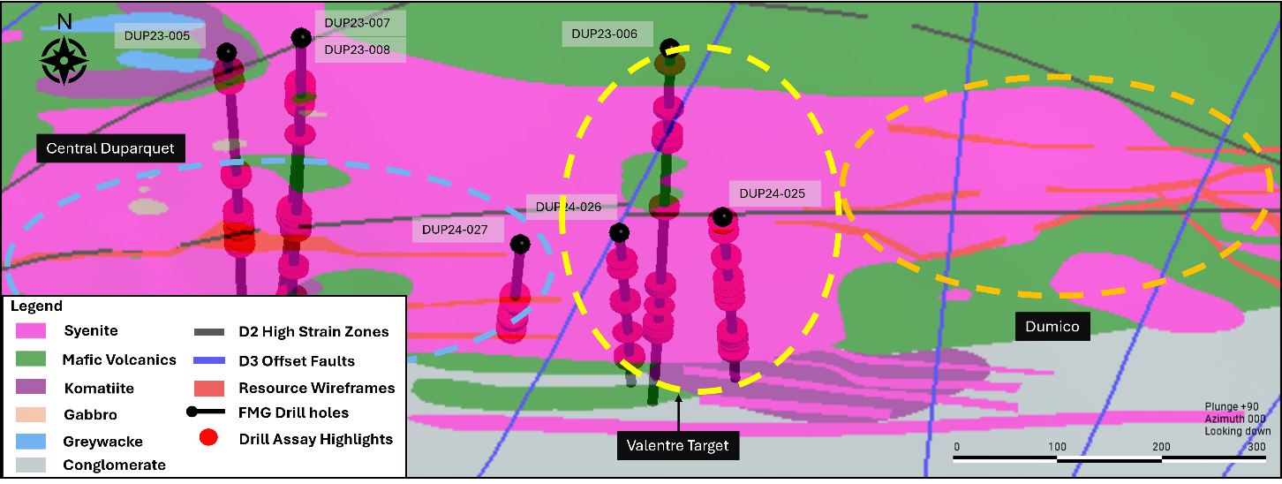
Figure 1: Plan view of select drill holes from the Phase 3 program at the Valentre Target area.
Additional Details on Valentre Drilling
The Valentre drilling strategy is focused on targeting resource growth opportunities towards the eastern side of the main resource where an opportunity for strike extension of the mineralization was identified. This mineralization extension opportunity spans 175 m on strike between two established centres of mineral resource wireframes (Central Duparquet and Dumico). During the 2023 drilling program, an initial single hole (DUP23-006) was drilled to test this opportunity, resulting in the successful identification of six intervals of significant gold mineralization including 1.71 g/t Au over 8.9m (refer to news release dated January 9, 2024).
The initial 2024 Valentre follow-up drilling campaign, comprising of three holes (DUP24-025, DUP24-026 and DUP24-027), has now confirmed continuity in the mineralization along strike and at depth. Mineralization in all three holes is associated with strong silica-altered syenite with dark grey quartz veining and up to 5% fine-grained disseminated pyrite throughout the unit as illustrated in Figures 2, 3 and 4. Higher-grade zones are consistent along interpreted D2 structures, which are characterized by strong shearing and/or brecciation observed in the core.
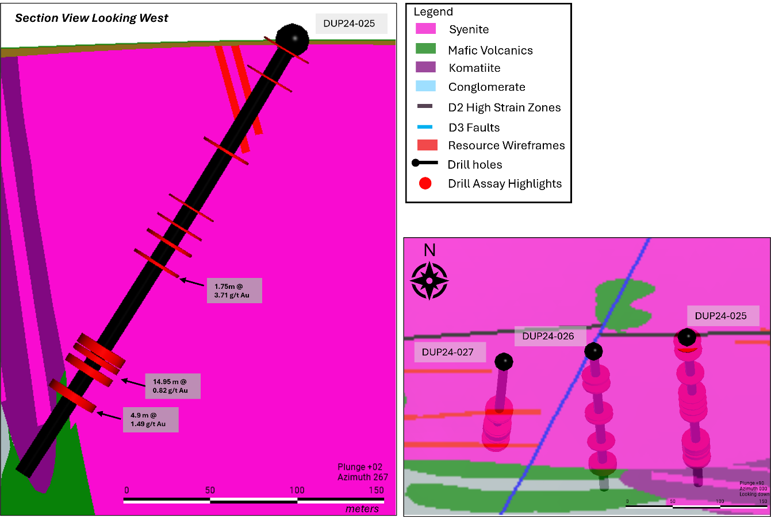
Figure 2: Valentre Target – DUP24-025 is a hole targeting the potential mineralization continuity between Central Duparquet and Dumico. Significant intercepts are highlighted downhole, with higher-grade zones identified along altered mineralized syenite units. The cross section is looking west.

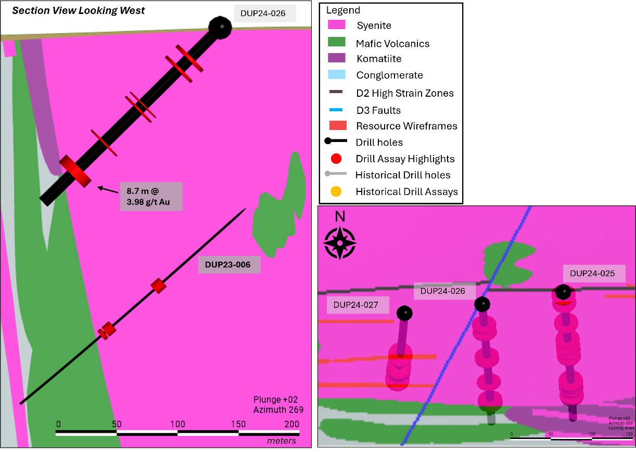
Figure 3: Valentre Target – DUP24-026 is a second hole targeting the potential mineralization continuity between Central Duparquet and Dumico. Significant intercepts are highlighted downhole, with higher-grade zones identified along altered mineralized syenite units. This drill hole is also a test of mineralization continuity up-dip of previously drilled hole DUP23-006. The cross section is looking west.

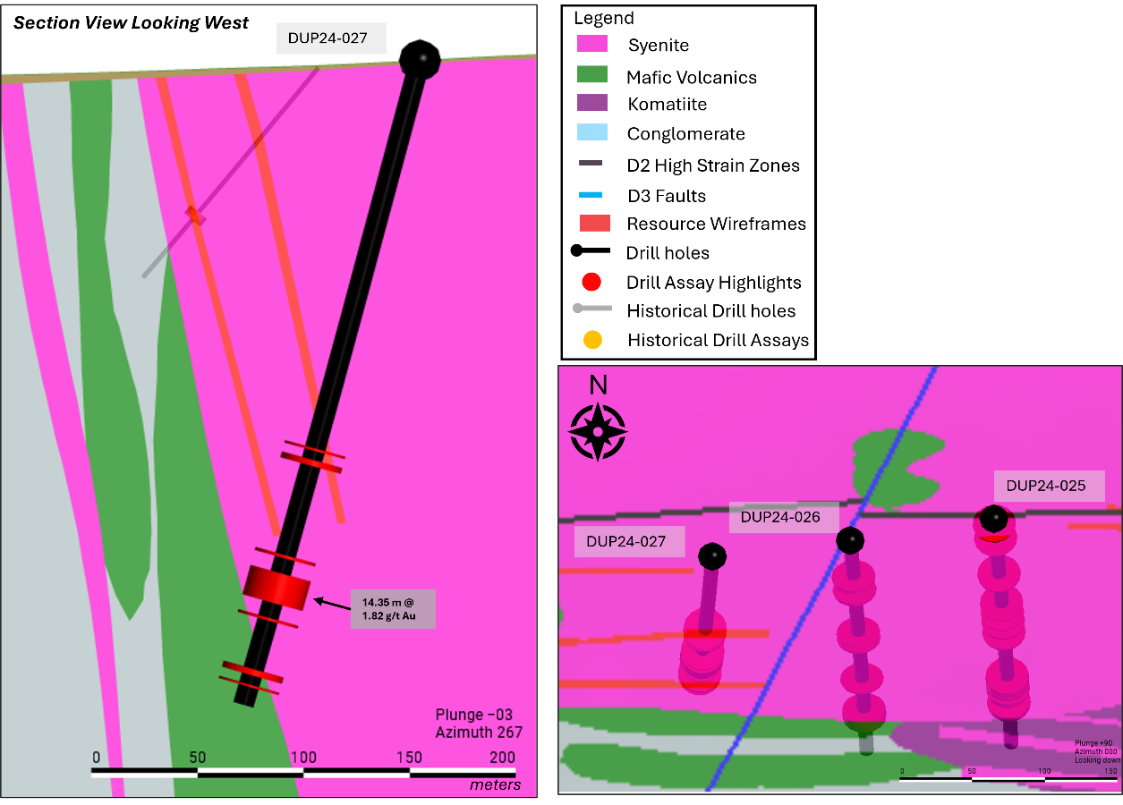
Figure 4: Central Duparquet Target – DUP24-027 is a hole targeting the potential mineralization continuity between Central Duparquet and Valentre as well as at depth. Significant intercepts are highlighted downhole, with higher-grade zones identified along altered mineralized syenite units. The cross section is looking west.
An additional 12 holes (Figure 5) are planned for Valentre in the 2024 drilling campaign, which aims to further test the strike extension as well as depth expansion opportunities alongside advancing the characterization of the mineralization in support of delineating higher-grade trends. This drilling will further provide support in new wireframe updates. Valentre has returned significant upside and value to the Duparquet Project and is a priority area for exploration optimization and potential extension of the current open pit and underground mineral resource. The recent drill results continue to support the area as a highly prospective target zone for the Project, with potential to unlock meaningful upside along strike and at depth (Figure 5).
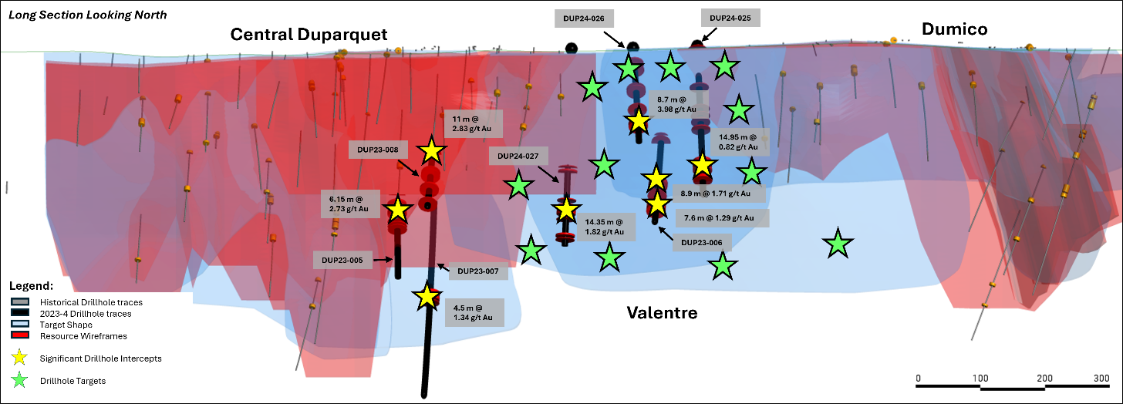
Figure 5: Representative long section through the Central Duparquet, Valentre, and Dumico Targets, highlighting the multiple significant intercepts returned in 2023 and in the 2024 Phase 3 program as well as the upcoming drill hole targets aimed at unlocking exploration opportunities.
Duparquet 2024 Exploration Program
Exploration activities continue to advance at the Duparquet Project through 2024, with ongoing drilling and regional field work programs. Exploration efforts are advancing with the follow up programs established through a prospectivity and target pipeline, which has recently been further augmented by the completion of an airborne geophysical magnetic and VLF-EM surveys as well as property wide expansion of the 3D geological and target model. The remainder of the 2024 program will advance with two drill rigs on the project and the close out of the summer field campaigns developed in support of the Company’s integrated geoscience exploration strategy.
Table 2: Phase 3 Valentre and Central Duparquet Drilling - Significant Assays
Hole ID |  | From (m) | To (m) | Length (m) | Grade (Au g/t)
DUP24-025 |  | 6.00 | 7.00 | 1.00 | 0.40
DUP24-025 |  | 25.00 | 26.00 | 1.00 | 0.72
DUP24-025 |  | 73.35 | 74.90 | 1.55 | 0.77
DUP24-025 |  | 112.00 | 113.00 | 1.00 | 4.85
DUP24-025 |  | 124.75 | 125.95 | 1.20 | 3.40
DUP24-025 |  | 135.45 | 137.35 | 1.90 | 0.74
DUP24-025 |  | 149.35 | 151.10 | 1.75 | 3.71
DUP24-025 | incl. | 150.00 | 150.50 | 0.50 | 8.45
DUP24-025 |  | 181.75 | 182.35 | 0.60 | 0.59
DUP24-025 |  | 207.00 | 208.00 | 1.00 | 0.92
DUP24-025 |  | 210.40 | 225.35 | 14.95 | 0.82
DUP24-025 | incl. | 220.65 | 224.55 | 3.90 | 1.98
DUP24-025 |  | 232.80 | 233.50 | 0.70 | 0.55
DUP24-025 |  | 238.20 | 243.10 | 4.90 | 1.49
DUP24-026 |  | 34.05 | 37.00 | 2.95 | 0.88
DUP24-026 |  | 46.85 | 49.25 | 2.40 | 0.55
DUP24-026 |  | 89.00 | 90.00 | 1.00 | 0.97
DUP24-026 |  | 94.00 | 95.65 | 1.65 | 0.52
DUP24-026 |  | 133.55 | 135.00 | 1.45 | 1.08
DUP24-026 |  | 163.00 | 171.70 | 8.70 | 3.98
DUP24-027 |  | 64.35 | 65.20 | 0.85 | 0.41
DUP24-027 |  | 189.50 | 190.65 | 1.15 | 0.90
DUP24-027 |  | 195.00 | 197.85 | 2.85 | 2.80
DUP24-027 |  | 207.80 | 208.65 | 0.85 | 0.47
DUP24-027 |  | 241.75 | 243.20 | 1.45 | 0.58
DUP24-027 |  | 250.55 | 264.90 | 14.35 | 1.82
DUP24-027 | incl. | 263.00 | 264.00 | 1.00 | 5.62
DUP24-027 |  | 272.25 | 273.50 | 1.25 | 2.74
DUP24-027 |  | 297.50 | 300.45 | 2.95 | 1.33
DUP24-027 |  | 305.00 | 306.00 | 1.00 | 1.26
*Reported intervals are drilled core lengths (true widths are estimated at 75-85% of the core length interval; assay values are uncut)

Table 3: Phase 3 Drill Hole Locations, Valentre and Central Duparquet Targets
Hole ID | Azimuth (°) | Dip (°) | Length (m) | Easting | Northing
DUP24-025 | 175 | -60 | 294 | 633555 | 5373924
DUP24-026 | 175 | -45 | 177 | 633456 | 5373909
DUP24-027 | 185 | -75 | 315 | 633361 | 5373898
Note: Collar coordinates in UTM NAD 83 z17

About the Duparquet Gold Project
The Duparquet Project is geologically situated in the southern part of the Abitibi Greenstone Belt and is geographically located approximately 50 km north of the city of Rouyn-Noranda. The Project benefits from easy access and proximity to an existing workforce and infrastructure, including road, rail and hydroelectric grid power. The Duparquet Project currently hosts an NI 43-101 compliant gold resource of 3.43 million ounces in the Measured & Indicated category, grading 1.55 g/t Au, and an additional 2.64 million ounces in the Inferred category, grading 1.62 g/t Au. First Mining completed a Preliminary Economic Assessment¹ (“PEA”) on the Project in 2023 (see news releases dated September 7, 2023 and October 23, 2023).
The Duparquet Project totals approximately 5,800 hectares focused on an area of 19 km of strike length along the prolific Destor-Porcupine Fault Zone, along with numerous mineralized splays and influential secondary lineaments. The Duparquet Project includes the past-producing Beattie, Donchester and Duquesne mines as well as the Central Duparquet, Dumico and Pitt Gold deposits.
¹ Further details on the Duparquet PEA can be found in the technical report entitled “NI 43-101 Technical Report: Preliminary Economic Assessment, Duparquet Gold Project, Quebec, Canada” dated October 20, 2023, which was prepared for First Mining by G Mining Services Inc. in accordance with NI 43-101 and is available under First Mining’s SEDAR profile at www.sedarplus.ca
Analytical Laboratory and QA/QC Procedures
All sampling completed by First Mining within its exploration programs is subject to a Company standard of internal quality control and quality assurance (QA/QC) programs which include the insertion of certified reference materials, blank materials and a level of duplicate analysis. Core samples from the 2024 drilling program at Duparquet were sent to AGAT Laboratories, with sample preparation in Val d’Or and analysis in Thunder Bay, where they were processed for gold analysis by 50 gram fire assay with an atomic absorption finish. Samples from selected holes were sent to AGAT Laboratories in Calgary, Alberta, for multi-element analysis (including silver) by inductively coupled plasma (ICP) method with a four acid digest. AGAT Laboratories systems conform to requirements of ISO/IEC Standard 17025 guidelines and meets assay requirements outlined for NI 43-101.
Qualified Person
Louis Martin, P.Geo., Senior Geologic Consultant of First Mining, is a “Qualified Person” for the purposes of NI 43-101 Standards of Disclosure for Mineral Projects, and has reviewed and approved the scientific and technical disclosure contained in this news release.
About First Mining Gold Corp.
First Mining is a gold developer advancing two of the largest gold projects in Canada, the Springpole Gold Project in northwestern Ontario, where we have commenced a Feasibility Study and permitting activities are on-going with a draft Environmental Impact Statement (“EIS”) for the project published in June 2022, and the Duparquet Project in Quebec, a PEA-stage development project located on the Destor-Porcupine Fault Zone in the prolific Abitibi region. First Mining also owns the Cameron Gold Project in Ontario and a portfolio of gold project interests including the Pickle Crow Gold Project (being advanced in partnership with Firefly Metals Ltd.) and the Hope Brook Gold Project (being advanced in partnership with Big Ridge Gold Corp.).
First Mining was established in 2015 by Mr. Keith Neumeyer, founding President and CEO of First Majestic Silver Corp.
ON BEHALF OF FIRST MINING GOLD CORP.
Daniel W. Wilton
Chief Executive Officer and Director

For further information, please contact:
Toll Free: 1 844 306 8827 | Email: info@firstmininggold.com
Paul Morris | Director, Investor Relations | Email: paul@firstmininggold.com

Cautionary Note Regarding Forward-Looking Statements
This news release includes certain “forward-looking information” and “forward-looking statements” (collectively “forward-looking statements”) within the meaning of applicable Canadian and United States securities legislation including the United States Private Securities Litigation Reform Act of 1995. These forward-looking statements are made as of the date of this news release. Forward-looking statements are frequently, but not always, identified by words such as “expects”, “anticipates”, “believes”, “plans”, “projects”, “intends”, “estimates”, “envisages”, “potential”, “possible”, “strategy”, “goals”, “opportunities”, “objectives”, or variations thereof or stating that certain actions, events or results “may”, “could”, “would”, “might” or “will” be taken, occur or be achieved, or the negative of any of these terms and similar expressions.
Forward-looking statements in this news release relate to future events or future performance and reflect current estimates, predictions, expectations or beliefs regarding future events. All forward-looking statements are based on First Mining's or its consultants' current beliefs as well as various assumptions made by them and information currently available to them. There can be no assurance that such statements will prove to be accurate, and actual results and future events could differ materially from those anticipated in such statements. Forward-looking statements reflect the beliefs, opinions and projections on the date the statements are made and are based upon a number of assumptions and estimates that, while considered reasonable by the respective parties, are inherently subject to significant business, economic, competitive, political and social uncertainties and contingencies. Such factors include, without limitation the Company’s business, operations and financial condition potentially being materially adversely affected by the outbreak of epidemics, pandemics or other health crises, and by reactions by government and private actors to such outbreaks; risks to employee health and safety as a result of the outbreak of epidemics, pandemics or other health crises, that may result in a slowdown or temporary suspension of operations at some or all of the Company's mineral properties as well as its head office; fluctuations in the spot and forward price of gold, silver, base metals or certain other commodities; fluctuations in the currency markets (such as the Canadian dollar versus the U.S. dollar); changes in national and local government, legislation, taxation, controls, regulations and political or economic developments; risks and hazards associated with the business of mineral exploration, development and mining (including environmental hazards, industrial accidents, unusual or unexpected formations, pressures, cave-ins and flooding); the presence of laws and regulations that may impose restrictions on mining; employee relations; relationships with and claims by local communities, indigenous populations and other stakeholders; availability and increasing costs associated with mining inputs and labour; the speculative nature of mineral exploration and development; title to properties.; and the additional risks described in the Company’s Annual Information Form for the year ended December 31, 2023 filed with the Canadian securities regulatory authorities under the Company’s SEDAR+ profile at www.sedarplus.ca, and in the Company’s Annual Report on Form 40-F filed with the SEC on EDGAR.
First Mining cautions that the foregoing list of factors that may affect future results is not exhaustive. When relying on our forward-looking statements to make decisions with respect to First Mining, investors and others should carefully consider the foregoing factors and other uncertainties and potential events. First Mining does not undertake to update any forward-looking statement, whether written or oral, that may be made from time to time by the Company or on our behalf, except as required by law.
Cautionary Note to United States Investors
The Company is a “foreign private issuer” as defined in Rule 3b-4 under the United States Securities Exchange Act of 1934, as amended, and is eligible to rely upon the Canada-U.S. Multi-Jurisdictional Disclosure System, and is therefore permitted to prepare the technical information contained herein in accordance with the requirements of the securities laws in effect in Canada, which differ from the requirements of the securities laws currently in effect in the United States. Accordingly, information concerning mineral deposits set forth herein may not be comparable with information made public by companies that report in accordance with U.S. standards.

Technical disclosure contained in this news release has not been prepared in accordance with the requirements of United States securities laws and uses terms that comply with reporting standards in Canada with certain estimates prepared in accordance with NI 43-101.

NI 43-101 is a rule developed by the Canadian Securities Administrators that establishes standards for all public disclosure an issuer makes of scientific and technical information concerning the issuer’s material mineral projects.

