Busch family partners with Assouline Capital to buy Red South Beach hotel
Longtime owner Simon Nemni sold the 110-key hotel for $33M
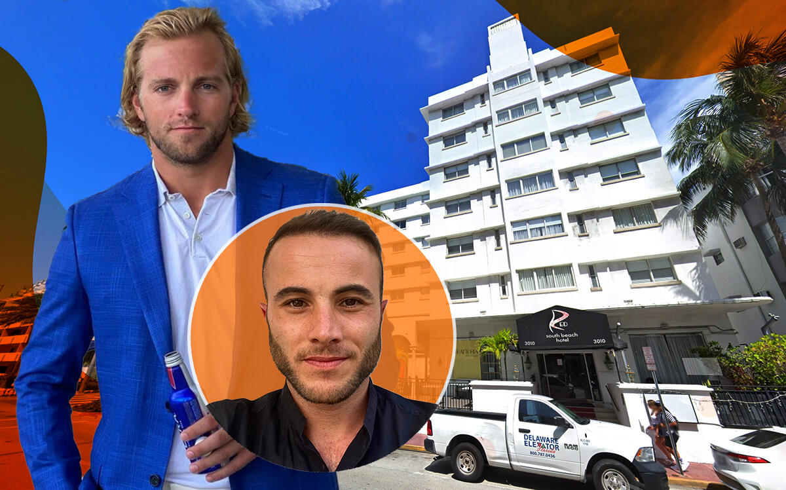

UPDATED, Sept. 23, 10:05 a.m.: Tom Assouline and members of the Busch beer family hope to make a splash in Miami Beach with their purchase of the Red South Beach hotel for $33 million.
A joint venture of Assouline Capital and Busch Real Estate, led by August “Gussie” Busch, paid $300,000 per key for the 110-room hotel at 3010 Collins Avenue, they said.
The buyers financed the deal with a $31 million loan from Michael Dell’s MSD Partners. Max Ralby of HKS Real Estate Advisors in New York arranged the financing.
The seller was 3010 Collins LLC, an entity led by French developer Simon Nemni, records show. The Moderne-style building, which in past lives has been called the Munroe Towers and The Villa Capri All Suites Hotel & Beach Club, among other names, was built in 1939 by Charles Rubin and designed by T. Hunter Henderson, according to the hotel’s website.
The property, which comes with a pool, restaurant and gym, last sold in 2009 for $9 million, records show. The buyers plan to renovate the property and reposition it by the end of next year, they said, though they will continue to operate it as a hotel.
Busch, a former football player at the University of Alabama, reality TV star and great-great-grandson of Anheuser-Busch co-founder Adolphus Busch, said his family’s investment marks the first of “many” to come in Miami Beach. The joint-venture partners said they’re looking at additional hotels, as well as multifamily properties.

Assouline said he’s been targeting underperforming hotels since the start of the pandemic. Last year, Assouline’s LWHT Property Management, a Coral Springs-based firm, paid $27.2 million for six boutique hotel and motel properties in Fort Lauderdale Beach. He has acquired and managed about $150 million worth of real estate in South Florida, he said.
The Busch family, among the wealthiest in the U.S., ran Anheuser-Busch until 2008, when Belgian-Brazilian conglomerate InBev completed a $52 billion hostile takeover of the company. A number of family members and heirs to the beer fortune have owned homes in South Florida.

