NEWS RELEASE

First Mining Expands and Advances High-Grade Gold
Discovery at its Birch-Uchi Greenstone Belt Project

September 9, 2024 – Vancouver, Canada – First Mining Gold Corp. (“First Mining” or the “Company”) (TSX: FF) (OTCQX: FFMGF) (FRANKFURT: FMG) is pleased to announce new assay results for the Challenger high-grade gold discovery at the Company’s Birch-Uchi Greenstone Belt Project (“BUGB Project” or the “Project”) located in northwestern Ontario, Canada. The Challenger target area is located 12 km southwest of the First Mining’s flagship Springpole Gold Project and has become one of several high priority exploration targets for the Company.
The 2024 follow-up field mapping program has yielded four new gold occurrences, including visible gold in grab and channel samples, that are proximal to the original 2023 discovery area. The new results also include detailed channel sampling across the discovery area with assay highlights of 6.53 g/t Au over 3 m (including 57.8 g/t Au over 0.3 m) and grab sample assays at the new outcrop sites of up to 26.6 g/t Au, 20.3 g/t Au, and 7.73 g/t Au. First Mining has now established a series of significant high-grade samples within additional outcrops that expand the mineralization footprint of the original discovery area (see news release dated December 5, 2023).
"We are extremely excited to be returning additional high-grade results from an emerging discovery in the Challenger target area, hosted in the Red Lake Mining District and in close proximity to our flagship Springpole Gold Project, stated Dan Wilton, CEO of First Mining Gold. “We fully believe that the endowment surrounding our Birch-Uchi Greenstone Project is at an early stage of maturity where immense value in discovery can be realized through our exploration efforts. While our Springpole Gold Project is in the final stages of its environmental assessment preparation, these exploration efforts will continue to demonstrate district-scale potential around Springpole.”
Challenger Target Highlights:
- Four newly discovered gold mineralization occurrences, including visible gold, in proximity to the Challenger discovery, with samples grading up to 26.60 g/t Au, 20.3 g/t Au and 7.73 g/t Au
- New channel sample results grading up to 6.53 g/t Au over 3 m (including 57.4 g/t Au over 0.3 m)
- Proximity to an expanding gold mineralization system identified in First Mining’s 2023 winter drill program (Challenger is located 375 m northwest of the Saddle target), where Saddle drilling returned 0.92 g/t Au over 114 m (see news release dated July 6, 2023)
- Located approximately 12 km southwest of the Company’s Springpole Gold Project
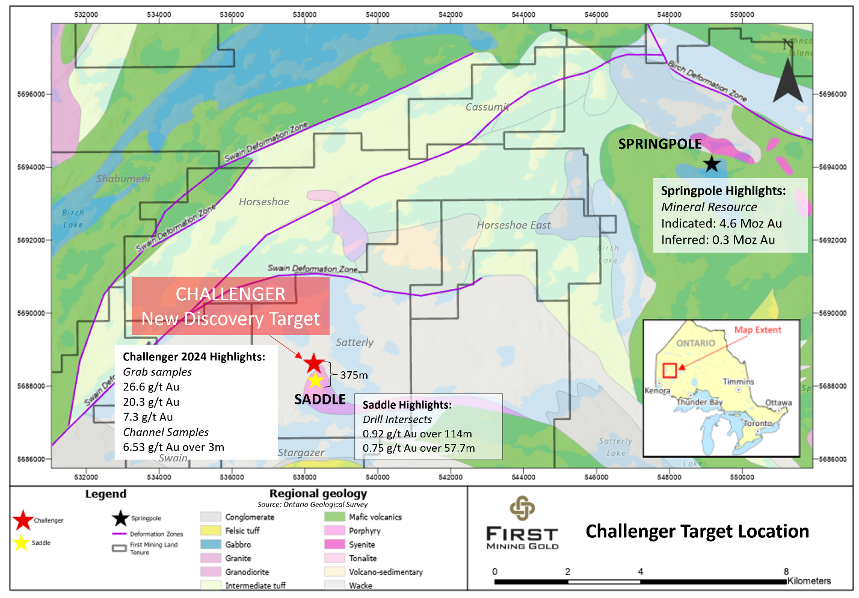
Figure 1: Challenger Discovery and Saddle Target Location, 12 km SW of the Springpole Gold Project
Table 1: Selected Rock Grab Sample Assays from the Challenger Target
Sample ID | UTM (E) | UTM (N) | Au (g/t) | Target
C262503 | 538228 | 5688539 | 2.85 | Challenger
C262506 | 538218 | 5688565 | 26.6 | Challenger
C262511 | 538045 | 5688390 | 20.3 | Challenger
C262513 | 538031 | 5688385 | 3.76 | Challenger
C262636 | 538302 | 5688461 | 1.67 | Challenger
C262637 | 538304 | 5688465 | 7.73 | Challenger
C262701 | 538485 | 5688727 | 3.74 | Challenger
C262708 | 538530 | 5688644 | 1.35 | Challenger
Note: Rock grab samples are selective in nature and may not be indicative of the true grade and style of mineralization on the property. Coordinates are in UTM, WGS84 Zone15N.

Table 2: Selected Channel Sample Assays from the Challenger Target
Channel ID |  | From (m) | To (m) | Length (m) | Grade (Au g/t) | Target Area
SAT24C-001 |  | 0.70 | 2.40 | 1.70 | 2.17 | Challenger
SAT24C-001 | inc. | 0.70 | 1.10 | 0.40 | 4.65 | Challenger
SAT24C-002 |  | 00.30.3 | 2.00 | 1.70 | 2.57 | Challenger
SAT24C-002 | inc. | 0.30 | 1.30 | 1.00 | 3.81 | Challenger
SAT24C-003 |  | 0.40 | 3.40 | 3.00 | 6.53 | Challenger
SAT24C-003 | inc. | 2.10 | 2.40 | 0.30 | 57.80 | Challenger
SAT24C-004 |  | 0.55 | 1.80 | 1.25 | 2.01 | Challenger
SAT24C-005 |  | 0.75 | 1.70 | 0.95 | 3.53 | Challenger
SAT24C-008 |  | 0.75 | 1.35 | 0.60 | 6.08 | Challenger
Note: Channel samples are selective in nature and may not be indicative of the true grade, width and style of mineralization on the property

Challenger Target
The Challenger target is located approximately 12 km southwest of First Mining’s Springpole Gold Project (see Figure 1), which hosts a NI 43-101 mineral resource of 151 million tonnes at 0.94 g/t Au, totalling 4.6 million ounces of gold in the Indicated category, and 16 million tonnes at 0.54 g/t Au, totalling 0.3 million ounces of gold in the Inferred category*. The Challenger target is hosted within the Company’s BUGB Project, where locally a significantly deformed and mineralized granodiorite intrusive occurs in contact with clastic sedimentary turbidites and conglomerates. Mineralization identified to date is associated with a series of interpreted parallel zones of increased silica and carbonate-altered shear structures and is now seen to occur over an expanded area of approximately 200 x 600 metres, with high concentrations of multiphase quartz veining within a thick bedded turbidite sequence. The dominant sulphide mineralization is composed of pyrite and occurs as very fine-grained disseminations averaging an abundance of 1-5%. At least two generations of quartz veining are documented subparallel and orthogonal to the controlling structure and vary from 1 cm to 50 cm in scale. Mineralization is coincident with geophysical resistivity low signatures interpreted to be associated with large-scale folding and associated deformation within the clastic sedimentary lithology. The 2024 field results indicate that several high-grade mineralized structures exist, with an open opportunity for further expansion and characterization with additional exploration work including diamond drilling.
* Details of the Springpole Gold Project mineral resource can be found in the technical report entitled “NI 43-101 Technical Report and Pre-Feasibility Study on the Springpole Gold Project, Ontario, Canada” which was prepared by AGP Mining Consultants Inc. in accordance with National Instrument 43-101 Standards of Disclosure for Mineral Projects (“NI 43-101”) and has an effective date of January 20, 2021.

2024 Challenger Summer Field Campaign
The 2024 summer field campaign for the Challenger area focused on mineralization expansion and characterization of the discovery area with a specific emphasis on mapping and prospecting, channel sampling and soil geochemistry programs. First Mining’s exploration teams this year completed 8 km of mapping transects, 9 channel samples, 59 grab samples, and 289 soil samples across the area to enhance the local and regional data resolution and geological understanding of this underexplored area.
Results of the 2024 Challenger target follow-up exploration program were successful in further expanding the mineralization along strike, with newly discovered mineralized outcrops to the west and southwest, supporting efforts in building up the geological understanding of the setting and controls on mineralization. The most westerly outcrop discovered returned visible gold in sample C261094 (Figure 2) and validated a further 40 m westerly strike extension from the second Challenger extension outcrop which returned 7.1 g/t Au in the 2023 program and which was already a 60 m extension from the initial 2023 Challenger discovery outcrop which returned 25.6 g/t Au (Figure 3). This latest western extension was channel sampled (SAT24C-001) and returned assays of 2.17 g/t Au over 1.7 m, including 0.4 m at 4.65 g/t Au, expanding the current established surface strike extent to 100 m (Figures 3, 4).
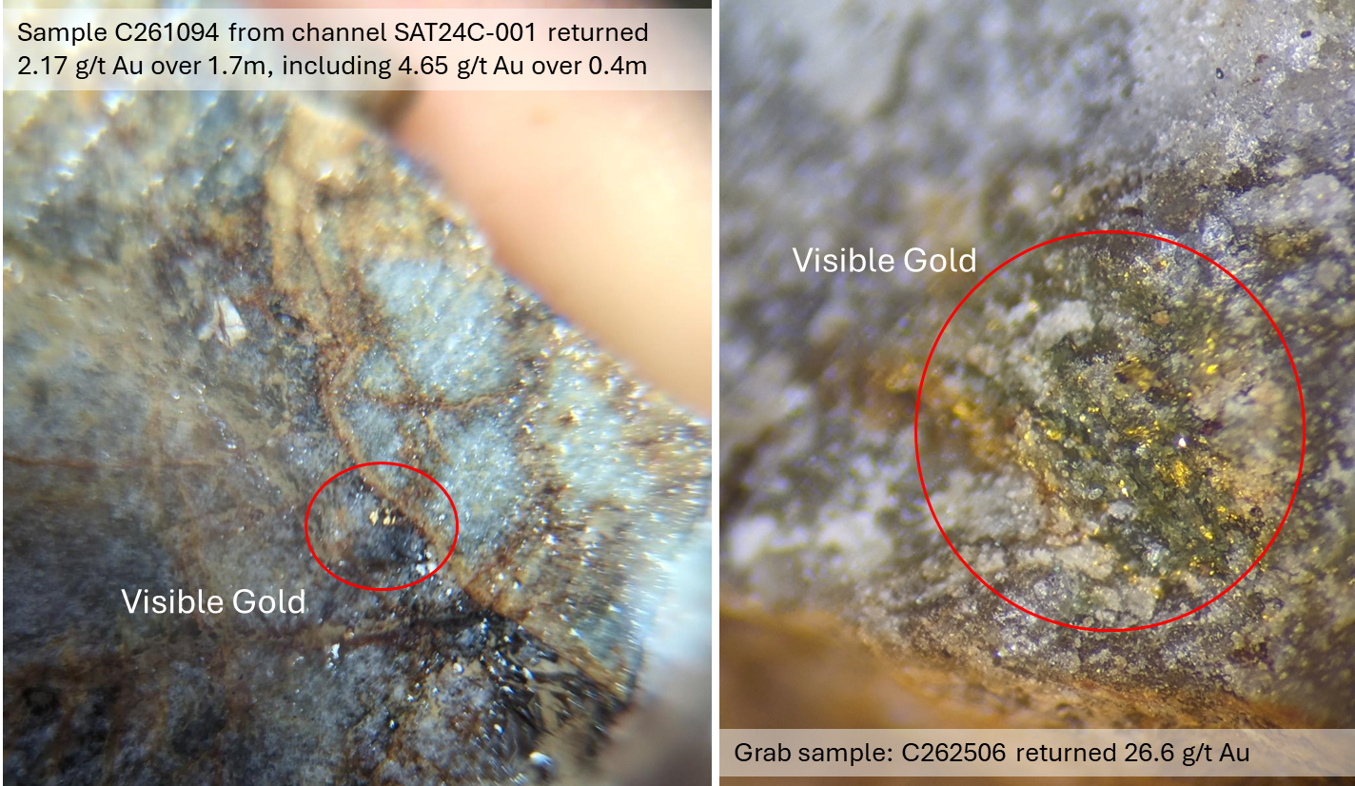
Figure 2 : Photos Showing Visible Gold in Grab Samples at the Challenger Target

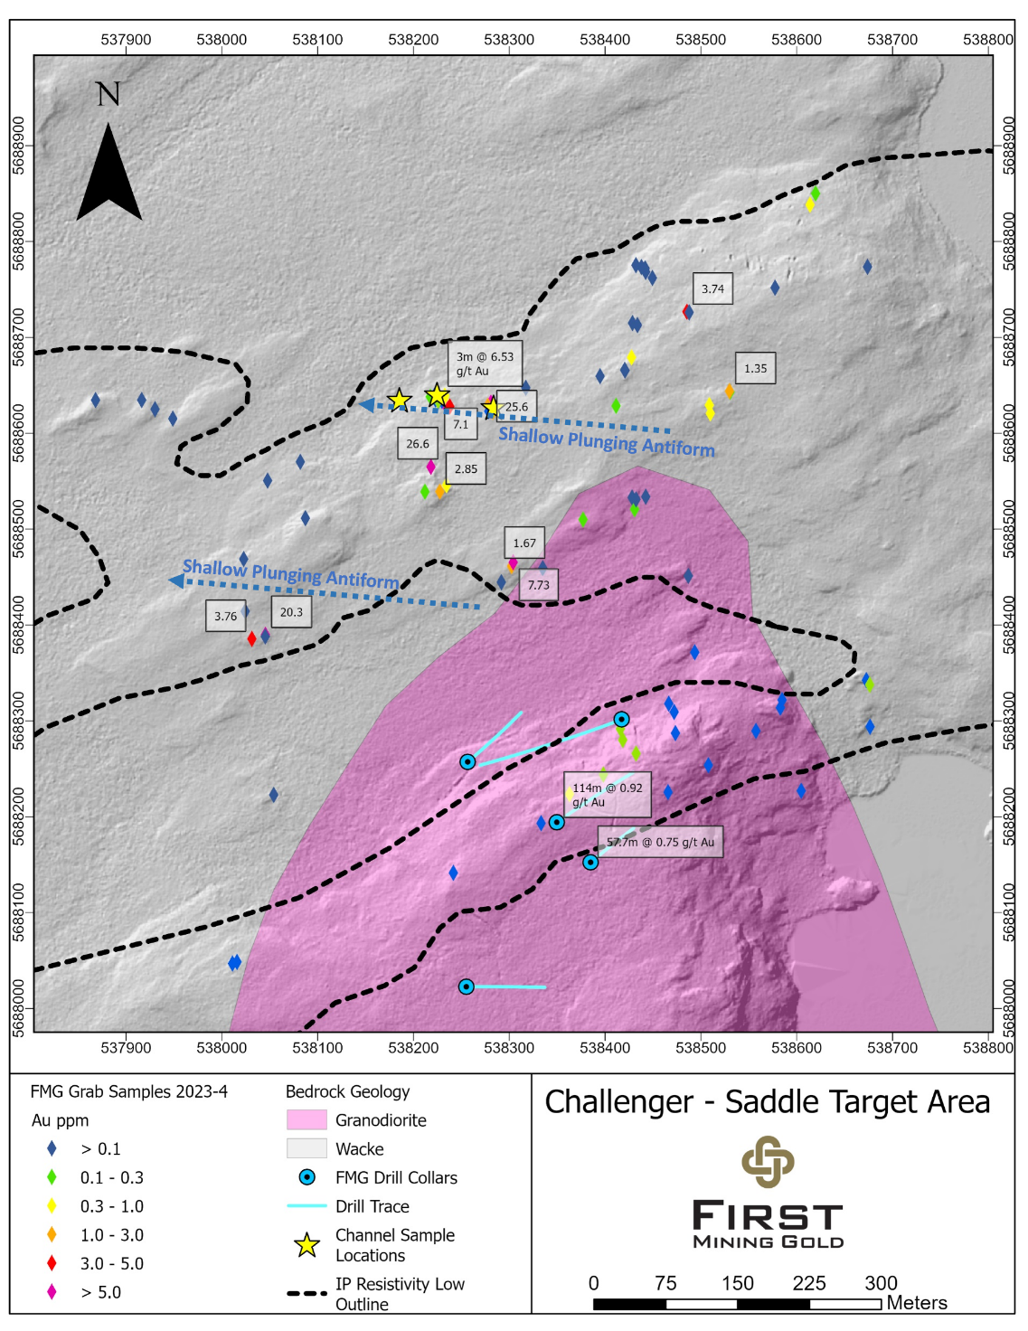
Figure 3: Grab Sample Highlights from the 2023-2024 Programs in the Saddle-Challenger Target Areas

Additional highlights from the Challenger target channel sampling program are SAT24C-002 returning 2.57 g/t Au over 1.7 m, including 3.81 g/t Au over 1 m, and SAT24C-003 returning 6.53 g/t Au over 3 m, including 57.80 g/t Au over 0.3 m from the silica-ankerite altered sheared structure with its two distinct quartz vein generations (Figure 4).
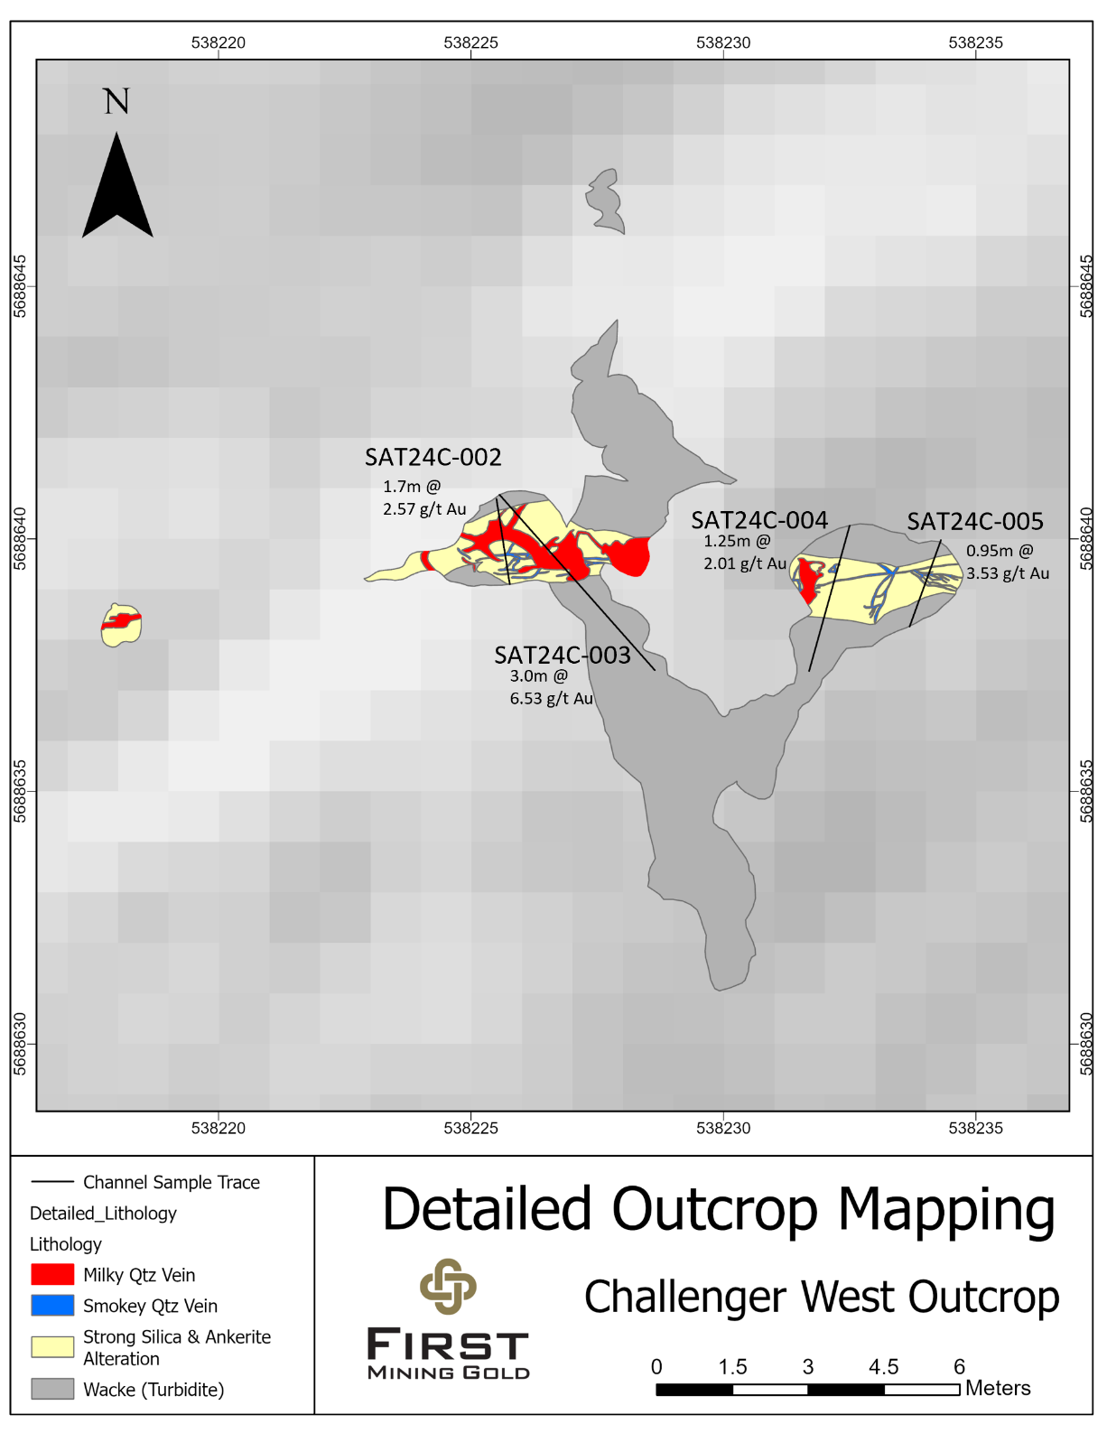
Figure 4 Example of the Detailed Outcrop Mapping at the Challenger Target, including Channel Sample Locations
Additional mineralized outcrops were identified 75 m to the southwest of the Challenger discovery target, returning up to 26.6 g/t Au in grab sample C262506, including visible gold (Figure 3).
A new area of gold mineralization was identified between Challenger and Saddle and initial data supports this to be a third interpreted trend (“Charger”) for further exploration advancement. Initial results from the Charger target trend returned up to 20.3 g/t Au in grab sample C262511 and 3.76 g/t Au in grab sample C262513, approximately 300 m towards the southwest of the Challenger discovery outcrop. Additional supporting grab samples include 7.73 g/t Au (C262637) and a 1.67 g/t Au grab sample (C262636), located approximately 165 m to the south of Challenger. There is an estimated 270 m distance between the two sample locations that remains open for exploration continuity. The Charger target is interpreted to be a parallel trend to the original Challenger discovery (Figure 5).
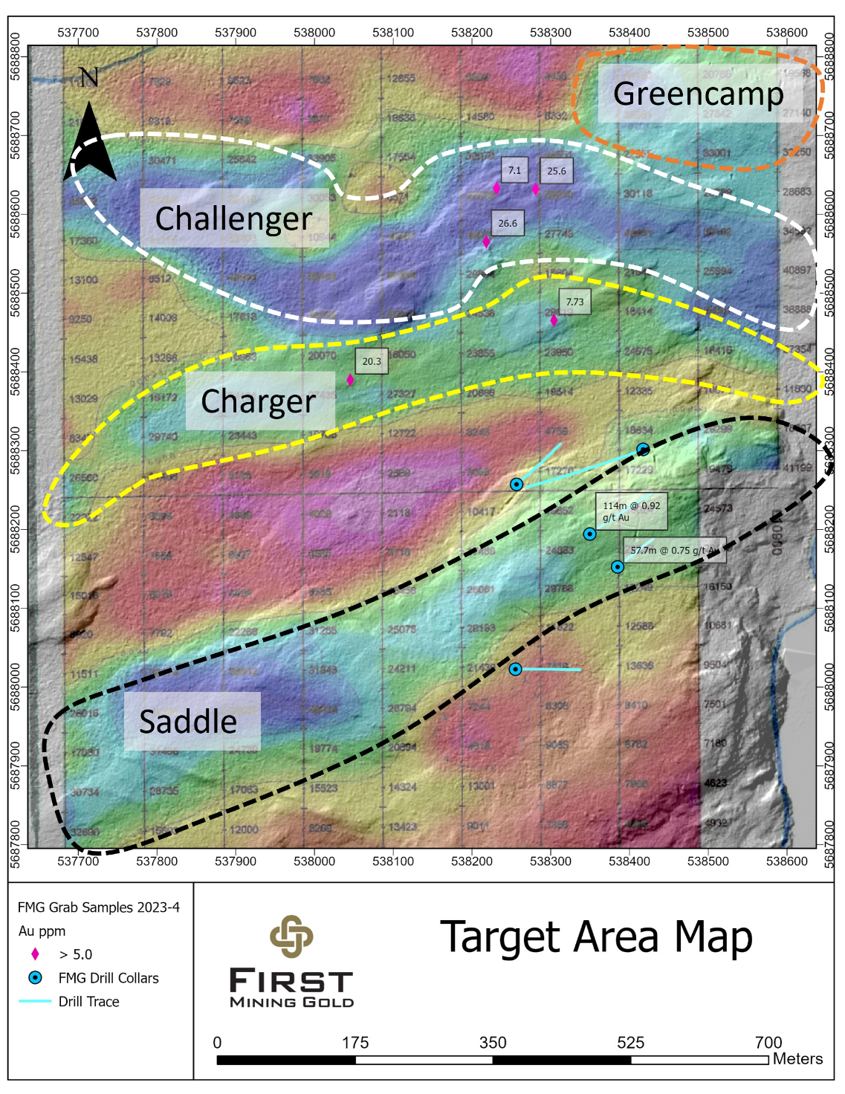
Figure 5: Location Map of Main Targets Saddle and Challenger, including Charger Trend and Greencamp

The geoscience data around the Challenger target and Charger target trend highlights the importance of the relationships between the surface mineralization, shear structures and an alteration expression that is coincident with a series of resistivity low signatures. Mapping campaigns have further enhanced the structural interpretation supporting the delineation of key fold structures, which are shallowly plunging towards the west along the trends of mineralization (Figure 3). Early indications support that the target area’s mineralization trends coincide with axial planar mapped fold structures, which are within clastic sedimentary units. By recognizing these relationships, exploration efforts are being more directed and focused on areas for favourable gold endowment.
Throughout the remainder of the 2024 program, exploration campaigns will be focused on completing final transects, reviewing assay data which is still pending from an infill soil geochemical survey, and updating interpretations for target model development and forward drill planning for this area.
“Unlocking new discoveries is a fundamental objective for our exploration teams in their efforts to advance a pipeline of prospective targets surrounding the Company’s Birch-Uchi Greenstone Belt Project and flagship Springpole Project”, stated James Maxwell, VP Exploration and Project Operations for First Mining Gold. “We look forward to providing additional updates on our regional exploration efforts where a number of high priority targets are gaining momentum.”
All assay results from the Challenger target grab and channel sample program are reported below in Table 3 and Table 4 which includes sample location data.
Table 3: Complete Grab Sample Assay Results at the Challenger and Saddle Target Areas
Sample ID | UTM (E) | UTM (N) | Grade ( Au g/t) | Target
C262501 | 538292 | 5688445 | 0.09 | Charger
C262502 | 538212 | 5688539 | 0.19 | Challenger
C262503 | 538228 | 5688539 | 2.85 | Challenger
C262504 | 538235 | 5688546 | 0.40 | Challenger
C262506 | 538218 | 5688565 | 26.60 | Challenger
C262508 | 538087 | 5688511 | 0.03 | Challenger
C262509 | 538024 | 5688414 | 0.06 | Charger
C262511 | 538045 | 5688390 | 20.30 | Charger
C262512 | 538045 | 5688388 | 0.08 | Charger
C262513 | 538031 | 5688385 | 3.76 | Charger
C262514 | 538054 | 5688223 | 0.001 | Charger
C262515 | 538082 | 5688570 | 0.002 | Challenger
C262516 | 538048 | 5688551 | 0.01 | Challenger
C262517 | 538023 | 5688469 | 0.01 | Challenger
C262518 | 537868 | 5688635 | 0.001 | Challenger
C262519 | 537916 | 5688635 | 0.001 | Challenger
C262521 | 537930 | 5688625 | 0.001 | Challenger
C262522 | 537949 | 5688615 | 0.001 | Challenger
C262523 | 538218 | 5688638 | 0.29 | Challenger
C262524 | 538317 | 5688647 | 0.001 | Challenger
C262526 | 538577 | 5688752 | 0.02 | Greencamp
C262527 | 538614 | 5688838 | 0.40 | Greencamp
C262528 | 538620 | 5688850 | 0.22 | Greencamp
C262636 | 538302 | 5688461 | 1.67 | Charger
C262637 | 538304 | 5688465 | 7.73 | Charger
C262638 | 538335 | 5688459 | 0.02 | Charger
C262639 | 538377 | 5688510 | 0.12 | Charger
C262641 | 538428 | 5688533 | 0.01 | Challenger
C262642 | 538442 | 5688534 | 0.05 | Challenger
C262643 | 538431 | 5688521 | 0.17 | Challenger
C262644 | 538432 | 5688531 | 0.09 | Challenger
C262646 | 538674 | 5688774 | 0.001 | Greencamp
C262647 | 538442 | 5688768 | 0.01 | Challenger
C262648 | 538449 | 5688762 | 0.04 | Challenger
C262649 | 538442 | 5688772 | 0.02 | Challenger
C262651 | 538432 | 5688775 | 0.01 | Challenger
C262652 | 538438 | 5688773 | 0.07 | Challenger
C262653 | 538434 | 5688713 | 0.003 | Challenger
C262654 | 538429 | 5688715 | 0.004 | Challenger
C262656 | 538428 | 5688679 | 0.31 | Challenger
C262657 | 538420 | 5688666 | 0.001 | Challenger
C262658 | 538421 | 5688666 | 0.01 | Challenger
C262659 | 538395 | 5688660 | 0.01 | Challenger
C262661 | 538411 | 5688629 | 0.27 | Challenger
C262701 | 538485 | 5688727 | 3.74 | Challenger
C262702 | 538488 | 5688726 | 0.01 | Challenger
C262703 | 538487 | 5688451 | 0.09 | Charger
C262704 | 538510 | 5688621 | 0.32 | Challenger
C262705 | 538509 | 5688629 | 0.32 | Challenger
C262707 | 538530 | 5688643 | 0.23 | Challenger
C262708 | 538530 | 5688644 | 1.35 | Challenger
C262709 | 538308 | 5687809 | 0.19 | Saddle
C262711 | 538319 | 5687811 | 0.04 | Saddle
C262712 | 538350 | 5687806 | 0.55 | Saddle
C262713 | 538362 | 5687761 | 0.04 | Saddle
C262714 | 538377 | 5687757 | 0.27 | Saddle
C262716 | 538363 | 5687750 | 0.01 | Saddle
C262717 | 538438 | 5687703 | 0.25 | Saddle
C262718 | 538513 | 5687701 | 0.51 | Saddle
Note: Rock grab samples are selective in nature and may not be indicative of the true grade and style of mineralization on the property. Coordinates are in UTM, WGS84 Zone15N.
Table 4: Complete Channel Sample Assay Results at the Challenger Target
Channel ID |  | From (m) | To (m) | Length (m) | Grade (Au g/t) | Target
SAT24C-001 |  | 0.70 | 2.40 | 1.70 | 2.17 | Challenger
SAT24C-001 | inc. | 0.70 | 1.10 | 0.40 | 4.65 | Challenger
SAT24C-002 |  | 0.30 | 2.00 | 1.70 | 2.57 | Challenger
SAT24C-002 | inc. | 0.30 | 1.30 | 1.00 | 3.81 | Challenger
SAT24C-003 |  | 0.40 | 3.40 | 3.00 | 6.53 | Challenger
SAT24C-003 | inc. | 2.10 | 2.40 | 0.30 | 57.80 | Challenger
SAT24C-004 |  | 0.55 | 1.80 | 1.25 | 2.01 | Challenger
SAT24C-005 |  | 0.75 | 1.70 | 0.95 | 3.53 | Challenger
SAT24C-006 |  | 0.00 | 1.20 | 1.20 | 1.60 | Challenger
SAT24C-007 |  | 0.00 | 1.80 | 1.80 | 0.99 | Challenger
SAT24C-008 |  | 0.75 | 1.35 | 0.60 | 6.08 | Challenger
SAT24C-009 |  | 0.45 | 1.80 | 1.35 | 1.09 | Challenger
Note: Channel samples are selective in nature and may not be indicative of the true grade, width and style of mineralization on the property
About the Birch-Uchi Greenstone Belt
First Mining’s BUGB Project hosts significant district-scale exploration leverage in forming part of a consolidated >70,000 hectare mineral tenure. The property and broader greenstone belt hosts historic production centres that are demonstrative of the strong gold endowment and an affinity for potential new discovery. First Mining’s extensive BUGB property position is located within the Red Lake Mining District and is situated approximately 80 km east of the Red Lake Mines Complex of Evolution Mining, and 75 km northeast of Kinross Gold’s Dixie Project (formerly owned by Great Bear Resources Ltd). Geology of the region is comprised of Archean Greenstone terranes that are endowed by significant gold mineralization inclusive of orogenic and alkaline intrusion-related deposit styles. Initial data compilation and validation to date has indicated that the region demonstrates an underexplored and previously fragmented exploration immaturity that is well leveraged to the Company’s strategy of consolidation and district screening.
The BUGB hosts multiple gold mineralization styles throughout, which supports having a strong multi-discipline geoscience foundation that can be applied in an integrated and iterative targeting approach. Early targeting and vectoring elements highlight consolidated target opportunities surrounding the Springpole Project.
Analytical Laboratory and QA/QC Procedures
All sampling completed by First Mining within its exploration programs is subject to a Company standard of internal quality control and quality assurance (QA/QC) programs which include the insertion of certified reference materials, blank materials and a level of duplicate analysis. Grab and channel samples from the 2024 field program were sent to AGAT Laboratories in Thunder Bay, Ontario, and Calgary, Alberta, where they were processed for gold analysis by 50 gram fire assay with an atomic absorption finish, and multi-element analysis (including silver) by inductively coupled plasma (ICP) method with a four acid digest. Select 1,000 g channel samples were subject to reassay by screen metallic analysis, also completed by AGAT Laboratories in Thunder Bay, Ontario.
AGAT Laboratories systems conform to requirements of ISO/IEC Standard 17025 guidelines and meets assay requirements outlined for NI 43-101.
Qualified Person
Hazel Mullin, P.Geo., Director, Data Management and Technical Services of First Mining, is a “Qualified Person” for the purposes of NI 43-101 Standards of Disclosure for Mineral Projects, and she has reviewed and approved the scientific and technical disclosure contained in this news release.
About First Mining Gold Corp.
First Mining is a gold developer advancing two of the largest gold projects in Canada, the Springpole Gold Project in northwestern Ontario, where we have commenced a Feasibility Study and permitting activities are on-going with a draft Environmental Impact Statement (“EIS”) for the project published in June 2022, and the Duparquet Gold Project in Quebec, a PEA-stage development project located on the Destor-Porcupine Fault Zone in the prolific Abitibi region. First Mining also owns the Cameron Gold Project in Ontario and a portfolio of gold project interests including the Pickle Crow Gold Project (being advanced in partnership with Firefly Metals Ltd.) and the Hope Brook Gold Project (being advanced in partnership with Big Ridge Gold Corp.).
First Mining was established in 2015 by Mr. Keith Neumeyer, founding President and CEO of First Majestic Silver Corp.
ON BEHALF OF FIRST MINING GOLD CORP.
Daniel W. Wilton
Chief Executive Officer and Director
For further information, please contact:
Toll Free: 1 844 306 8827 | Email: info@firstmininggold.com
Paul Morris | Director, Investor Relations | Email: paul@firstmininggold.com

Cautionary Note Regarding Forward-Looking Statements
This news release includes certain “forward-looking information” and “forward-looking statements” (collectively “forward-looking statements”) within the meaning of applicable Canadian and United States securities legislation including the United States Private Securities Litigation Reform Act of 1995. These forward-looking statements are made as of the date of this news release. Forward-looking statements are frequently, but not always, identified by words such as “expects”, “anticipates”, “believes”, “plans”, “projects”, “intends”, “estimates”, “envisages”, “potential”, “possible”, “strategy”, “goals”, “opportunities”, “objectives”, or variations thereof or stating that certain actions, events or results “may”, “could”, “would”, “might” or “will” be taken, occur or be achieved, or the negative of any of these terms and similar expressions.
Forward-looking statements in this news release relate to future events or future performance and reflect current estimates, predictions, expectations or beliefs regarding future events. All forward-looking statements are based on First Mining's or its consultants' current beliefs as well as various assumptions made by them and information currently available to them. There can be no assurance that such statements will prove to be accurate, and actual results and future events could differ materially from those anticipated in such statements. Forward-looking statements reflect the beliefs, opinions and projections on the date the statements are made and are based upon a number of assumptions and estimates that, while considered reasonable by the respective parties, are inherently subject to significant business, economic, competitive, political and social uncertainties and contingencies. Such factors include, without limitation the Company’s business, operations and financial condition potentially being materially adversely affected by the outbreak of epidemics, pandemics or other health crises, and by reactions by government and private actors to such outbreaks; risks to employee health and safety as a result of the outbreak of epidemics, pandemics or other health crises, that may result in a slowdown or temporary suspension of operations at some or all of the Company's mineral properties as well as its head office; fluctuations in the spot and forward price of gold, silver, base metals or certain other commodities; fluctuations in the currency markets (such as the Canadian dollar versus the U.S. dollar); changes in national and local government, legislation, taxation, controls, regulations and political or economic developments; risks and hazards associated with the business of mineral exploration, development and mining (including environmental hazards, industrial accidents, unusual or unexpected formations, pressures, cave-ins and flooding); the presence of laws and regulations that may impose restrictions on mining; employee relations; relationships with and claims by local communities, indigenous populations and other stakeholders; availability and increasing costs associated with mining inputs and labour; the speculative nature of mineral exploration and development; title to properties; and the additional risks described in the Company’s Annual Information Form for the year ended December 31, 2023 filed with the Canadian securities regulatory authorities under the Company’s SEDAR+ profile at www.sedarplus.ca, and in the Company’s Annual Report on Form 40-F filed with the SEC on EDGAR.
First Mining cautions that the foregoing list of factors that may affect future results is not exhaustive. When relying on our forward-looking statements to make decisions with respect to First Mining, investors and others should carefully consider the foregoing factors and other uncertainties and potential events. First Mining does not undertake to update any forward-looking statement, whether written or oral, that may be made from time to time by the Company or on our behalf, except as required by law.
Cautionary Note to United States Investors
The Company is a “foreign private issuer” as defined in Rule 3b-4 under the United States Securities Exchange Act of 1934, as amended, and is eligible to rely upon the Canada-U.S. Multi-Jurisdictional Disclosure System, and is therefore permitted to prepare the technical information contained herein in accordance with the requirements of the securities laws in effect in Canada, which differ from the requirements of the securities laws currently in effect in the United States. Accordingly, information concerning mineral deposits set forth herein may not be comparable with information made public by companies that report in accordance with U.S. standards.

Technical disclosure contained in this news release has not been prepared in accordance with the requirements of United States securities laws and uses terms that comply with reporting standards in Canada with certain estimates prepared in accordance with NI 43-101.

NI 43-101 is a rule developed by the Canadian Securities Administrators that establishes standards for all public disclosure an issuer makes of scientific and technical information concerning the issuer’s material mineral projects.

